Tumours or neoplasia

* Abnormal mass of tissue formed as a result of excessive & un controlled proliferation which persist even if the first stimuli that initiate it is disappeared.

* Neoplasm may be benign , when they are slow growing & localized without causing much harm to the host .OR Malignant (cancer) when they proliferate rapidly , spread throughout the body & may eventually cause death .

* All tumors have two basic component .

-Parenchyma comprised by proliferating tumor cells . parenchyma determine the nature & evolution of tumors .

- Supportive stroma composed of fibrous C.T & b.v .

For nutrition and support.

* the suffix .OMA indicate tumour or swelling. However, not all swelling is a tumour e.g. granulomas.

Dysplasia :

Disorder of growth in epithelium characterized by constellation of changes that include ; loss of uniformity of individual cells as well as loss of their architectural orientation . dysplastic cells exhibit considerable pleomorphism , large hyperchromatism ,with high nucleocytoplasmic ratio . the orientation of the tissue may be disordered e.g progressive maturation of tall basal cell to flat surface is lost & replace by basal looking cell throughout the entire thickness of epithelium ,mitosis is abundant but normal looking .

Dysplasia is mild , moderate or sever ( carcinoma in situ) in which dysplastic changes is marked & involve the whole thickness of epithelium but once it invade the basement membrane it is called invasive carcinoma .

Mild & moderate dysplasia is reversible once the causative agent is removed .

Classification of tumors

.according to:

A-cell of origin

. Epithelial cell tumor

.mesenchymal[stromal]cell tumor

.lymphoid cells tumor

.melanocytic cell tumor

B-Behavior

.benign

.borderline

.malignant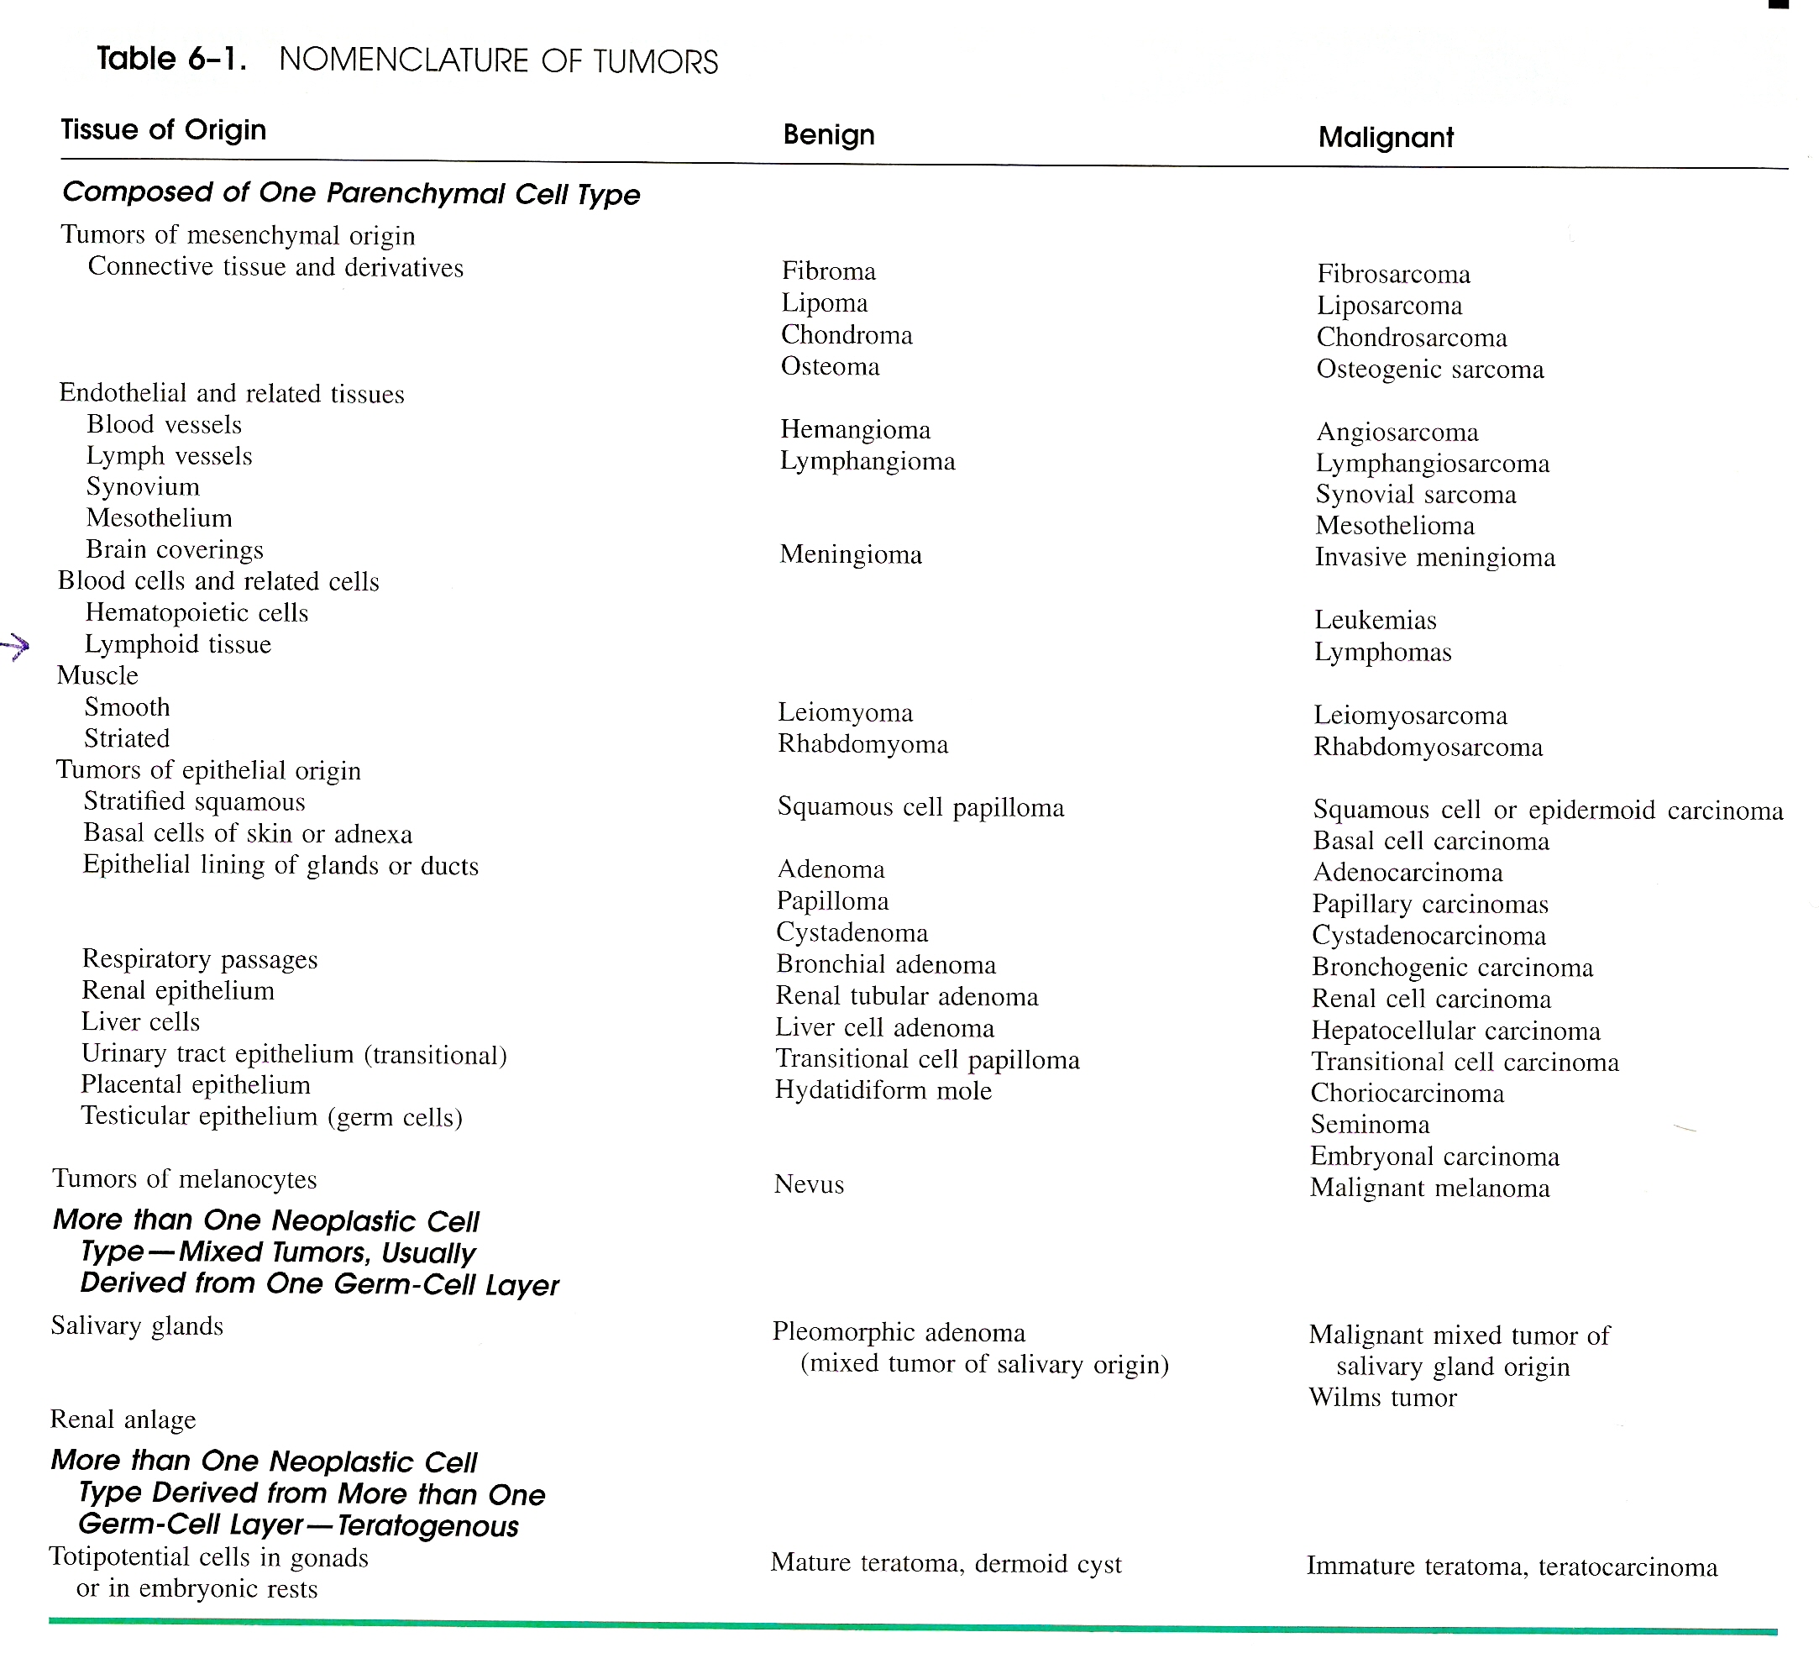

Nomenclature of tumors

.all tumors have suffix oma .

.benign epithelial tumors are papilloma or adenoma

.benign connective tissue tumors have prefix denoting cell of origin then oma.

.malignant connective tissue tumors are sarcoma while malignant epithelial tumors are carcinoma .

Clinically :
Benign tumors are slowly growing & clinically depend on location .It may remain asymptomatic as subcutaneous lipoma or may produce serious symptoms as in meningioma .
Malignant tumors grow rapidly & may ulcerate to the surface , invade locally or spread to distant sites & also produce systemic effects as anorexia , weight loss & anemia .
The cardinal sign of malignant tumors are invasiveness & metastasis .

Characteristic features of benign & malignant tumours :

1- Differentiation & anaplasia :

Differentiation is the degree of resemblance of tumor cell to the cell of origin both structurally & functionally .

If neoplastic cells show marked resemblance to tissue of origin it is called well differentiated as in benign tumors & in low grade malignant tumors .while poorly differentiated (undifferentiated) tumors show poor resemblance to tissue of origin . .

All benign tumor are look exactly like cell of origin e.g . lipoma look exactly like normal fat cells. While .malignant tumors can be:

-extremely well differentiated.

-moderately differentiated,or

-poorly defferetiated.

- Anaplastic

Anaplasia : Lack of differentiation & it is a characteristic feature of malignancy .

Cytological features of anaplsia (atypia) :

1- inc in the size of cell

2-pleomorphism;variation in nuclear & cell size

3- increase nuclear size, [n/c ratio]

4-hyperchromatism;increased nuclear DNA content

5-prominent nucleolus & sometime multiple

6-increased mitotic figures & presence of atypical mitosis

7-loss of polarity in an epithelial surface

8-formation of malignant giant cell.

2- Rate of growth :

In general the rate of growth correlate with the degree of differentiation , so malignant tumour grow more rapidly than benign tumour & there is some exception to this role in which benign tumor grow faster , also the rate of growth of both tumors are not constant all the time e.g leiomyoma may regress after menopause due to hormonal changes .

3- Local invasion :

Nearly all benign tumor grow by expansion remain localize to the site of origin without invading or metastasis to distant region as it grow it press the surrounding tissue forming a capsule which make the tumor discrete movable mass that can easily removed by inoculation .

The growth of malignant tumor accompany by infiltration , invasion & destruction of the surrounding tissue .

Invasion is the second reliable features of malignancy after metastasis.

4- Metastasis :
It is tumor implant discontinuous with primary tumor. it is the unequivocally marks of malignancy as benign tumor donot metastasis .
In genera the more aggressive , the more rapaidly growing , the larger primary tumor , the more likely to be metastasized .

Routes of spread :
1- Lymphatic spread : In general carcinoma metastasis by lymphatic while sarcoma favor haematogenous route . However sarcoma may also spread by lymphatic .
The regional L.N involve first . Sometime spread skip the regional L.D this happen due to lymphatic obstruction .
2- Haematogenous spread : It is common route for sarcoma , but certain carcinomas may spread by this route as those of lung , breast , kidney .
3- Other routes of metastasis :
- Transcoelomic spread : Certain tumors may spread through body cavity e.g. ca of stomach may spread the peritoneal cavity
to the ovary (krukenberg tumor ) .
- Intra epithelial spread : rare e.g . spread of breast carcinoma to the nipple ( paget disease ) by the lining epithelium of mammary duct .

.

Properties of Benign & Malignant Tumors:

Property Benign Malignant
Structure Similar to Normal Less Similar to Normal
Mitosis rare Common
Growth Expension Invasive
Growth Rate Slow Rapid
Capsule Usual Rare
Metastasis Never * frequent **

* benign tumors not metastasized except in hydatidiform mole .
** malignant tumors always metastasized except in glioma & basal cell carcinoma .

Grading & staging :
Grading :\
The degree of resemblance of tumor cells to the cell of origin .& it based on microscopic criteria :
Grade 1 : well differentiated
Grade II : moderate diff.
Grade III: poor diff.
Grade IV: undifferentiated ( anaplastic).

Staging :
The extent of spread of tumor within the body of the patient .This can be assessed by 3 ways – clinical examination – investigation & by pathologic examination .
- TNM staging (T for primary tumor , N – L.N involvement , M- for distal metastasis ) .
- AJC staging (American Joint Committee staging ).

Epidemiological factors of neoplasm:
1 - Racial & geographical factors :
* European & American : ca of lung , breast & colon .
* Black African : ca of liver , cervix & skin .
* Japanese : ca of stomach .
* Chinese : nasopharangeal carcinoma .

2- ENVIROMENTAL FACTORS
- DIET : Fatty diet with low fiber --- colonic cancer.
- OCCUPATION : asbestoses ------mesothelioma .
- SUN LIGHT : BCC
- PERSONAL HABITS :
smoking ----ca of oral cavity , oropharynx . larynx , esophagus , lung , pancreas & bladder ,.
alcoholism ---ca of oropharynx . larynx , esophagus & liver )
- RADIATION & POLLUTION :leukemia , ca lung & breast .

3- AGE
- In general cancer incidence increase with increasing age.
- Certain tumors occur more in children
- Acute Leukemia
- CNS tumor
- Blastoma as neuroblastoma , retinoblastoma ,
- Sarcoma

4- HEREDITARY (genetic ) factors :
*Some tumors shows familial tendency e.g. ca breast shows 3 times rate higher in a family of cancer patient than in control group.
*Retinoblastoma.
*Neurofibromatosis type I .
*Familial polyposis coli .
* DNA – chromosomal instability syndrome : group of preneoplastic condition due to defect in DNA repair as in Xeroderma pigmentosa

5- ACQUIRED PRENOPLASTIC SYNDROMES
-These are associated with increase risk for cancer :a.
- endometrial hyperplasia -----------& endometrial ca
- cervical dysplasia -------------------& cervical ca
- liver cirrhosis ------------------------& hepatocellular ca
- villous adenoma ---------------------& colorectal ca
- ulcerative colitis & colorectal cancer . Molecular

Carcinogenesis :

Principle in Molecular basis of cancer :
1-Non lethal genetic damage is the heart of carcinogenesis .Such damage may be acquired (chemical, physical , or virus ) or inherited.
2-four genes are the target for genetic damage , growth promoting gene (proto-oncogen) , growth suppressor gene , gene regulate apoptosis &DNA repair gene.
2- Tumor arise from single precancerous cell (monoclonal).
4-Carrcinogenesis is a multistep process at phenotypic & genetic level.
Although cancer is monoclonal in origin but later become heterogeneous .

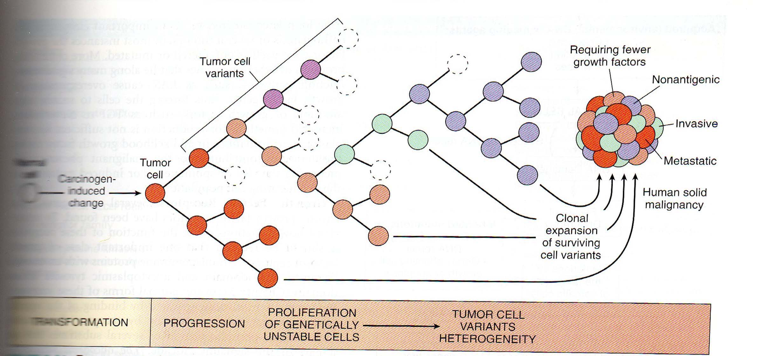

Essential alteration for malignant transformation (Molecular pathogenesis for cancer): seven key changes as follow:
1-Self sufficiency in growth signal : Tumor has the capacity to proliferate without external stimuli.
2-Insensitivity to growth inhibitory signal :
The cell not respond to molecule that inhibit the proliferation of normal cell such molecule called tumor suppressor gene (anti-oncogen ) as P53 & RB gene.
3- Evasion of apoptosis :
Tumor cells not respond to apoptosis due to inactivation of P53 OR activation of anti a poptotic gene .
4- Limitless replication potential (Telomerase) :
Proliferation of tumor cell is not restricted . it resist permanent cycle arrest or mitotic catastrophe .
5- sustained angiogenesis:
Tumor cells are not able to grow without formation of vessels to supply O2 & nutrient & remove waste product .
6- Ability to invade & metastasis :
7- defect in DNA repair :
Tumor may fail to repair DNA damage caused by carcinogen lead to genetic instability & mutation of proto-oncogen & tumor suppressor gene .

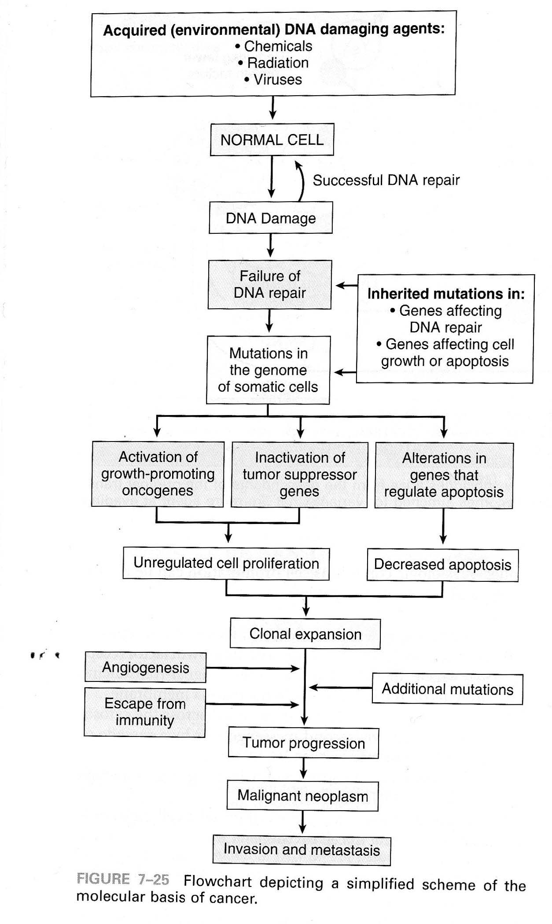

**Insensitivity to growth inhibitory signal :

About 50% of human cancer show mutation in P53 gene & mutation of both allel seen in all cancer especially cancer of breast , lung & colon , while mutation in one allel make the person have 25 times greater chance to develop cancer than normal population .
Normally if the cell expose to substance that damage the DNA or to hypoxia , activation of P53 occur which arrest cell cycle at G1, then DNA repair happen by DNA repair gene . If DNA repair fail ,P53 trigger apoptosis or permanent cell cycle arrest (senescence ) .
In cell with loss or mutation of P53 gene , DNA damage not cause cell cycle arrest or DNA repair & instead damage cell undergo proliferation give rise to malignancy . 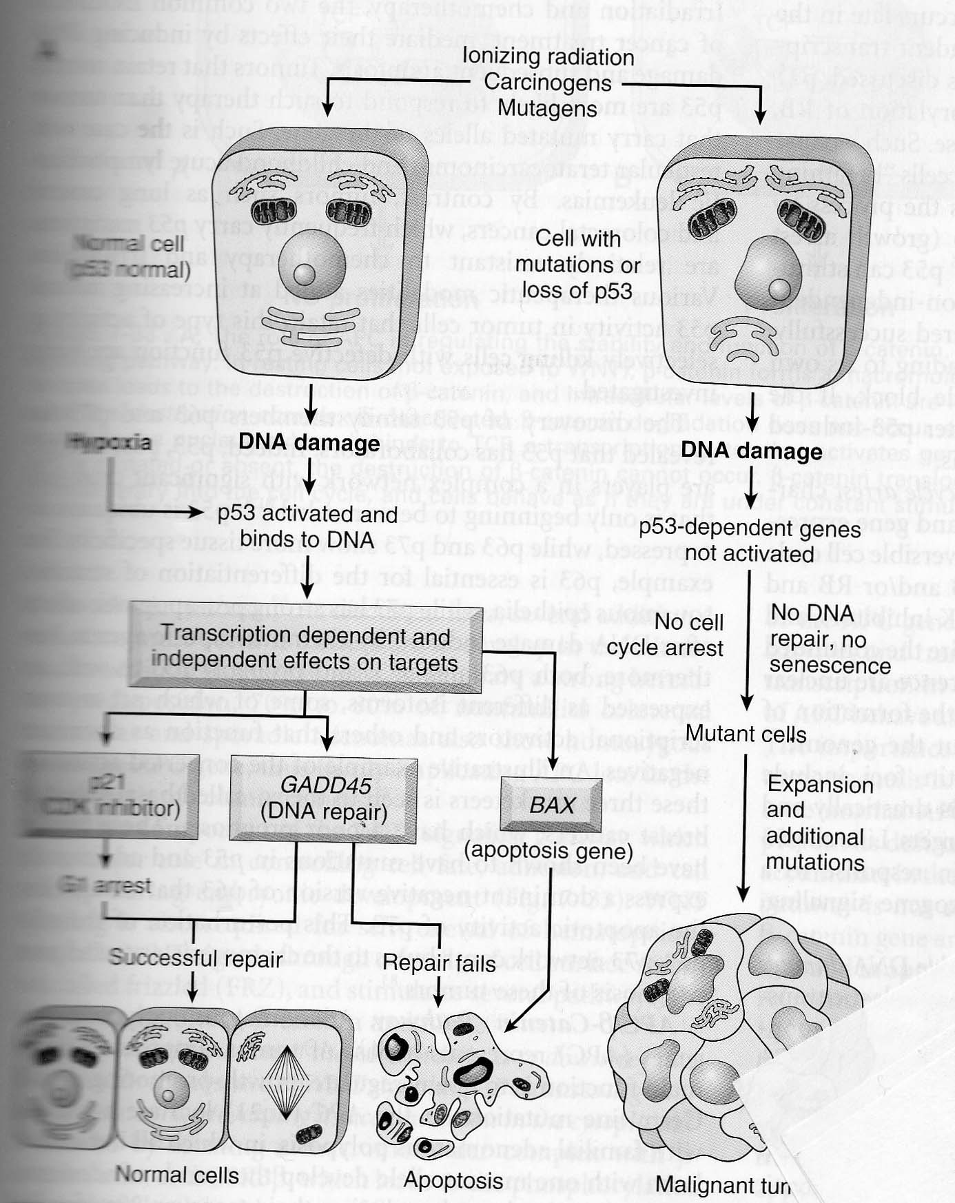

3- Evasion of apoptosis :
Accumulation of neoplastic cells result not only from activation of growth promoting gene , inactivation of tumor suppressor gene but also from mutation in the gene that regulate apoptosis.

4- Limitless replication potential (Telomerase) :
Somatic cell after multiple replication (50-70) times lead to short telomers at the end of chromosome which recognized by DNA repair machinery as double strand break lead to permanent cycle arrest (senescent) by p53 & RB gene . In the absence of P53 the short ends join form dicentric chromosome . At mitosis dicentric point pull a part generating random double strand break & cell undergo numerous mutation .Normally somatic cell fail to re-express telomerase so it undergo mitotic catastrophe & death , if the cell activate telomerase it cause lengthening of telomere so the cell escape death & undergo carcinogenesis . 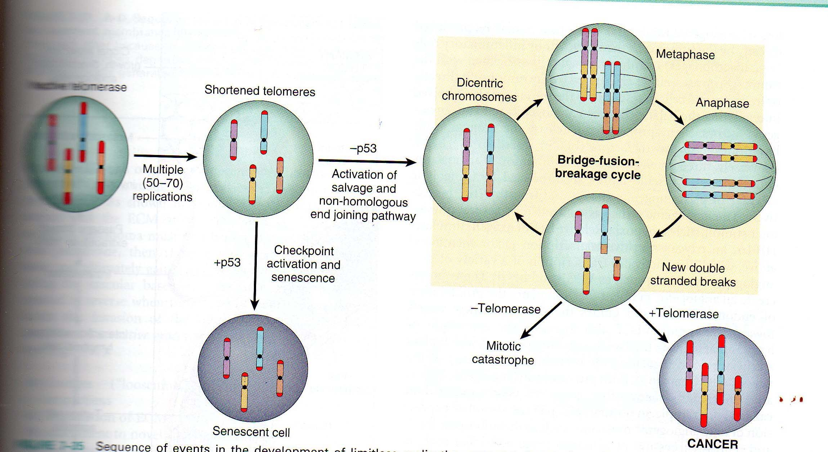

5-Angiogenesis :
Tumor cells are not able to grow without formation of vessels to supply O2 & nutrient & remove waste product .

6- Ability to invade & metastasis :
Invasion & metastasis are the hall mark of malignancy . Tumor cells are variable in its metastatic potential i.e only certain subclonal cell have the ability to complete whole step of metastasis .
metastasis cascade divide into 2 stages :
A-Invasion of ECM (B.M & interestial tissue ) : which has 4 steps :
1- detachment of tumor cell from each other by loss of adhesive substance such as cadherine .
2- attachment to ECM.
3-Passage through extra cellular matrix by lyses of ECM by collagenase enzyme .
4-Invasion of lymphatic or vascular channels .
B-Vascular dissemination & homing :
Once tumor cells enter b.v it become vulnerable to destruction by immune system .some tumor cells aggregate form together with platelets an emboli .
Extravasations involve adhesion to endothelium follow by egress through basement membrane by mechanism similar to that of invasion.
The site at which emboli depend on the site of primary tumor & its vascular & lymphatic drainage , however sometime the site of secondary is not related to the natural drainage & this is called homing ,Ex. Ca.of breast spread to the bone .

. 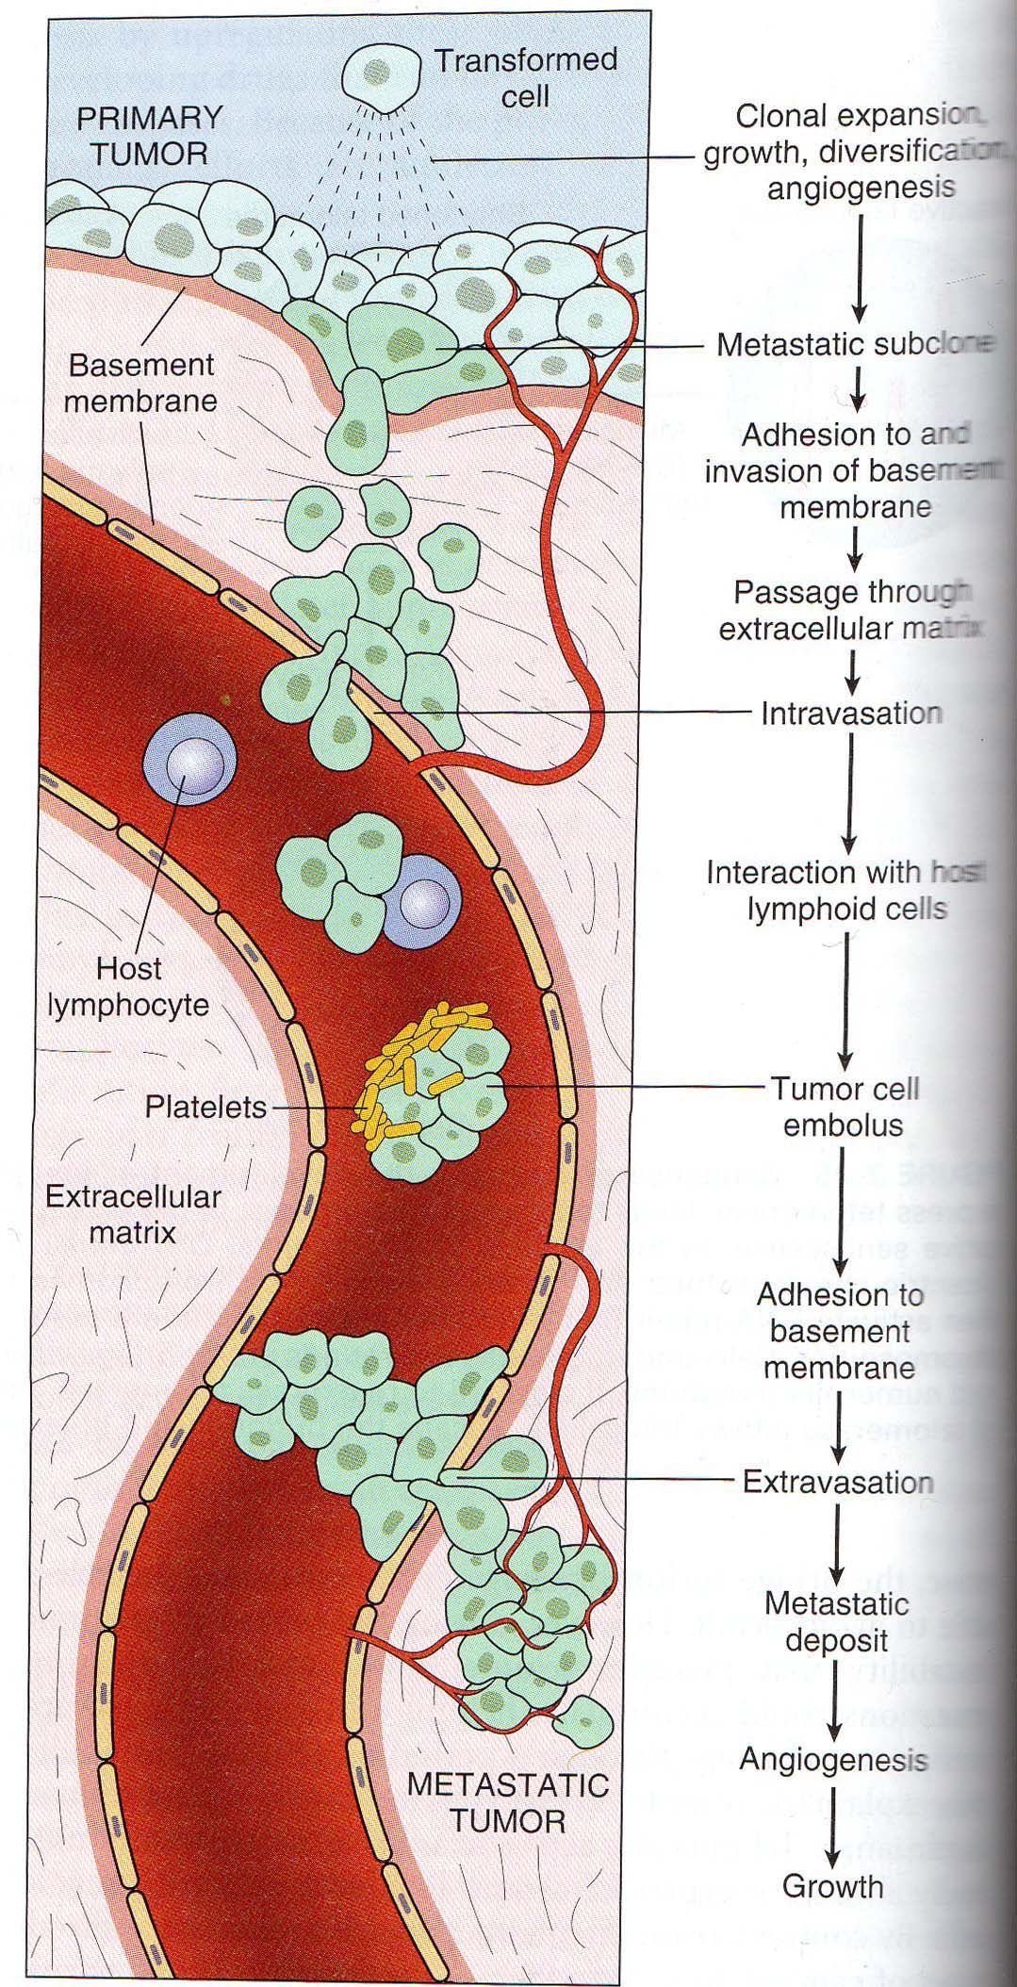

7- defect in DNA repair :
Tumor may fail to repair DNA damage caused by carcinogen lead to genetic instability & mutation of proto-oncogen & tumor suppressor gene .

Types of carcinogen :

1- CHEMICAL CARCINOGENS :
It pass into 2 stages :
1- Stage of initiation : which is the first stage of carcinogenesis in which the target cell transformed into mutated cell ( damage DNA) . These changes are sudden ,irreversible , dose & time independent . chemicals inducing irreversible DNA damage is called initiator & it is of 2 types :
*Direct carcinogens: directly produce damage & induced cancer e.g. alkylating agents
*Indirect carcinogens ( procarcinogen ): need metabolism in liver before it become ultimate carcinogen e.g. aromatic amine & polycyclic hydrocarbons .
Both direct & ultimate carcinogen are highly reactive electrophiles( electron deficient atom) that react with nucleophilic site (electron rich) in the cell such as DNA, RNA& protein.
Direct & ultimate carcinogen when apply usually change in the liver form electrophilic intermediate which produce specific changes in DNA which not necessary lead to initiation because majority are repaired by enzyme , so the presence of unrepaired ( permanent damage ) DNA is the first step of the altered cell .
Initiation is not sufficient to produce tumour it need the presence of other substance called promoter which themselves are not tumorigenic.

2-Stage of promotion ( Promoter) : It augment the effect of initiator by promoting cellular growth as phenol , phenobarbitone . Promoter differ from Initiator by :
1-They don't produce sudden change .
2-It require sufficient time & dose for administration .
3-Changes is reversible .
. 4-It act by activation of growth factor lead to clonal proliferation
Application of promoter lead to proliferation & clonal expansion ( preneoplastic clone ) which need further mutation to develop malignant tumour .
Ex of initiators:
- direct alkylating agent (anticancer drug) : cause lymphoma & Leukemia.
- Polycyclic aromatic hydrocarbon : bladder & liver cancer .
- Aflatoxin B1 : hepatocellular carcinoma .

Ex.of promoters :
-exogenous as cigarette smoke & viral infection .
- endogenous as estrogen ( endometrial carcinoma ) & fatty died (colonic cancer ) & alcohol(oral ,laryngeal----).

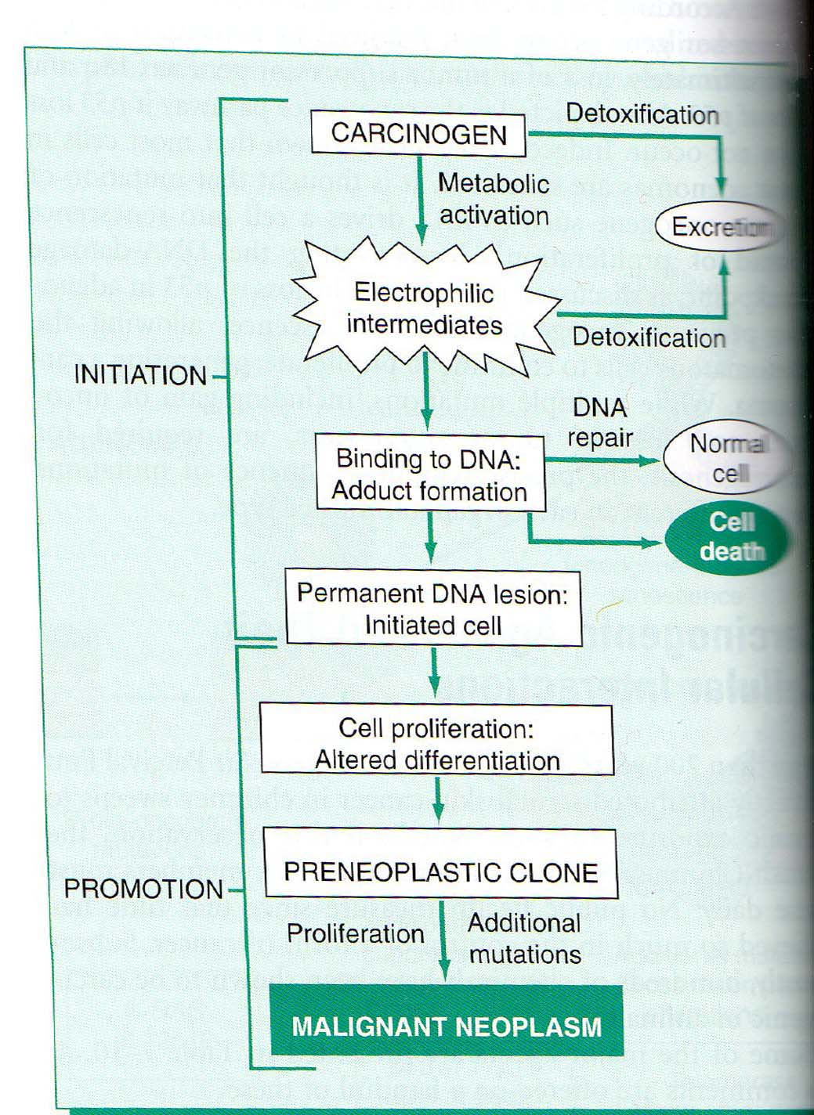

2- PHYSICAL CARCINOGENESIS:
- Radiation :
A/ Non-ionizing as U.V LIGHT
Effect depends on intensity of exposure & quantity of melanin Causing skin cancer
- squamous cell ca
- basal cell ca
- melanoma
esp. affected patient with xeroderma pigmentosa which is autosomal recessive disease characterized by extreme photosensitivity & has200 fold increase risk of skin cancer on sun exposure associated with neurological abnormalities.

B/ IONIZING RADIATION :
include electromagnetic X- Ray & gamma Ray )& particulate (alpha & beta particles , proton & neutron) . All are carcinogen .
Present in environment as explosions OR therapeutic exposure
- explosions cause leukemia , breast, colon, thyroid & lung cancer
- therapeutic exposure causes thyroid ca & leukemia

C/Non-radiating agents :
Asbestose fiber inhalation Causes Mesothelioma (malignant pleural tumour) , lung ca & GIT ca.

3- VIRAL CARCINOGENESIS
A/DNA VIRUSES :
1-HPV (human papilloma virus)
- Low risk group (6&11) causes sq cell papilloma(viral wart or condyloma acuminata)
- High risk group (16&18) causes sq cell carcinoma of cervix, anogenital, & oral cavity.

2-EBV (EPSTEIN BARR VIRUS)
- Burkitt’s lymphoma
- B-cell lymphoma
- Nasopharyngeal ca

3-HBV (HEPATITIS B & C VIRUS)
- causes liver cirrhosis end in hepatocellular ca.

4- Human Herpesvirus 8 (HHV-8)
- Causes Kaposi sarcoma in AIDS patients.

B-RNA virus
- HTLV-1 : leukemia/lymphoma in human .

.
EFFECT OF NEOPLASIA ON THE BODY
1-Local effect seen in benign & malignant tumors due to their size or location .
a- Compression : some benign tumors has serious effects due to their location , small benign tumors in the ampulla of vater may lead to biliary obstruction .
b- Mechanical obstruction : benign & malignant tumors in the gut cause intestinal obstruction .
c- Infarction , ulceration & hemorrhage These are seen more in malignant tumors .

2-Hormon production : seen in tumour of endocrine origin . In general benign tumour produce more hormone than in malignant endocrine tumour.

3-Cancer cachexia : wasting syndrome characterized by anorexia , loss of body fat with marked weakness , anemia & fever . Possibly due to TNF alpha , loss of appetite ,

4- Paraneoplastic syndrome: syndrome that can't be explained by the effects of either local or distant spread of tumor or by usual hormones secreted by cell of origin of tumors , they may precede the tumor, they occur in about 10% of malignant tumor . include:
a- Endocrine syndrome :
* Hypercalcemia seen in Sq cell ca of lung.
* cushing syndrome : Small cell carcinoma of the lung.
* Hypoglycemia : tumor of pancreas.
b- Neuromyopathy : as myosthenia gravis
c- Hematological syndrome as DIC , venous thrombosis & autoimmune hemolytic anemia .
d- Cutaneous syndrome as acanthosis nigricans seen in carcinoma of the gut .
5- Amyloidosis .

Diagnostic methods for neoplasia :
1- History & physical examination :
Sign & symptom such as anaemia , weight loss , anaemia ,prescence of mass .

2-Radiographic techniques :
X –ray ; CT , (computed tomography ) , MRI ; US & mammography .

3-Laboratory analysis :
general findings such as anemia , enzyme abnormality ; haematuria , positive stool for occult blood are helpful .

4-Cytology : e.g.
a- cell exfoliative cytology as Pap smear for cervical dysplasia & carcinoma of the cervix .
b-FNA (fine needle aspirate): study of cells obtained by fine needle introduced under vacuum into the lesion . the superficial mass aspirated under direct vision while deep seated masses are investigated by US or by CT guided FNA .it may have sampling error but with experienced hand , it is reliable rapid & useful .

5-Tissue biopsy :

6-histochemistry & cytochemistry both are additional diagnostic tool that help the pathologist in identifying the chemical composition of the cells by special staining methods .

6- Immunohistochemistry . By using specific antibody that react with certain component of the cell ( a.g) in formalin fixed paraffin section or cytological smears . the reaction is made visible for light microscope either by fluorescent dyes or by enzyme system .it is used in the followings:
a-diagnosis of undifferentiated tumor e.g anaaplastic carcinoma , lymphoma , melanoma.
b- determine the site of origin of metastatic tumor.
c-detection of molecules which has prognostic significant e.g hormone (estrogen receptor in breast make the tumor susceptible to antiestrogen therapy .

8-Flow cytometry : helpful in identification & classification of tumors arise from T- lymphocyte , B lymphocyte & macrophage.

7- Tumors markers : they are biochemical indicators for the presence of tumor, they include surface a.g , cytoplasmic protein, hormone & enzyme . They lack specificity & sensitivity used for detection of early cancer It is used in follow up after excision to detect early recurrence .
Carcino embryonic antigen : normally found in fetal colonic , pancreatic & liver tissue . it is found in 60-90% of colonic & pancreatic cancer & less commonly in gastric & breast cancer . Low level is found in certain benign condition as cirrhosis , hepatitis & inflammatory bowel disease .

Alpha fetoprotein : normally found in embryonic yolk sac & liver tissue .
Increase in certain malignancy as ca of liver & testicular tumor & in certain non neoplastic condition as hepatitis & cirrhosis .

Tumour immunity :
Tumour cell has 2 antigens : tumour specific A.g that present on tumour cells only & tumour associated A.g that present on tumour cell & on some normal cells .

Anti tumour effec ( mechanism of tumour immunit ) :
1- cell mediated immunity which is most important mechanism & include :
*Cytotoxic T cell (CD8+) play an important role in virus associated neoplasm e.g EBV associated tumor as it recognize A.g present on tumour cell by MHC class 1 molecule.

**Natural killer cell (NK):
It is T lymphocyte that able to destroy tumour cell without previous sensitization , it is first line of defense against tumor.
- After activation by IL15 Nk cell lyses wide range of tumour cell .
- In addition tumour that fail to express MHC class 1 A.g (due to virus) this will block the inhibitory receptor of NK cell so the activating receptor will lyse tumour cell .normal cell is not killed because inhibitory receptor over ride the activating signal.
- NK cell also induce antibody dependent cellular cytotoxicity.

*** Macrophage :
Gamma interferon activate Macrophage to kill tumour cells either by generation of oxygen species or by release of TNF.

2- Humeral mechanism ; can destroy tumour cell by activation of complement system or by induction of antibody dependent cellular cytotoxicity.

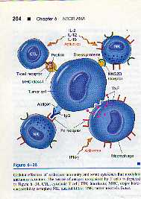
.
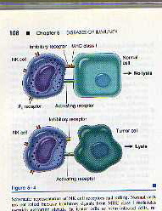

Immune surveillance :
Recognition & destruction of tumour cells on their appearance .
This is shown by increase in the frequency of tumor in immune deficient patient whether congenital or acquired as in AIDs.
However most patient who do not suffer from immune deficiency & despite the presence of Immune surveillance cancer occur , this could be explain by:
1-selective over growth of Ag negative subclone .
2- loss of expression of major histocompatibility class 1 Ag so the cell cannot attack by cytotoxic T cell .
3- Lack of costimulatory factor B7 which normally stimulate cytotoxic
T cell , deficiency of such factor make the cell anergy .
4- immunosupression : many chemical oncogen suppress host immune system .
5-antigen masking : a.g of tumor cell may be hidden from immune system by glycocalyx molecule which present in tumor more than normal cell.
6-apoptosis of cytotoxic cell as seen in hepatoma & melanoma.

