THE CONJUNCTIVA I
Lec:4
د. عامر يحيى رجب
6/11/2013
العدد ( 8)
THE CONJUNCTIVA
The conjunctiva is a transparent mucous membrane lining the inner surface of the eyelid and covering the anterior sclera.
Gross anatomy
- Palpebral conjunctiva
- The conjunctival fornix
- Bulbar conjunctiva
- Plica Semilunaris
- Caruncle
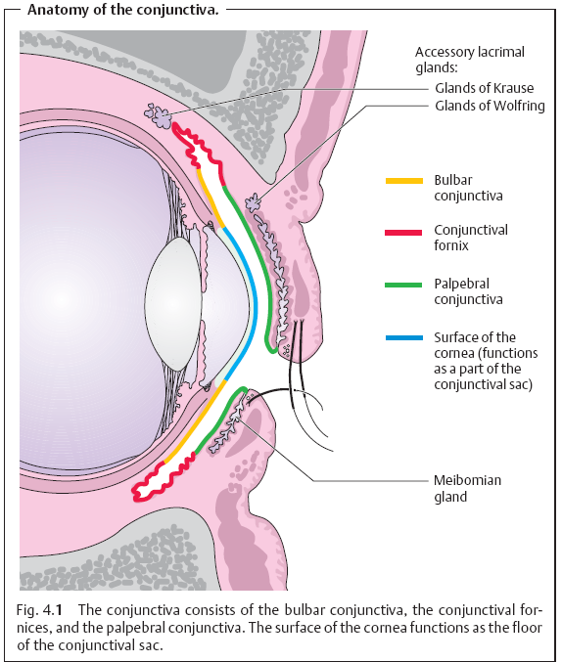
Blood supply and lymph drainage:
I. Arterial supply
1.Posterior conjunctival arteries
2.Anterior conjunctival arteries
II. Venous drainage
1.Palpebral vein
2.Ophthalmic vein
III. Lymphatic drainage
1.Preauricular lymph node
2.Sub mandibular lymph node
IV. Nerve supply ( Trigeminal nerve)
Minute anatomy
- The epithelium.
- The substantia propria
A. Adenoid Layer
B. Fibruos Layer
Pathological manifestation of conjunctival inflammation
- discharges.
- Chemosis.
- Hypereamia.
- Follicles.
- Papillae.
- Giant papillae.
- Membranes.
- Pseudomembrane.
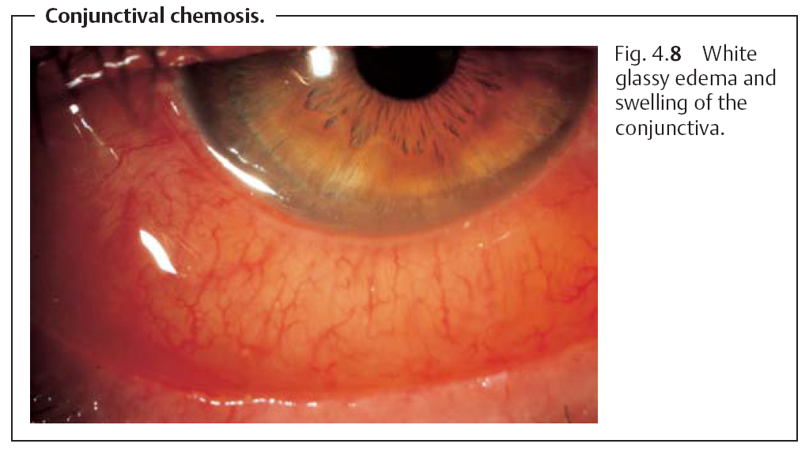
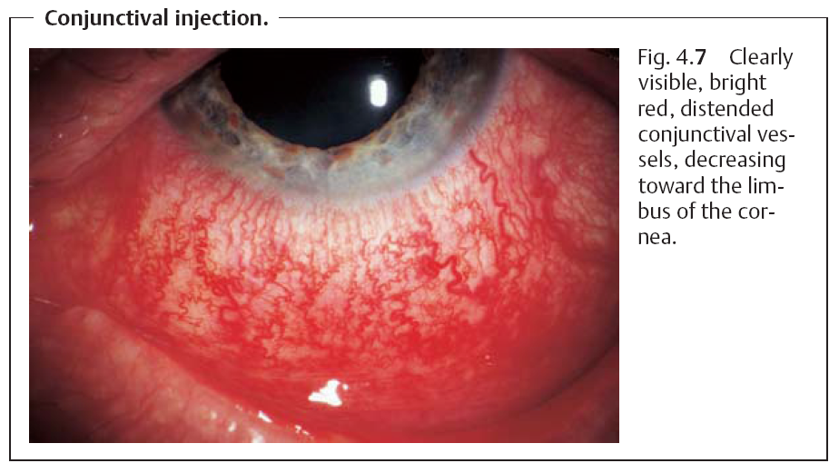
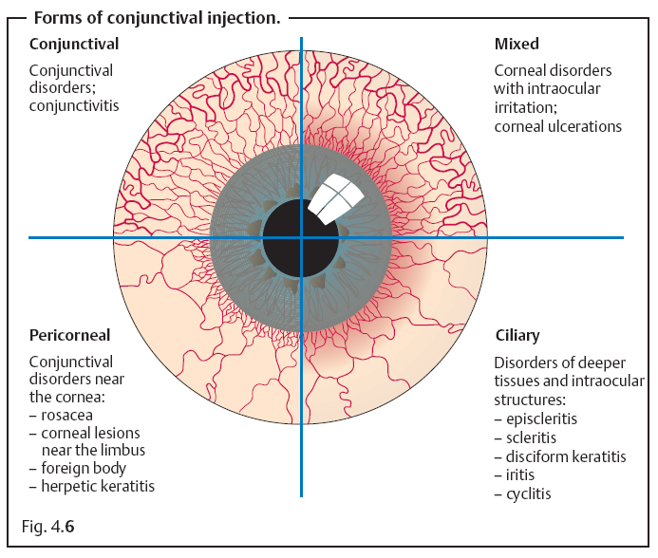
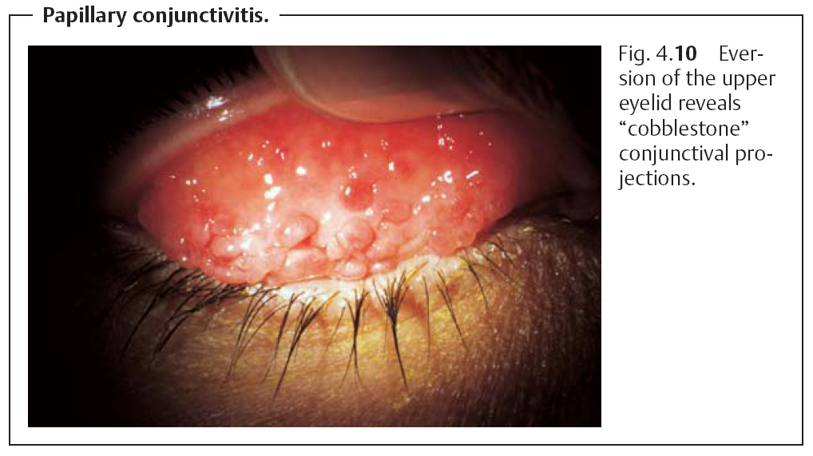
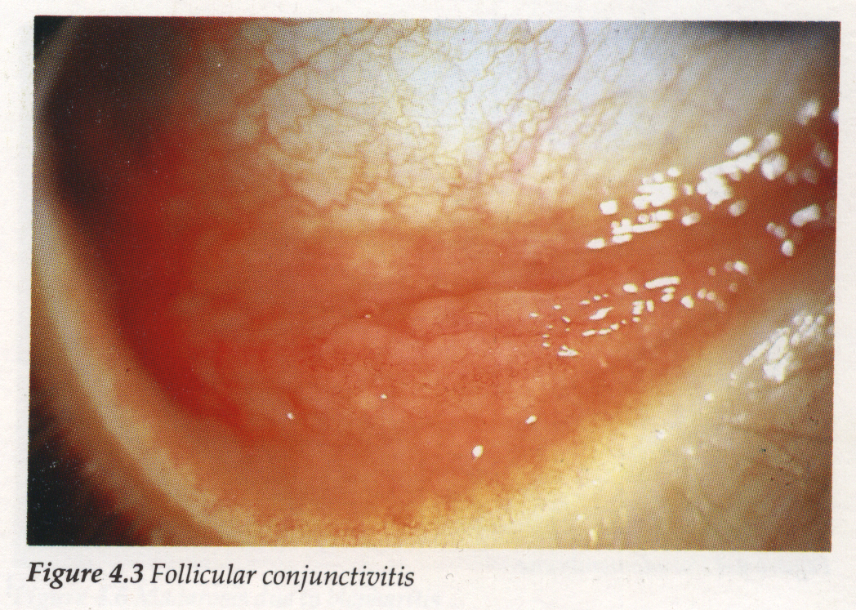
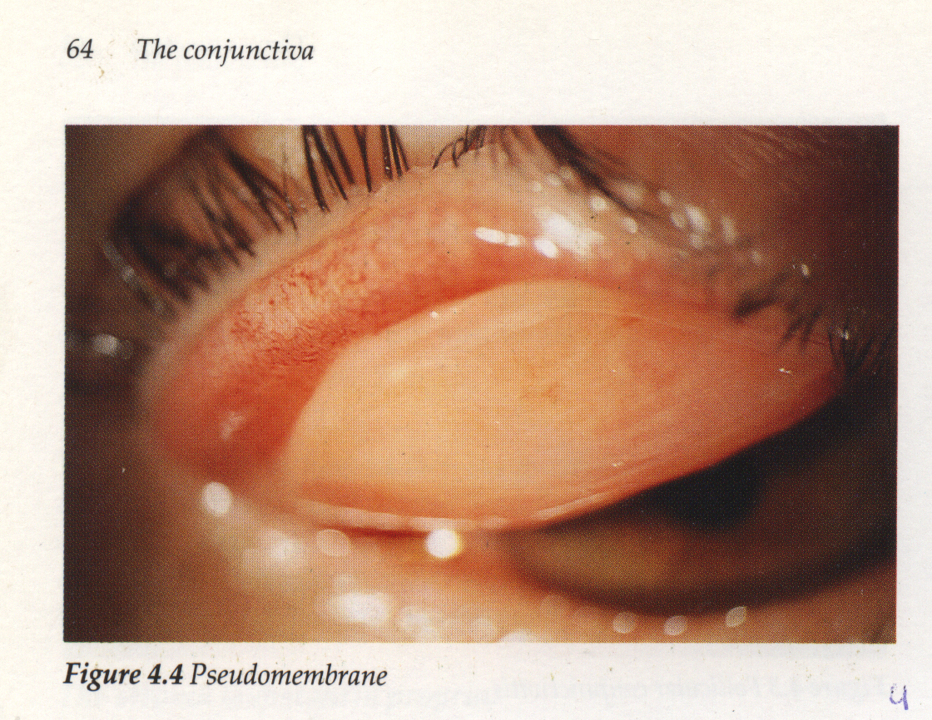
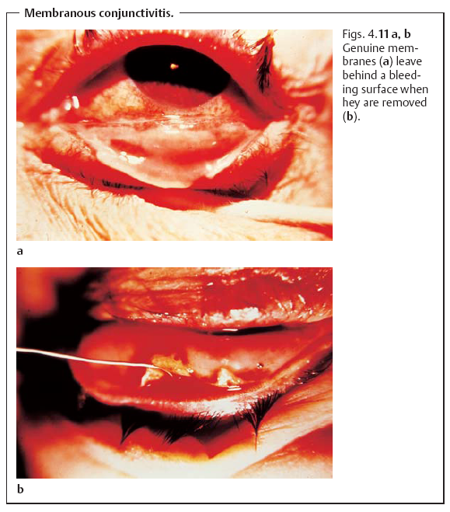
Disease of the Conjunctiva
- Inflammations.
- Degenerations.
- Dry eye.
- Pigmentations.
- Conjunctival tumors.
Conjunctivitis
Classifications:
- Infective conjunctivitis;
A. acute:( serous, catarrhal, muco-purulent, purulent, viral and membranous).
B. Sub acute:( catarrhal, angular and follicular).
C. Chronic:( follicular and granulomatous).
Non-infective conjunctivitis
A. acute:( mechanical injuries, allergic, photophthalmia and burns)
B. chronic :( simple catarrhal, keratoconjuncvtivitis sicca, vernal, phlyctenular and ocular pemphigoid.
ACUTE INFECTIVE CONJUNCTIVITIS
Mucopurulent Conjunctivitis
Causative agents: The commonest organisms are
- Haemophilus aegypticus (Koch-Week’s bacillus): causes epidemics in April, May & September, and October. This is related to the fly breeding season
- Staphylococci, streptococci and peneumococci
- Acute fevers
Clinical features
It’s an acute infective type of conjunctivitis characterized by hyperaemia of the bulbar conjunctiva and papillary hypertrophy of the palpebral conjunctiva associated with muco-purulent discharge.
It may manifest itself either in severe or mild form.
Treatment
Based on two principles :
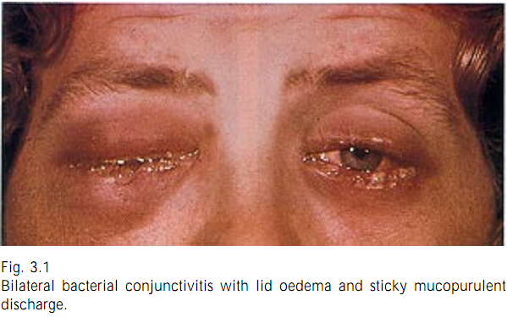
1- Frequent irrigation of the conjunctival cul-de-sac to remove the discharge.
2- Control of the infection.

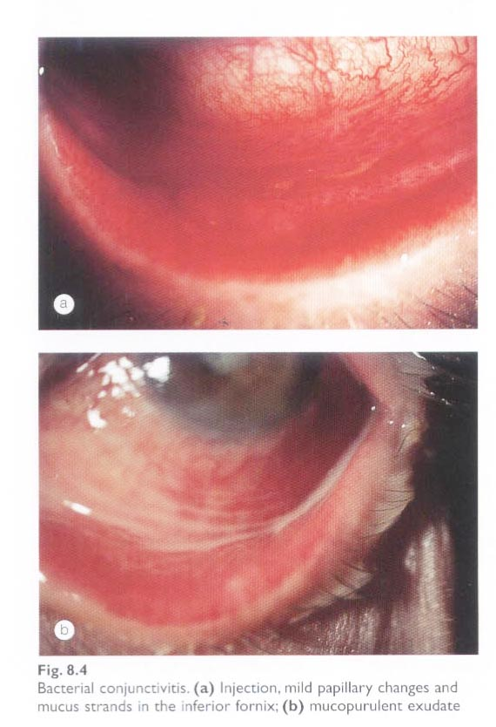
OPHTHALMIA NEONATORUM
- In children aged <30 days
- Any discharge or watering, in the first week of life should arouse suspicion
- ETIOLOGY:
  - Before birth: infected amniotic fluid
  - During birth: infected birth canal
  - After birth: first bath, soiled clothes, unhygienic conditions
- CAUSITIVE AGENTS:
  - Chemical conjunctivitis: silver nitrate solution
  - Gonococcal infection:
  - Other bacterial infections:
    - Staph aureus
    - Strept hemolyticus
    - Strept pneumoniae
  - Neonatal inclusion conjunctivitis:
    - Chlamydia trachomatis serotype D to K
  - Herpes Simplex Ophthalmia Neonatorum
- Incubation period:
  - Chemical conjunctivitis: 4-6 hours
  - Gonococcal infection: 2-4 days
  - Other bacterial infections: 4-5 days
  - Neonatal inclusion conjunctivitis: 5-14 days
  - Herpes Simplex Ophthalmia Neonatorum : 5-7 days
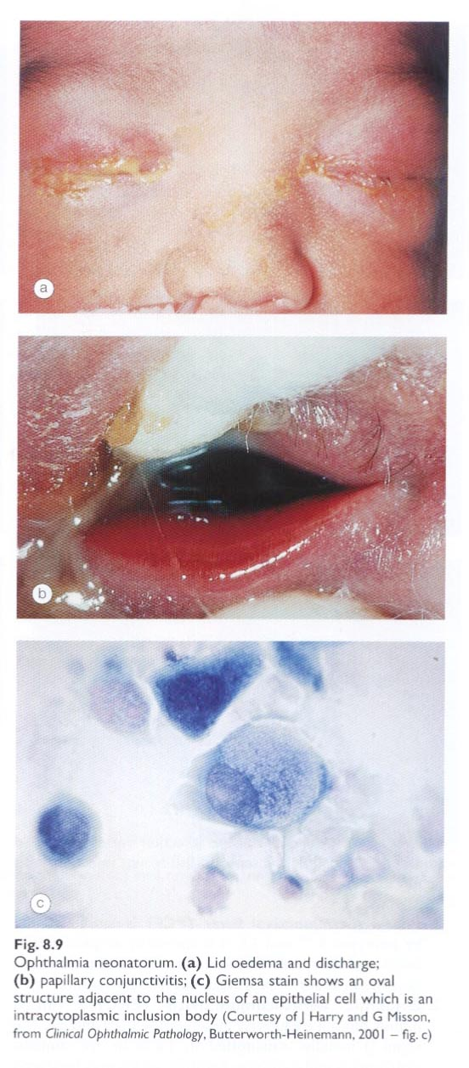
SYMPTOMS:
  - Pain and tender eyeball
  - Purulent conjunctival discharge (gonococcal)
  - Mucoid / mucopurulent (other bacterial
infections)
  - Swollen lids
  - Chemosed conjunctiva
  - Corneal involvement rarely
COMPLICATIONS:
Corneal ulceration with tendency to perforate
- PROPHYLAXIS:
  - Antenatal:
    - Treatment of genital infections of mother
  - Natal:
    - Delivery under aseptic conditions
    - Newborns eyelids should be well cleaned
  - Postnatal:
    - 1% tetracycline / 0.5% erythromycin ointment
    - 1 % silver nitrate solution (Crede’s method)
    - Single injection of Ceftriaxone 50mg/kg IM/IV

ACUTE FOLLICULAR CONJUNCTIVITIS
- Epidemic keratoconjunctivitis:
  - Associated with SPK and occur in epidemics
  - Adenovirus type 8 and 19
  - Markedly contagious and direct contact transfer
  - Incubation : 8 days
    - Phase 1 : acute serous conjunctivitis
    - Phase 2 : acute follicular conjunctivitis
    - Phase 3 : acute pseudomembranous conjunctivitis
    - Corneal involvement : SPK
    - Pre-auricular lymphadenopathy in all cases
  - Treatment : supportive therapy
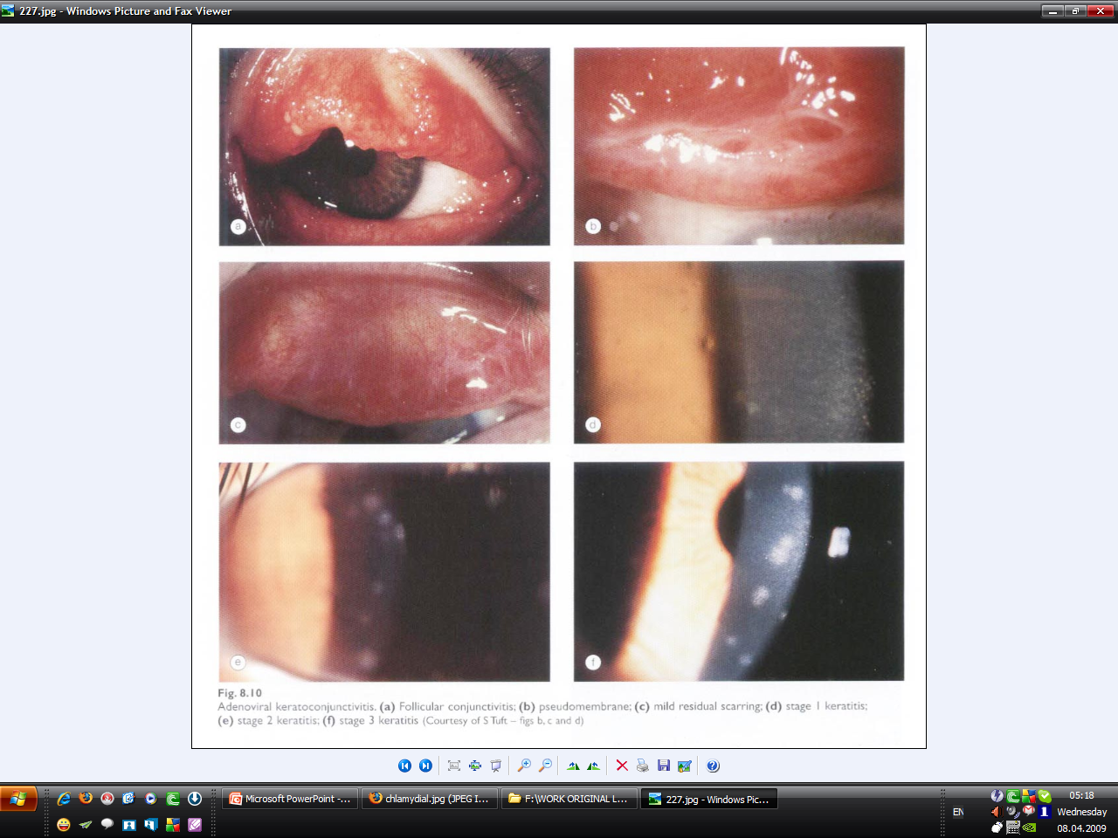

- Pharyngoconjunctival fever:
  - Adenovirus type 3 and 7
    - Acute follicular conjunctivitis
    - With pharyngitis, Fever & Pre auricular LN
  - Primarily in children and in epidemic forms
  - Corneal involvement in 30% cases
  - Treatment is supportive
ACUTE NON-INFECTIVE CONJUNCTIVITIS
- Mechanical injury
- Photophthalmia
- Acute allergic conjunctivitis
ANGULAR CONJUNCTIVITIS
Mild chronic conjunctivitis confined to the conjunctiva & lid margins near the angles
- ETIOLOGY:
  - Moraxella Axenfield Bacilli
  - Rarely staphylococci
- PATHOLOGY:
  - Production of proteolytic enzyme
  - Causes maceration of epithelium
- SYMPTOMS:
  - Irritation discomfort
  - Collection of dirty white foamy discharge at the angles
  - Redness in the angles of the eye
- SIGNS:
  - Hyperaemia of bulbar conjunctiva near the canthi
  - Hyperaemia of lid margins near the angles
  - Excoriation of skin around the angles
  - Presence of foamy mucopurulent discharge at the angles
- COMPLICATIONS:
  - Blepharitis
  - Marginal catarrhal corneal ulceration
- TREATMENT:
  - Good personal hygiene
  - Oxytetracycline 1 % eye ointment 2-3 times x 10-14 days
  - Zinc lotion at day time and zinc oxide ointment at bedtime
CHRONIC NON-INFECTIVE CONJUNCTIVITIS
PHLYCTENULAR CONJUNCTIVITIS
It is an allergic reaction of the conjunctiva caused by endogenous bacterial toxins and characterized by bleb or nodule formation near the limbus.
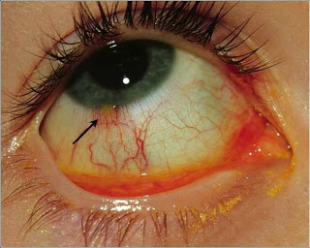
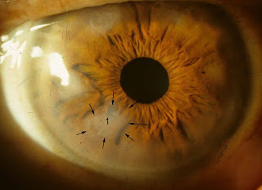
Aetiology :
- Tuberculo-protein
- Toxins from staphylococcus or streptococcus
- Toxins from intestinal parasites
Clinical Types :
- Phyctenular conjunctivitis
- Phyctenular Kerato-conjunctivitis
- Phyctenular Keratitis

Vernal kerato-conjunctivitis (spring Catarrh):
It is a chronic allergic condition of the conjunctiva, affecting mainly children and young adults characterized by seasonal variation and may be associated with Keratoconus. It is due to hypersensitivity to airborne allergens. It is common in patients with asthma, hay fever or atopy.
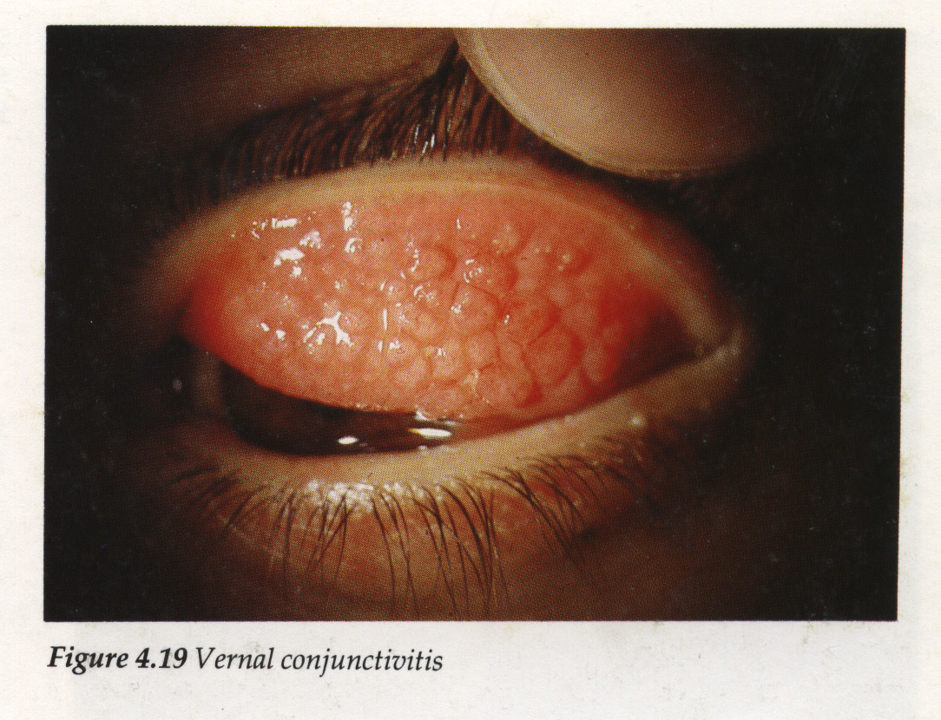
Clinical picture:
- Itching and lacrimation
- Scanty whitish ropy mucoid discharge.
- Hyperemia.
- Photophobia and belpharospasm.
- Symptoms increase in spring and summer ( seasonal variation)
Signs
- Palpebral Type
- Bulbar Type: more severe
- Mixed type
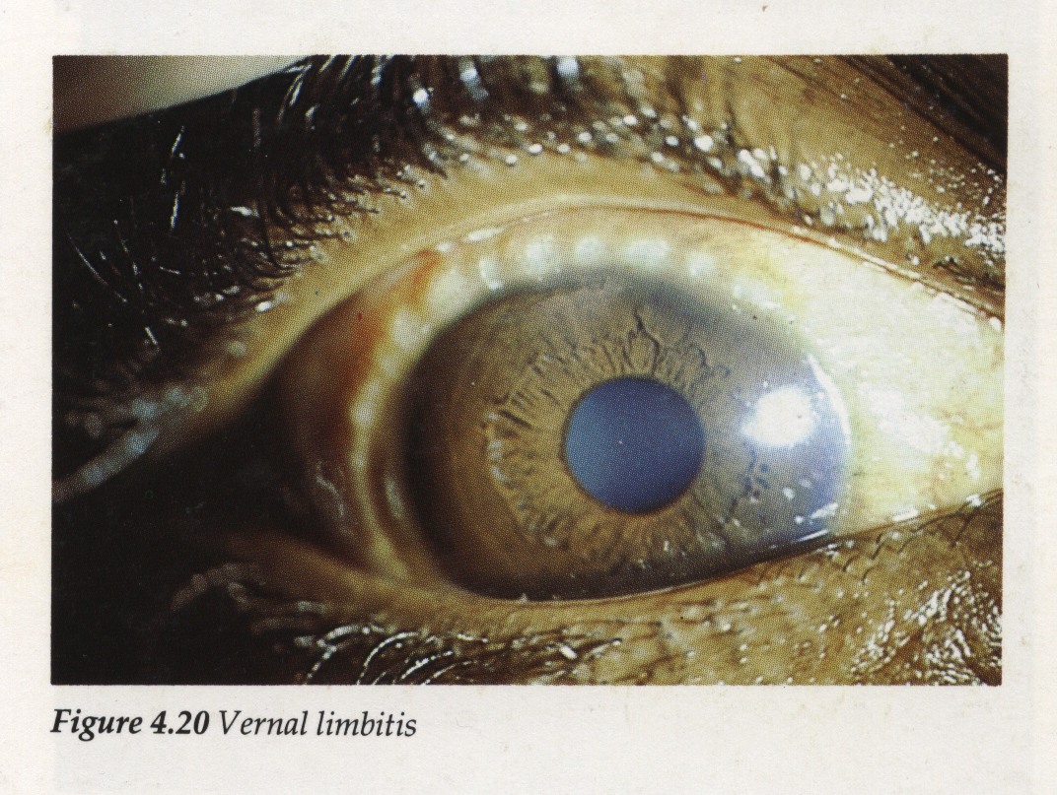

Giant papillary conjunctivitis
Etiology:
Associated with contact lens wear especially extended-wear contact lenses least with hard lenses.
May result from irritation with ocular prosthesis or by exposed corneal sutures.
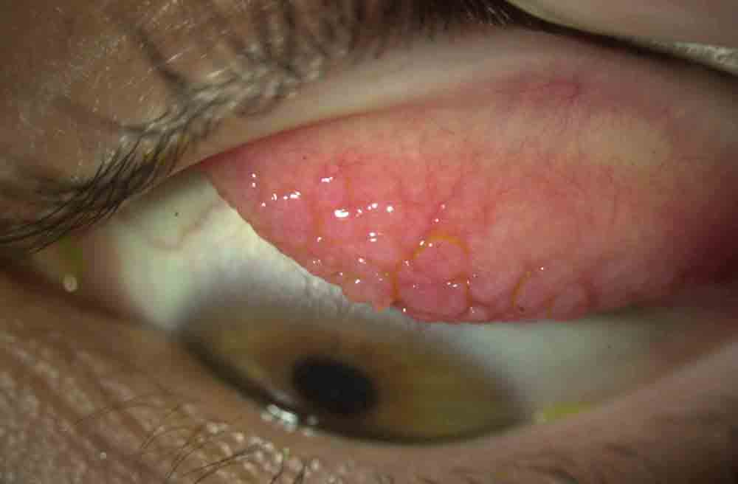

By : younis alomary

