***Hemorrhagic Disorders..***

These include

Disorders of platelets.

Disorders of blood vessels.

Disorders of coagulation & fibrinolysis.

***Platelet Disorders***

Quantitative : Thrombocytopenia.

Qualitative : Platelet defects (functional anomalies).

***Thrombocytopenia***

Thrombocytopenia exists when platelet count is less than 150 x 109 /L .

Normal platelet count = 150 – 400 x 109 /L

Bleeding is unusual when count is >50x109 /L

Spontaneous bleeding occurs when count is < 20x109 /L

***Causes of Thrombocytopenia***

1.***decresed platelet production***

Characterized by reduction of megakaryocytes in bone marrow & by small mean size of circulating platelets (Mean Platelet Volume –MPV ) and association with anemia and leucopenia :

Aplastic anaemia.

Megaloblastic anaemia ( decrease Vit. B12 or /and decrease folic acid ).

Bone marrow infiltration by neoplasms.

Cytotoxic drugs ( Dose Dependant ).

Ionizing radiation (Dose Dependant ).

Drugs; cause thrombocytopenia in some recipients :Metheprim, Phenylbutazone, Gold compounds .

Alcohol.

2. ***Increased destruction of platelets***

Characterized by normal or increased numbers of megakaryocytes in bone marrow , circulating platelets appear larger than normal ( raised MPV) and that platelets are usually only affected ( no anaemia or leucopenia ).

***Causes of Increased Destruction of Platelets :***

**hypersensitivity to drugs**

Occurs suddenly following single dose drugs act as a hapten forming antigenic complex by binding to plasma protein and then antibody ( usually IgG) is formed against this complex , this antigen-antibody complex then binds to platelets leading to destruction by phagocytosis usually in the spleen .

Drugs : Chlorothiazides , Digoxin , Methyl- dopa ,PAS ( para-aminosalicylic acid ), Quinine, Quinidine, Sulphonamides .

**Autoimmune Thrombocytopenia**

Autoantibodies usually of IgG class either as

isolated disorder :idiopathic (immune ) thrombocytopenic purpura ( ITP)

in association with other autoimmune disorders : SLE ,myasthenia gravis ,Evan’s syndrome( autoimmune hemolytic anemia + autoimmune thrombocytopenia), lymphoma , chronic lymphocytic leukaemia .

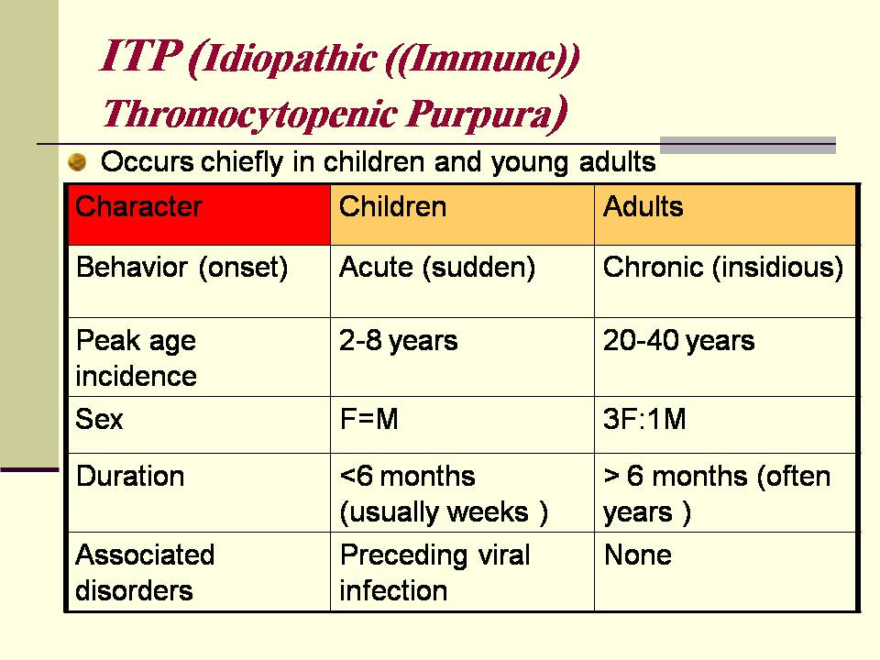

***ITP (Idiopathic ((Immune)) Thromocytopenic Purpura)***

Occurs chiefly in children and young adults

Responsible antibody usually belongs to subclass 3 of IgG.

Clinically

Varies from mild cutaneous bleeding to gross uterine or GIT hemorrhage .

In severe cases it lead to intracerebral hemorrhage .

Treatment

Steroids

Immunosuppressive drugs

Splenectomy

3. ***Hypersplenism***

Clinical syndrome :

Enlargement o f the spleen.

Reduction in one or more of cell lines of blood (anemia, leucopenia, thrombocytopenia).

Normal bone marrow.

Cure after splenectomy.

4.***DIC(disseminated intravascular coagulation)***

This causes thrombocytopenia by excessive utilization & destruction of platelets .

5. ***Massive blood transfusion***

***Qualitative Platelet Defects***

Platelet count is normal ,but there is defect in platelet aggregation .

e.g. Glanzmann’s disease (thrombosthenia, autosomal recessive)

***Disorders of Blood Vessels ( Vascular Purpra )***

***Congenital :***

Hereditary Hemorrhagic Telagiectasia

Autosomal dominant

Clinically: usually epistaxis , multiple telangiectatic spots in the skin & mucus membranes leading to hemorrhage & iron deficiency anemia ,haemoptysis.

***Acquired :***

1)Purpura simplex in women .

2)Senile purpura :on the dorsum of hands & arms due to poor capillary support from collagen as also in :

3)Steroid therapy or Cushing syndrome

4)Scurvy ,vit. C needed for polymerization of mucopolysaccharides necessary for collagen synthesis .

Henoch Schonlein Purpura : necrotizing vasculitis give rise to small hemorrhages especially in the skin & gut ,there may be associated glomerulonephritis ,usually follow streptococcal infection.

Damage to capillaries as in :

severe acute bacterial infection: septicaemia.

subacute bacterial endocarditis .

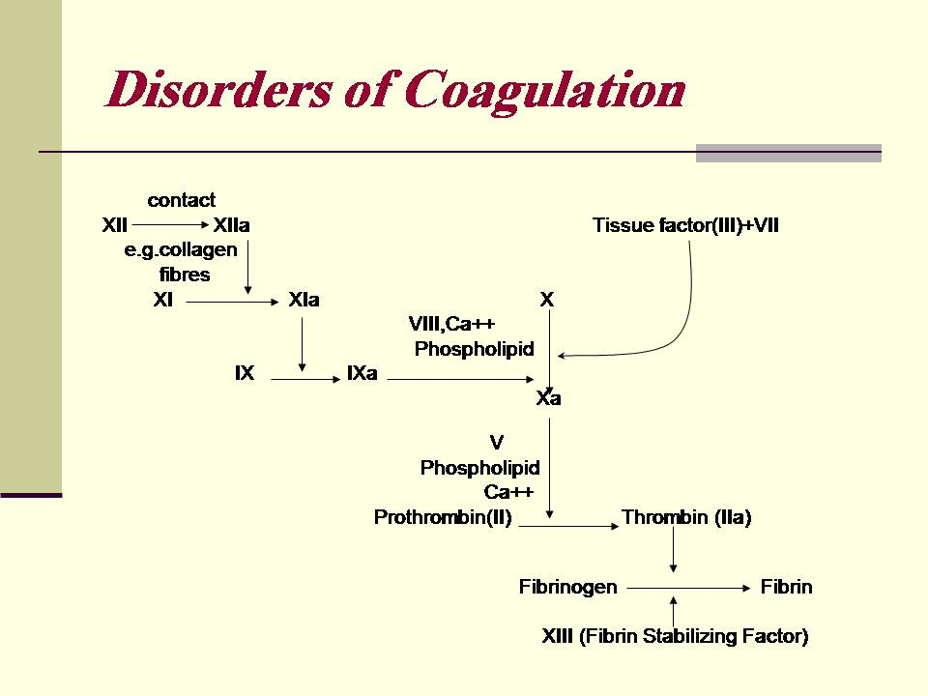

***Inherited Disorders of Coagulation***

Of these coagulation factors deficiencies factor VIII deficiency is important .it can lead to Haemophilia A and von Willebrand’s disease .

***Structure of factor VIII***

Plasma factor VIII is now considered to be a complex of two components ;the larger of the two ,factor VIII /von Willebrand factor ( VIII R: WF) is coded by autosomal genes and is deficient in von Willebrand ‘s disease , it promotes primary haemostasis by interacting with platelets and also appears to function as a carrier of smaller component factor VIII coagulant (VIII C) which is coded by an X chromosome which participates directly into cascade clotting reaction & is deficient in classical haemophilia ,when assayed immunologicaly these two components are expressed as antigen (Ag)

i.e. VIII R: Ag and VIII C : Ag .

***Haemophilia A***

Hereditary abnormality of coagulation.

Sex linked : affect ♂ ,while ♀ are carriers .

Xْ Y XX

YX YX Xْ X Xْ X

Normal ♂ Carrier ♀

50% of daughters of carrier female are carriers .

50% of sons of carrier female are diseased .

XY Xْ X

XXْ XX YXْ YX

How do you get it ctd.

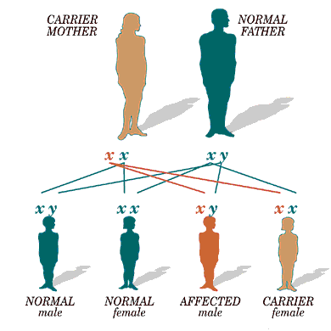

***Clinically***

Male child will suffer from bleeding following circumcision , haemarthrosis usually after crawling .

Severity of haemophilia is graded according to the level of VIII C into:

Severe ( VIII C < 1% of normal ).

Moderate ( 2-5% of normal).

Mild ( 5-20% of normal).

This is a diagram of the joints most commonly affected by Hemophilia. It most often occurs at the knees, hips, ankles, shoulders, and elbows

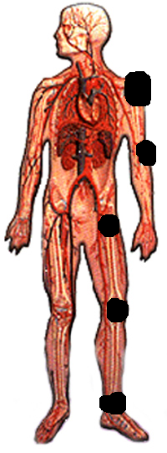

Diagnosis

APTT ↑

Bleeding time normal

VIII C activity ↓

VIII C : Ag ↓

VIII R: Ag normal

***Von Willebrand’s Disease***

Inherited hemorrhagic disease in which bleeding time is prolonged due to deficiency of von Willebrand’s factor (vllll R) as this factor is important for platelet adhesion to vascular subendothelium.

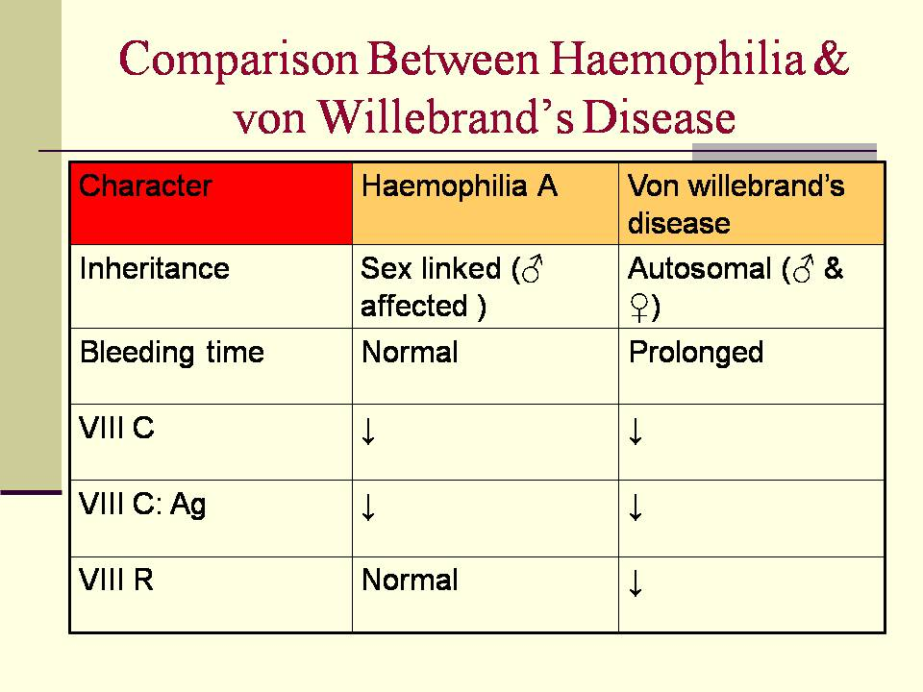

***Factor IX deficiency ( Haemophilia B or Christmas Disease )***

Inherited disorder shows the same pattern of inheritance as haemophilia A (sex linked ).

Same clinical picture but incidence of disease = 1/5th of the haemophilia A .

Treated by factor IX concentrate .

***Acquired Disorders Of Coagulation***

**Vitamin K deficiency**

Vitamin K is necessary for γ carboxylation of precursors of factor II ( prothrombin ) & some other coagulation factors. It is fat soluble ,present in leaf vegetables & also synthesized by the normal intestinal flora.

*Dietary deficiency of sufficient severity to produce bleeding is well recognized in:*

Neonates (Haemorrhagic Diseases of the newborn) in whom normal bacterial flora is not yet established.

In children & adults( malnourishment).

↓ absorption in billiary obstruction, coeliac disease.

**Liver disease**

Liver is the site of synthesis of most coagulation factors.

Severe impairment of liver lead to combined factor deficiency particularly II , VII ,IX ,X, &

I (fibrinogen).

**Renal Impairment**

Lead to thrombocytopenia ,platelet dysfunction ,(II ,VII ,IX ,X ,XIII ) ,DIC (haemolytic uraemic syndrome).

**Warfarin therapy**

Oral anticoagulant act as competitive inhibitor of vit. K ,suppressing the synthesis of four vit. K dependant clotting in the liver prothrombin ( factor ll ,VII ,IX & X .)

***Control of Warfarin Therapy by*:**

Doing prothrombin time

Control = seconds.

Test = seconds.

Test/control ratio (R) =

INR (international normalized ratio ) =

Accepted INR = 2 - 3.5

INR = (R)^s

S= sensitivity index ,fixed figure provided by manufacturer of the kit ( e.g S = 2)

**Heparin therapy control**

Coagulation ( Clotting ) time

Thrombin time

Activated Partial Thromboplastin Time (APTT)

***Disseminated Intravascular Coagulation (DIC)***

wide spread deposition of fibrin in the small vessels of many organs causing tissue necrosis & multiple organ dysfunction and subsequent bleeding state due to consumption of platelets & clotting factors and secondary enhancement of fibrinolytic activity . Microangiopathic haemlytic anaemia is a common accompaniment.

***Causes of DIC***

Extensive burn

Septicaemia

Shock

Liver disease

Renal disease

Complications of labour : retroplacental haemorrhage & aminotic fluid embolism.

Malignancies , leukaemia especially acute promyelocytic leukaemia (M3 in FAB classif.)

**DIC: Disseminated Intravascular Coagulation:**

