Pathology

Respiratory system

**Diseases of the nose :**

**Rhinitis :** Inflammation of the nasal mucosausually accompany by sinusitis ,it may be :

1-Acute rhinitis : a- Specific as in diphtheria .

b- Nonspecific as in catarrhal ( common cold ) & allergic rhinitis

2- Chronic rhinitis : a- Chronic specific ( granuloma) as T.B , syphilis , scleroma & leprosy .

b- chronic non specific as : atrophic rhinitis , hypertrophic rhinitis & allergic rhinitis .

**Acute catarrhal rhinitis:** viral disease & exposure to cold is a predisposing factor usually followed by secondary bacterial infection .

Complication : extension of infection to the sinuses causing sinusitis ,OR to the near by structure causing otitis media, laryngitis & bronchitis .

**Chronic atrophic rhinitis**: rare disease, more common in females around puberty, may be due to hormonal changes.

Mic: the mucosa is thin, covered by crust of dried discharge which has offensive odour.

Atrophy of the nasal bones causing widening of the nasal cavity.

Atrophy of the nerve endings causing loss of smell.

**Chronic hypertrophic rhinitis :**

The mucosa is thickened, polypoidal & covered by mucopurulent exudates & may form nasal polyp .

**Epistaxis :** Bleeding from the nose.

Causes

**(1) Local causes :**

(a)trauma.

(d) nasal polyps.

**(2) Systemic causes :**

(a) Hypertension.

(b)leukemia's.

(c) Hemorrhagic blood diseases as purpura

(d)Acute infections e.g. typhoid fever and measles .

(e) Deficiency of vitamin C & K .

**Scleroma (RHINOSCLEROMA)**

Definition : A granulomatous inflammation of the upper respiratory tract caused by KLebsieLLa rhinoscleromatis It commonly affects the nose (rhinoscleroma).The disease is endemic in Egypt .

Gross picture:

(1) The lesion appears as multiple small hard nodular masses or single large nodular mass filling the nasal cavity

(2) The lesion may extend to the nasal sinuses anteriorly to the upper lip or posteriorly to the nasopharynx pharynx (soft tissue & doesn't involve cartilage or bone ) .

Mic :.The lesion is confined to the mucosa show ch. Inflammatory cell infiltrate (lymphocyte , plasma cell , mickulicz cell which is foamy macrophage with pyknotic nucleous & Russell body which is plasma cell with hydropic changes .

Complication :

Nasal discharge &deformity .

Ulceration & secondary bacteria .

**Tumors Of the nose & Para nasal sinuses :**

!- Benign tumors :

Epithelial : Squamous cell papilloma , inverted papilloma , Mesenchymal : angioma , chondroma , myxoma & osteoma .

2-Malignant tumors :

Epithelial : squamous cell carcinoma , adenocarcinoma .

Mesenchymal tumors : Fibro sarcoma , osteosarcoma , chondrosarcoma & malignant lymphoma .

**Acute laryngitis:**

result from inhalation of irritant; caused by allergic condition or may be caused by the same causative agent of common cold.

**Chronic laryngitis** : may be specific or non specific .

**Chronic non specific laryngitis** : Common condition caused by excess use of voice , heavy smoker & chronic alcoholism .

The vocal cords are diffusely thickened & may show polypoidal mass called laryngeal polyp ( singer nodule)

**Chronic specific laryngitis** : Include :

* Tuberculous laryngitis ,
* Syphilitic laryngitis

**Diphtheria**

Pseudo membranous inflammation of tonsil , throat ,larynx ,pharynx rarely the nose & conjunctiva Caused by corynebacterium diphtheria which release exotoxine cause necrosis of mucus membrane accompany by exudates result in classical dirty, grey pseudo membrane. transmitted by droplet infection , the incubation period is 3-4 days

Pathological features :

X : dirty white pseudo membrane fibrinopurulent cover the affected area .

Mic :

Complication :

* Local :-Laryngeal obstruction & asphyxia due to laryngeal edema , peripheral neuritis & detach membrane .
* General due to toxemia :

1- Temporary paralysis of ocular muscle , soft palate ,diaphragm & respiratory muscle

2- Toxic myocarditis

3- Focal necrosis & fatty liver .

4- Acute adrenal insufficiency .

5- Zenker degeneration of the muscle .

6- Toxic arthritis .

**Nasopharyngeal carcinoma:**

Rare neoplasm, has strong epidemiologic link to EBV common in Chinese.

It has 3-histological variant :

* keratinizing squamous cell carcinoma .

* non keratinizing squamous cell carcinoma .

* undifferentiated carcinoma which compose of large cell with indistinct cell border and prominent eosinophilic nucleoli in addition there is marked infiltration with lymphocyte so it is also called lymphoepithelioma a misnomer because lymphocyte are not apart of neoplastic process.

It is a radiosensitive tumor and the 5-year survival rate is 50% even for advanced cancer.

**Laryngeal tumors:**

**Benign tumors** :It include (vocal cord polyp and laryngeal papilloma).

**Vocal cord polyps** are smooth protrusion less than 0.5cm in diameter usually located on the true vocal cord.

**M:** compose of core of edematous fibrous tissue cover by stratified squamous epithelial , contain chronic inflammatory cell infiltrate . These lesions occur usually on heavy smoker or singers (singers nodule) so it could be due to chronic irritation .

**Squamous cell papilloma:**

Usually arise from true vocal cord as soft pink rarely >1cm in diameter.

**M:** multiple finger like projection of fibro vascular cords cover by stratified squamous epithelial.

Squamous cell papilloma usually single in adult but in children it may be multiple.

**Carcinoma at the larynx:**

* Usually occur after the age of 40 affect male > female.

* causes : Environmental influence are very important in its causation nearly all cases occur in smoker while alcohol and asbestos exposure are also play a role.

* 95% are of squamous cell carcinoma rarely it is adenocarcinoma.

**Sqamous cell carcinoma :**

In the majority of cases it arise from the vocal cord (glottic) next it may arise from above the vocal cord (supraglottic) next to it is subglottic tumor ..

Carcinoma of larynx usually present as persistent hoarseness of voice .

The location of the tumor has great influence on the prognosis. 90% of glottic tumor has excellent prognosis because it affect the motility of the vocal cord so the patient present early also because this region has no lymphatic supply so spread outside the vocal cord is rare. In contrast to supraglottic which is rich with lymphatic supply also the supraglottic tumor usually remain silent and the patient present late so it has poor prognosis ,

**Atelectasis (collapse):**

Loss of lung volume cause by inadequate expansion associated with shunting of inadequately oxygenated blood from pulmonary artery to the vein result in hypoxia and it is of four types:

1. **Resoption collapse:** it occurs when there is an obstruction prevents air from reaching distal airways. The air already present distally gradually absorbed and alveolar collapse then occur. Obstruction usually occur by mucus plug (seen postoperatively, in asthma, bronchiectasis); aspirated foreign body or by tumor.
2. **Compression atelactasis:** usually associated with accumulation of blood, fluid, or air in the pleural cavity which mechanically collapsed the adjacent lung.
3. **Microatelacasis:** generalize loss of lung expansion due to loss of surfactant substance . It is seen in acute and neonatal respiratory distress syndromes, and in many lung disease associated with interestial inflammation.
4. **Contraction atelectasis:** occur due to localized or generalize fibrotic changes in the lung or pleura which hamper expansion and increase elastic recoil during expiration.

All types apart of contraction atelactasis are reversible and should be treated to prevent hypoxia and superimposed infection.

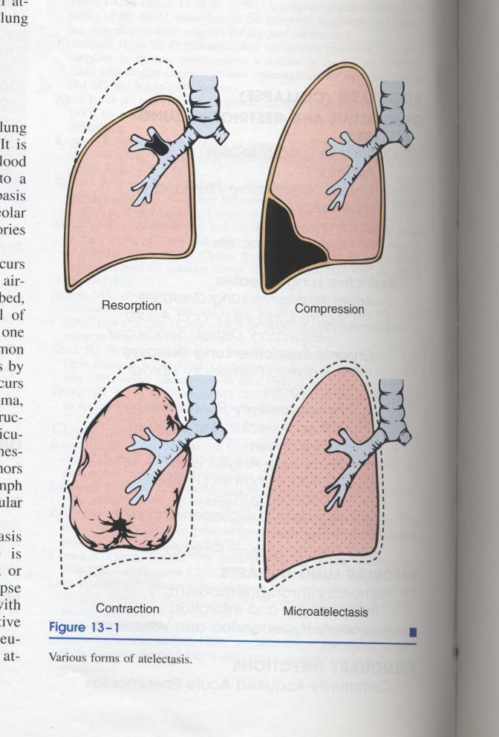

**Diffuse pulmonary disease:**

1. **Obstruction airway diseases (excluding tumor and foreign body**): include (asthma, emphysema, bronchitis, bronchiectasis, cystic fibrosis and bronchiolitis).
2. **Restrictive lung disease:**
3. Extra pulmonary disease: that affect the movement of the chest wall (obesity-scoliosis, kyphoscoliosis and neuromuscular disorder).
4. Pulmonary causes :

* Acute : as acute respiratory distress disease .
* Chronic: as pneumoconiosis, sarcoidosis, idiopathic pulmonary fibrosis.