Pathology

Arteriosclerosis :
Non specific term mean thickening & hardening of blood vessels . it include :
1-Monckeberg medial calcification : characterized by deposition of calcium in the wall of medium size arteries , seen over 50 , without narrowing of the lumen .
2-Arteriolosclersis : seen in hypertension .
3-Atherosclerosis :

Atherosclerosis (AT) :Disease of large & medium sized b.v characterized by intimal thickening due to deposition of fibro fatty plaque it affect mainly the aorta, Coronary & cerebral arteries.

Etiology ( Risk factors )
A . major risk factor :
1* Non modifiable
- Age : It is age related disease , fully developed At appear in the 4th decade. However early lesion may appear at childhood .
- Sex : Before menopause male: female ratio is 3:1 ,the low incidence in ♀ at this age is due to high Estrogen & high density lipoprotein . But after menopause the difference is reduced.
- Genetic factors : include abnormality of lipoprotein metabolism that lead to high cholesterol .
- Familial or racial factors : this is related to other factors as D.M, hypertension & hyper lipoproteinaemia .
2* Modifiable :
- Hyperlipidemia :
* Low density lipoprotein ( LDL ) has sever adverse effect .
* Very low density lipoprotein ( VLdL ) has less adverse effect .
* High density lipoprotein ( anti a therogenic ) .
2. Hypertension :
Hypertension has 5 time risk of AT than normal persons probably due to mechanical damage of b.v wall .
3. Smoking
It reduce HDL & cause Co accumulation in the blood which lead hypoxia .
4. D.M :
It is due to accumulation of platelet, ↑ LDL, & decrease HDL .
B . Minor risk factors :
- Lack of exercise .
- Obesity .
- environmental factors. It is high in well developed countries.
- type A personality .

Pathogenesis :
- Response to injury theory .
- Monoclonal theory .

Response to injury theory :
Risk factors ( such an cigarette smoking, hyperlipidaemia D.M & hypertension ) Cause :
1-endothelial injury lead to increase endothelial permeability & insudation of lipid to the intima .
2- adhesion of platelet to the damaged endothelium with subsequent release of growth factors including platelet derived growth factor which lead to migration of SMC from media to intima & its proliferation producing large amount of extra cellular matrix mainly collagen.
3- macrophage that enter from circulation change into foamy cell after engulfing the oxidized LDH.
While the extra cellular lipid is derived from insudattion from the lumen & from degeneration of foamy cell .
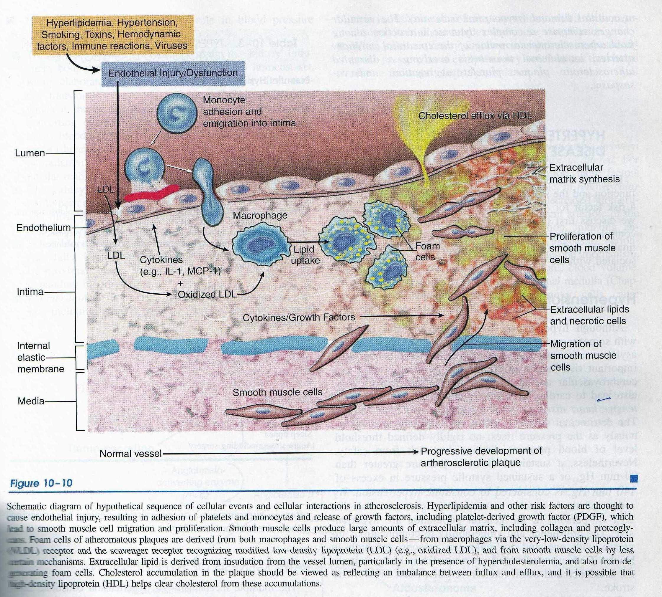
Monoclonal hypothesis : SMF proliferation is the initial event is it is monoclonal in origin as in neoplasm ( leiomyoma ).

Complication of atherosclerosis :
- Calcification .
- ulceration & release of lipid debris into blood stream causing emboli.
- Hemorrhage inside the plaque lead to narrowing of the lumen.
- aneurysm .
grossly :
White to yellow lesion, 1-2cm in diameter, raised above the surface.
On cross section : compose of white fibrous cap near the luminal surface & central core of yellow soft porridge like material.
M : of fully developed ( non complicated atheroma ) :
Fibrous cap over by endothelial layer & consist of SMF, macrophage, foamy cell & collagen while the soft core consist of cellular debris, , cholesterol crystal & foamy cells & calicium.

Hypertension :
Sustained diastolic pressure greater then 9o mmHg .
Causes :
- Essential hypertension : account of 90 – 95% of cases & the cause unknown .
- Secondary hypertension : due to
  - Renal causes : acute glomerulonephritis – chronic renal diseases – renal artery stenosis
b.Endocrine : as pheochromocytoma . drug as ( oral
contraceptive – glucocorticoid ).
c. Cardio vascular disease as coaractation of aorta .
d .Neurogenic causes ; as Psychogenic or stress .

Malignant hypertensive :
5% of hypertensive patients show rapid rise in b.p which if not treated lead to death with in 2 years .
Characterized by sever hypertension – diastolic pressure over 120 mmHg – renal failure & retinal bleeding with or without papilledema.

M : ( vascular pathology in hypertensive ) :
- Hyaline arteriolosclerosis, The arteriolar wall is hyalinized (Homogenous pink ) with marked reduction in the lumen .
This lesion could be seen also in D.M & elderly person .

- Hyperplasic arteriolosclerosis :
Concentric thickening at the arteriolar wall as onion skin appearance ) with narrowing of lumen . seen more in malignant hypertension where it is associated with fibrinoid necrosis of the wall .

Pathogenesis ( Mechanism of Essential hypertension ) :
Hypertension occur when the relation between blood volume & peripheral resistance in changed ,It is due to genetic or environmental factors , that cause .
1. Na & water retention → ↑ in blood volume → ↑ cardiac output.
2- Functional vasoconstriction
3-defect in SMF growth → thickening in →↑ peripheral
of the wall & narrowing of the lumen . resistance
Genetic factors : hypertension common in twins & it show familial tendency In addition several single gene disorder contribute to rare cause of hypertension .
Environmental factors : ( excess Na in take, stress, obesity & smoking ) all potentiate the effect of genetic factors .

Clinical features & complication of hypertension:
* asymptomatic .
*headache .
*Heart disease ; left or right ventricular hypertrophy , ischemic heart disease.
* Renal disease :ch renal failure .
* Neurologic disease : cerebral thrombosis with infarction , cerebral hemorrhage .
* Visual disturbance .
* Dissecting aortic aneurysm.

Vasculitis :
Inflammation of wall of any size is any organ .
Pathogenesis :
- Direct invasion of b.v wall by infectious agent ( bacterial as niseria& Viral as herpes zoster )
- Immune mediated inflammation .
- Unknown cause as giant cell arteritis .

Classification of vasculitis according to the size of b.v :
- Large cell vasculitis as giant cell arteritis .
- Medium sized vasculitis as polyarteritis nodosa .
- Small sized vasculitis as wegner granuloma .

Giant cell ateritis ( temporal arteritis ) :
  - Uncommon but it is the most common vasculits .
  - ♀ > ♂ .
  - Symptoms vary from mild constitutional symptoms (fever – malaise as loss of weight) to sever localizing sign in the form of pain & headache along the distribution of super fiscal temporal artery with swelling & redness of overlying skin & visual disturbances.
  - It is granulomatous type of inflammation.

Polyarteritis nodosa :
- Systemic vasculitis of medium sized b.v typically affect renal & visceral b.v .
- Characterize by transmural inflammation of the artery, with infiltration by neutrophils, eosinophil & monocyte often accompany by fibrinoid necrosis & in advance stage it is replaced by fibrosis.
- Clinically :
Affect mainly young adult with fever of unknown cause , weight loss, abdominal pain & hypertension.

Wegener granuloma :
characterized by triad of :
- acute necrotizing granuloma of respiratory tract.
- necrotizing granuloma in the wall of small sized b.v .
- Renal disease in the form of glomerulonephritis

Tumors of b.v :
* Benign : capillary – cavernous haemangioma.
Capillary haemangioma : Common in skin ,subcutaneous tissue & mucus membrane of oral cavity & lip it may occur in the liver & kidney .
Mic : consist of collection of thin wall capillaries , fill with blood , lined by flat endothelium , separated by scanty stroma .

Cavernous haemangioma : less common than capillary type , occur in deep structure , Consist of large communicating vascular spaces filled with blood separated by scanty stroma .

* Border line ( low grade – ) tumours .as Kaposi Sarcome :
Uncommon but important due its association with AIDS
Types of kaposi sarcoma :
- Chronic ( classic ) European type .
affect skin only .
2-African ( endemic ) type .
Affect only viscera .
  - Transplant – associated Kaposis sarcoma :
Occur few year after organ transplantation .Lesion either localized to skin or viscera .
  - AIDS – associated KS ..
    - Have no specific organ predilection .

* Malignant tumour : Angiosarcoma :
      - Malignant endothelial tumour affect old adult .
      - Occur any where but more in the skin . soft tissue . breast & liver .
      - It vary in degree of differentiation from well differentiated (compose of vascular space with plump , anaplastic cells) to undifferentiated tumour compose of solid spindle cells .

