AIDS

Dr. Mahmoud Y.M Taha

1980: Beginning of the disease
Pandemic threat human life
1981: Acquired immunodeficiency syndrome (AIDS) Starting of search for causative agent
1983: Luc Montagnier (Pasteur Institute) (L AV)
1983: Abraham Karpas (Cambridge) (C-LAV)
Paul Feorine (CDC) Atlanta
Virus resembles animal virus
1984: Robert Gallo (NCI) Maryland HTLV-I, III
E.M comparison of all isolates same virus
1986: ICTV HIV

Origin of the Virus

* Oncorna (human) or Lentivirus (animal) ?

HIV common ancestor with African Monkey virus (Simian virus)

Origin shrouded in tropical darkness

Virus jump species barrier in central Africa

* Politics: genetically engineered

* Genetics: human genome contains

sequence of HIV

Structure of the Virus

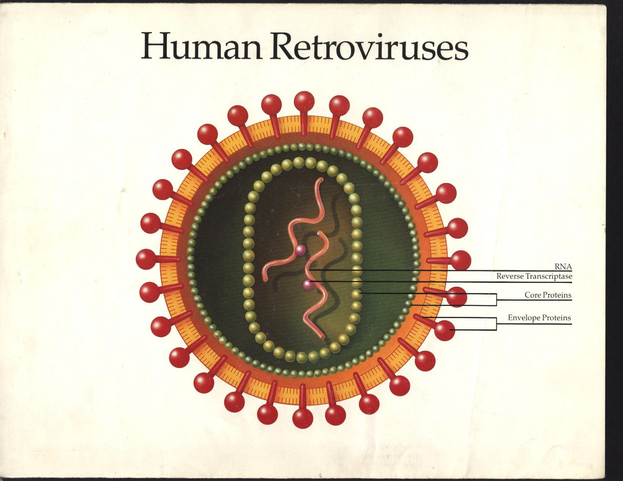

Multiplication Cycle

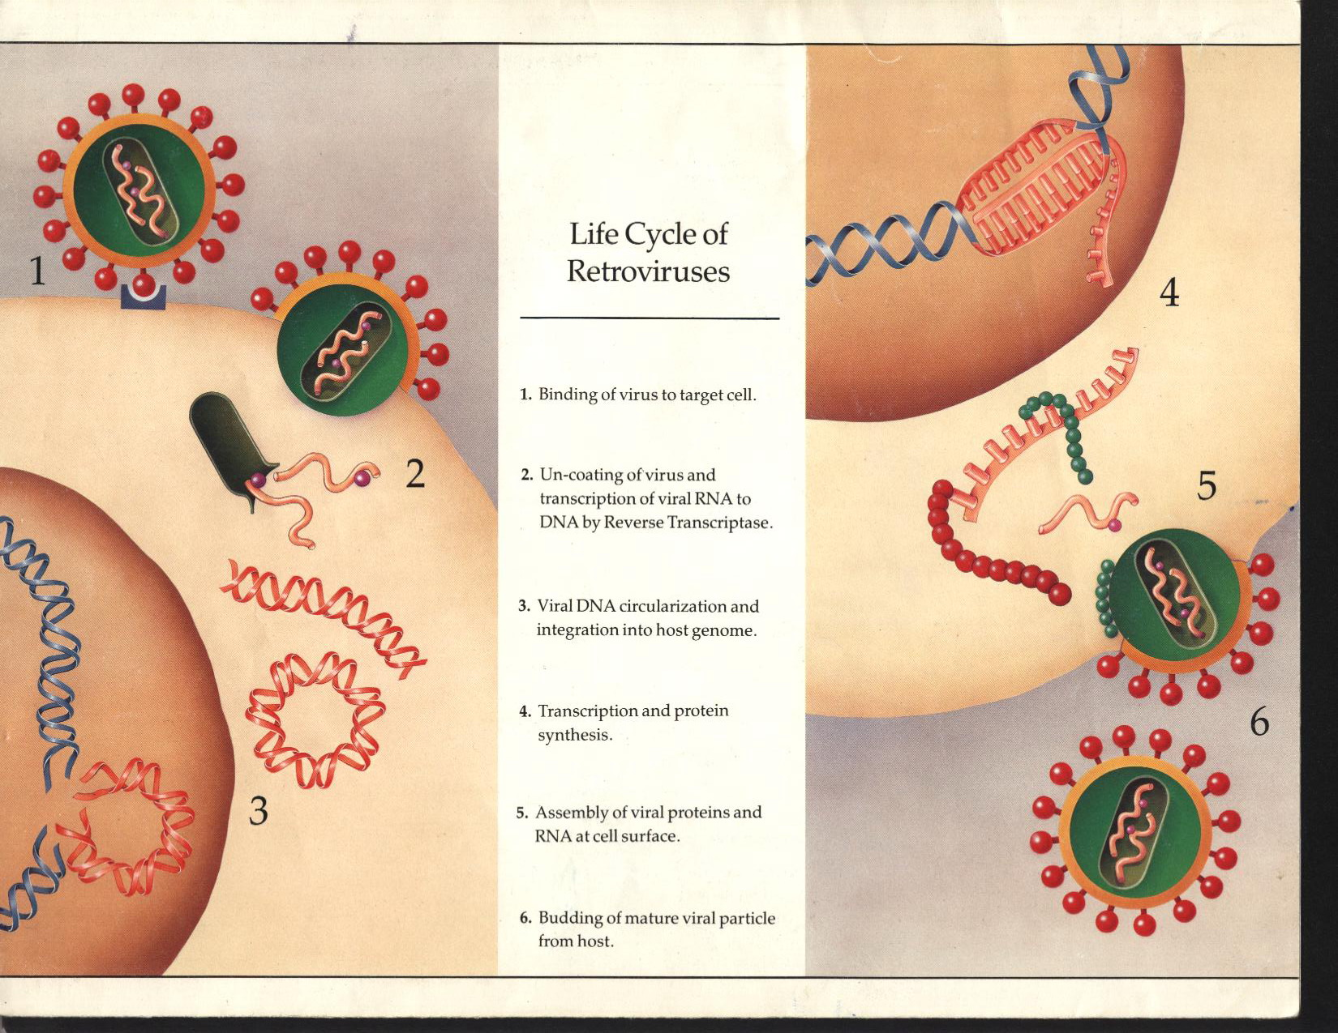

Stability of the Virus

* Destroyed by heat (autoclave or hot air oven).

100 fold each hour at temperature 60 Co.

* Survive up to 15 days at RT or body temp.

* Disinfectant (2% gluteraldehyde and

hypochloride at 103 ppm kills 105 unit of virus.

* Veridical activity of alcohol is relatively low.

Epidemiology

Exact number of people infected !?

* Test is not compulsory

* 3rd world countries

* Political reason

Transmission

* Sex

-homo and heterosexual

Traumatic sexual activity or ulceration of GT

Not necessary for transmission

artificially

Healthy women develop Abs to HIV

inseminated

principle factor is number of sexual contact

*Blood

- Blood transfusion (no risk for donor)

- Hemophiliacs

- Possibly following: ear piercing acupuncture

Dialysis

Tattooing

- Sharing needles ( I.V drugs and drug addicts)

* From mother to child

- Pregnancy

- At birth

- Breast milk

ٍSaliva and HIV Transmission

Small minority of HIV infected people harbor HIV in saliva

No cell free virus in the saliva

* Saliva contains IgA which neutralize viral infectivity

* HIV inhibitory factor ( high m.wt. mucins)

* Salivary leukocytes protease inhibitor which block

cell surface receptor

* Loss of viral infectivity when virus exposed to mixed saliva

for 30 min

* Animal study showed impossibility to transmit HIV by

sutface application on oral mucosa

* High dose of HIV is required for infection

No transmission by:

* Causal and social contact

* Human bite and kissing

* Swimming pool

Insects:

* HIV replicates in narrow range of cells Malaria enter

mosquito to salivary gland

Injected to other person

* Age distribution of HIV in Africa !

Malaria is more common in children

HIV is rare in children

Receiving contaminated blood born with it

Course of the Disease

A: Subclinical HIV infection

HIV +ve clinically well

25-50% seropositive AIDS

B: Persistent generalised lymphadenopathy (PGL)

* Asymptomatic * lymphadenopathy of 2 or more LN

* Reactive hyperplasia

C: AIDS Related Complex (ARC)

* fever ≥ 3 months * lymphadenopathy ≥ 3 or more

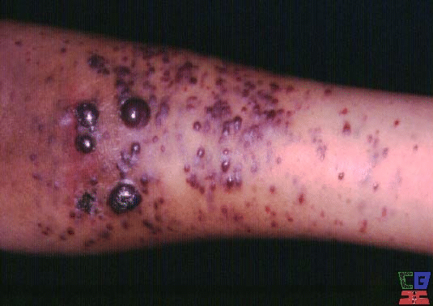 * Weight loss * Fatigue

*Diarrhea ≥ 3 months * Night sweat

D: AIDS:

1. Diagnostic for HIV:

* Kaposi sarcoma * Pneumocystic carinii

* Opportunistic infections:

-Protozoal: Toxoplasmosis, Cryptosporidium, isospora

-Fungal: Candida, Cryptococcus, Aspergellosis, Histoplasmosis

-Bacterial: T.B, Salmonella, Pygenic infections

-Viral: HSV, VZV, CMV

2. Diagnostic only if HIV +ve Antibody test:

Histoplasmosis , isosporiasis, broncheal and pulmonary

candidiasis, Non-Hodgkin lymphoma, Kaposi sarcoma in older than 60 years.

Enlargment of 1-2 cervical LN and persist for 3 months

Persistent oral candidiasis

Painful herpes stomatitis

Oral Kaposi sarcoma

Sever gingivitis and periodontitis

Enlargment of 1-2 cervical LN and persist for 3 months

Persistent oral candidiasis

Painful herpes stomatitis

Oral Kaposi sarcoma

Sever gingivitis and periodontitis

Laboratory Diagnosis of HIV

ELISA detection of Abs ( does mean patient has AIDS)

Patient infected with HIV

Time between infection & appearance of Abs 1-4 mon. or longer

+ELISA confirmed by Western Blot analysis

gp 120 gp 40 carrier

Western Blots

Negative: no

Positive: reactivity to gp41 + gp120/160 or p24+120160

Indeterminate: Presence of any band patterns that does not meet positive criteria

Treatment and Prevention

AZT Blocks RT (prevent RNA to DNA)
Combination of AZT and protease inhibitor

In the absence of vaccine
* prevent spread of the disease by reduce transmission
* care should be taken in dental clinic ( gloves, mask,
autoclave)
* public education
Advertising
* Do not die of ignorance
* The only way to reduce the transmission is by
persuading people to change their habit
*Once you get it, that is it, that is for your life and you
will die sooner or later

