**Diagnosis of Pregnancy**

**Dr. sarab salih**

**SYMPTOMS AND SIGNS OF PREGNANCY**:-

* **Amenorrhea:** is the first suggestion of pregnancy in most women with regular cycle . Decidual bleeding , women may continue to bleed in early pregnancy at the time of suppressed mense , may continue to about 12 weeks
* **Nausea or sickness:** Many women suffer some gastric upset in the early months of pregnancy-from nausea and anorexia to repeated vomiting-especially in the morning. Raised levels of Oestrogen and HCG have been blamed. Gastric motility is reduced , and in early pregnancy , the lower oesophageal sphincter is relaxed.
* **Bladder symptoms :**
* Increased frequency of micturition in the second and third months is due to:

1) Increased vascularity

2) Pressure from the enlarging uterus

* Near term , frequency may again appear due mainly to pressure of the fetal head on the bladder.

* **Breast changes :**

1. Increased vascularity and feeling of heaviness, almost of pain appear at 6 weeks.
2. Primary areola ; The nipple and surrounding area become more pigmented by 8 weeks . Montgomery’s tubercles are sebaceous glands which become more prominent as raised –pink –red nodules on the areola.
3. )) Secondary areola ; a mottled effect due to further pigmentation , become prominent by 20 weeks.
4. Colostrum is a clear fluid which is secreted by 16 weeks and may also be expressed.

* **Uterine changes:**

Uterine enlargement may be detected on bimanual examination at 7-8 weeks

* **Palpable uterine enlargement:**

1. At 7 weeks the uterus is the size of a large hen’s egg.
2. At 10 weeks it is the size of an orange.
3. At 12 weeks it is the size of a grape fruit
4. By 12 weeks the uterus is palpable abdominally.
5. By 22 weeks the fundal height nearly at the level of the umbilicus.
6. Lightining ; is reduction in the fundal height that may occur at the end of pregnancy.

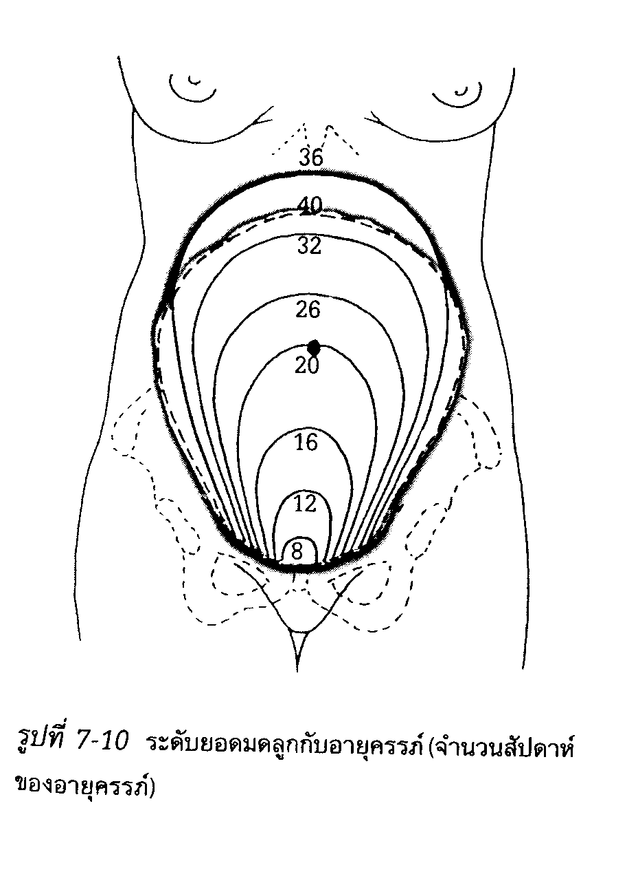

* **Palpable uterine contractions**: Braxton Hicks are palpable uterine contractions on abdominal exam . at 20 weeks ,become more frequent as pregnancy advances
* **Quiqening:**  Awareness of fetal movement for the first time , may be felt at 16-18 weeks in parous women and 2-3 weeks later in primi
* **Auscultation of the fetal heart** by two methods:

**Pinard** : From about 24-26 weeks

**Sonic aid** : From 12-14 weeks

* **Palpable fetal parts:**

These can be felt from around 26 weeks

* **Skin changes:**
* Areas which are already pigmented become more so including the nipples, external genitalia , and anal region and these increase as pregnancy advance.
* Some fresh pigmentation appear

1. Cloasma on the face.
2. The Linea nigra on the abdomen.
3. Striae gravidarum , are depressed streaks on the skin of fat areas including abdomen, breasts , and thighs .After delivery they regress and persist as striae albicans , they are due to stretching ,but may be associated with increased secretion of ACTH affecting connective tissues.

* **Presumptive signs :-**

**i- Cessation of mense.**

**ii- Breast tenderness and swelling.**

**iii-Nausea and vomiting.**

**iv-Changes in the skin and mucous membranes**

**1)) Chadwick’s sign ((discoloration of the vulva ,vagina , and cervix)).**

**2)) Increased skin pigmentation.**

**3)) Development of abdominal striae**

* **Probable signs :-**

**A- physical changes in the uterus:**

**1) Uterine enlargement.**

**2) Hegar’s sign.**

**3) Uterine contraction.**

1. **Palpation of fetal parts.**

* **Positive signs :-**

1. **Auscultation of the fetal heart tones.**
2. **Recognition of fetal movement by external examiner.**
3. **Imaging the fetus by sonogram.**