Microbiological aspect of dental caries

Dental caries is an infectious microbiologic disease of the teeth that results in localized dissolution and destruction of the calcified tissues

Changing concepts of caries microbiology

* Van leeuwenhoek (1600) first microscopic observation of oral bacteria.
* Pasteur_koch (late 1800s) germ theory of disease.
* Underwood and milles(1884) association between germs and enamel decay.
* Miller(1890) chemicoparasitic theory of caries.
* Clarke(1924) identification of mutans streptococcus and association with initial caries.
* Loesche(1986)association of mutans streptococci with caries (specific plaque hypothesis).
* Marsh (1994) ecological plaque hypothesis emphasizes balance between bacterial species.

Main Etiological Factors

* Tooth location and morphology
* Dental biofilm microorganisms with acidogenic and aciduric properties
* Frequent dietary exposure to fermentable carbohydrates
* Salivary flow rate and composition

The “cariogenic bacteria bacteria associated with dental caries

1. Mutans streptococci (S. mutans) – caries initiation
2. Lactobacilli (L. casei) – caries progression
3. Actinomyces – early colonizers and root caries

Streptococcus mutans

* Mutant streptococci are undetectable in pre-dentate infants.
* S. mutans appear in the mouth after teeth have erupted as they need solid surfaces to colonize
* Produces lactic acid from sucrose aciduricity/ acidogenesis
* Can live at ph as low as 4.2
* Forms large amounts of extracellular insoluble glucans– Allows the cariogenic bacteria to stick onto the teeth and form a biofilm – Glucan mediated biofilms are more resistant tomechanical removal – Bacteria in these biofilms are more resistant to antimicrobial treatment
* adherence to pellicle and contributes to plaque formation
* production of biologically active metabolites suppressing growth of other competing species (metabolites, bacteriocins)

Dental caries is transmissible

* Babies are born without these harmful bacteria.
* Studies have shown that moms are the primary source of these bacteria.
* It happens when you transfer your saliva through kissing, cuddling or letting your toddler brush with your tooth brush.

Vertical transmission

* Window of infectivity is the first two years of life
* The earlier a child is colonized with S. mutans the higher the risk of caries
* Children whose mothers have high S. mutans count present with a 9 times greater chance of having cavities. In another study 88% of 2 years old children infected with S. mutans developed tooth decay by age 4.

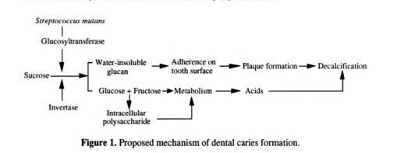

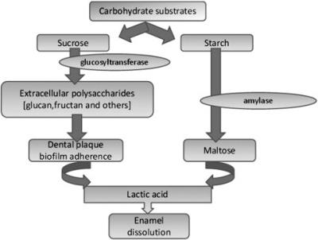

Caries-Associated Virulence Traits

• Biofilm formation - adherence and colonization

• Acid producing ability – mainly lactic acid from fermentable carbohydrates

• Aciduric potential - ability to survive and continue to produce acid at a low pH

• Formation and utilization of storage lysaccharides

• Formation of insoluble extracellular glucans

Role of dental plaque

* Dental plaque is a diverse microbial community

on the tooth surface found as a biofilm consisting of an extracellular matrix of polymers from both host and microbial origin.

* The onset of caries is a result of ashift in the normal dental plaque microflora toward dominance by acidogenic and aciduric organisms

Composition of dental plaque

* 50-60% microorganisms
* 10% Glucan
* Mineral ions Zn, Cu, Fe, FL
* Food debris
* 30% Mucin
* Inorganic salts Ca, Ph, Cl, K
* Desquamated epithelial cells

Function of dental plaque

1. Provide nutrition for bacterial metabolism to produce acids.
2. Helps to retain acid-in contact with the tooth surface for long time.
3. Protects the acid from the diluting effect of saliva.

Mechanism of dental plaque formation

1. Deposition of the acquired pellicle.
2. Colonization of the acquired pellicle by bacteria.
3. Maturation and proliferation of microorganisms increasing the thickness of dental plaque.

Preventive Treatment Planning

* Oral hygiene .
* Dietary modification.
* [Fluoride](http://en.wikipedia.org/wiki/Fluoride) has a direct inhibitory effect on the enolase enzyme, as well as assisting in remineralization of demineralized enamel.
* Use of dental sealant.
* Plaque control .
* [*Chlorhexidine*](http://en.wikipedia.org/wiki/Chlorhexidine) *reduces populations of S. mutans presumably by interfering with bacterial adherence .*

Xylitol

* Cannot be fermented by plaque bacteria.
  + Microorganisms like *S. Mutans* do not readily metabolize xylitol into energy sources.
* Inhibits growth and metabolism of   
  *S. mutans* and reduces dental plaque.
* Thus reduces *S. mutans* levels in plaque and saliva =
  + Reduction in acid production
  + Reduction in dental caries