The Endocrine System

INTRODUCTION & GENERAL FEATURES OF THE ENDOCRINE SYSTEM:

The endocrine system consists of cells, tissues and organs that synthesize and secrete hormones directly into blood and lymph capillaries.

By contrast to exocrine glands, such as the salivary, mammary, and sweat glands, which pour their secretions onto a surface of the body by means of ducts, the endocrine glands have no ducts and are therefore sometimes called the ductless glands.

The autonomic nervous system and the endocrine system work closely together to regulate the metabolic activities of the different organs and tissues of the body so as to maintain homeostasis.

The activities of the autonomic nervous system and the endocrine system are integrated and coordinated by the hypothalamus (the neuroendocrine system).

The autonomic nervous impulses releases neurotransmitter substances at nerve endings in order to obtain a rapid and localized response, whereas the endocrine system exerts a slower and more diffuse response by synthesizing and releasing into the bloodstream organic chemical substances (messengers) called hormones .

Hormones are molecules with specific regulatory effects, which may be disseminated throughout the body by the bloodstream where they may act on specific target organs or affect a wide range of organs and tissues. Other hormones act locally, often arriving at their site of action by way of specialized microcirculation.

Hormones elicit specific and dramatic effects at very low concentrations, and they directly or indirectly affect all tissues. They regulate carbohydrate, protein, and lipid metabolism; the mineral and water balance in body fluids, growth; sex-related differences in body shape and sexual function; behavior, and emotions.

Components of the System:

The endocrine system is made up of cells that are found in 3 distinct anatomic distributions:-

Gathered together in one specialized organ to form an endocrine gland e.g. pituitary, thyroid, parathyroid and adrenal glands;
2- Forming discrete clusters in another specialized organ e.g. pancreas, ovary, testis, placenta ( when present);

3- Dispersed singly among other epithelial tissues, particularly in the gastrointestianal and respiratory tract, in which case they form part of what is referred to as the diffuse neuroendocrine system .

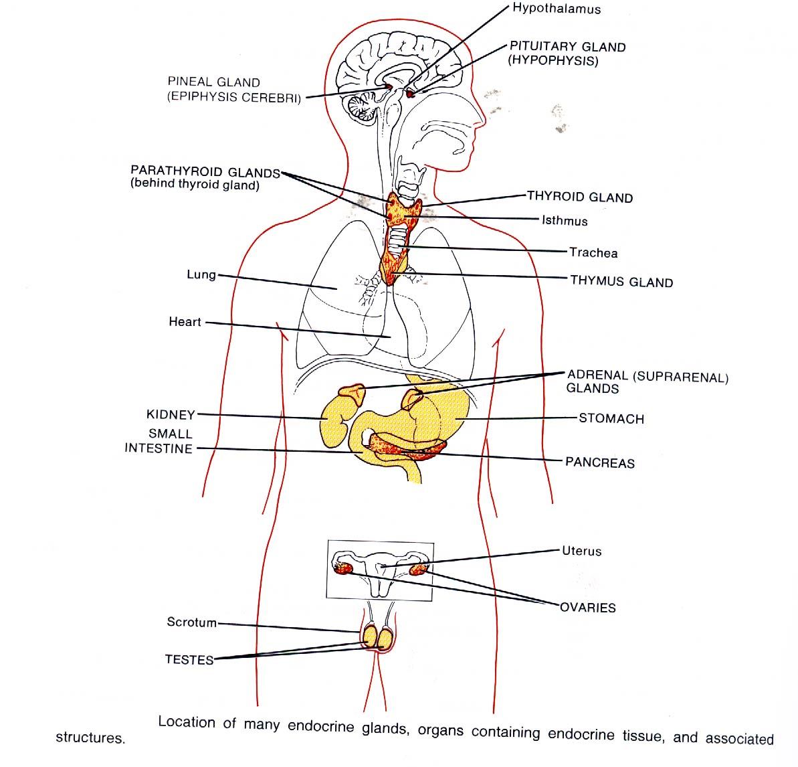

Microscopic Structure:

Endocrine glands typically contain secretory cells arranged as cords, clumps, or follicles that are in direct contact with abundant capillaries or sinusoids.

Reflecting their active synthetic function, endocrine cells are usually characterized by prominent nuclei, abundant cytoplasmic organelles, especially mitochondria, endoplasmic reticulum, Golgi bodies and secretory vesicles.

Pituitary Gland

LOCATION, GENERAL ORGANIZATION, & EMBRYONIC ORIGINS:

The pituitary gland (hypophysis), is suspended by a stalk from the hypothalamus at the base of the brain.

It rests in a depression in the sphenoid bone called the sella turcica, behind the optic chiasm.
- Its normal dimensions in humans are about10x13x6mm, and weighs about 0.5 – 0.9 g .

Its two major divisions, the anterior adenohypophysis and the posterior neurohypophysis, differ in embryonic origin, structure, and function.

A. Adenohypophysis:

General structure.
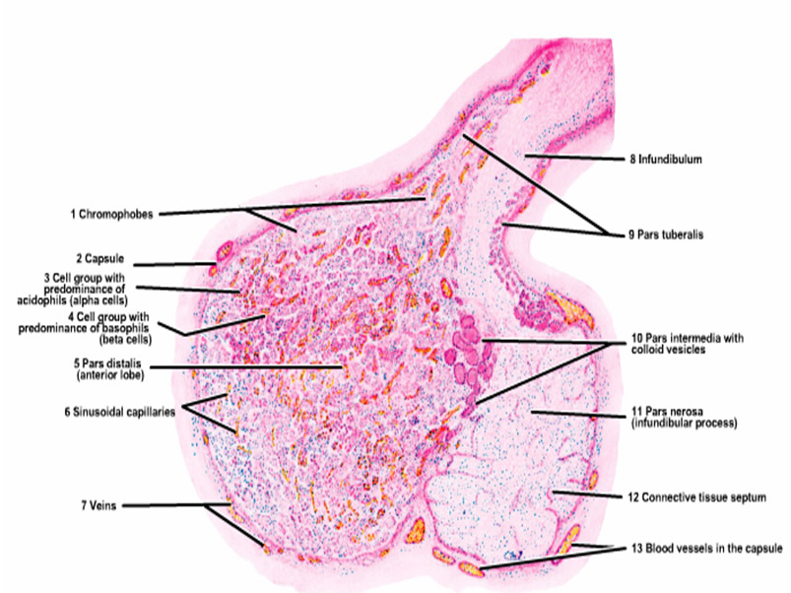

The adenohypophysis consists of glandular epithelial cell cords separated by the many sinusoidal capillaries of the secondary capillary plexus.

It is not directly innervated by hypothalamic nerves; only by autonomic fibers from carotid plexus.

Subdivisions.

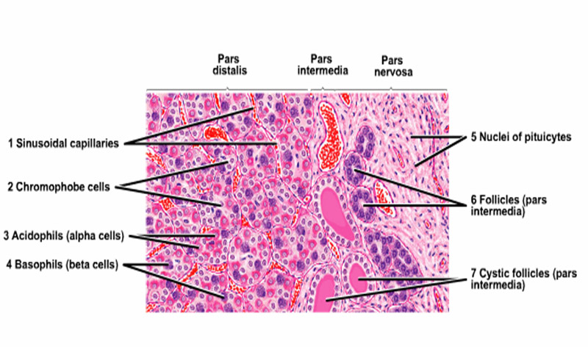

1.The pars distalis (pars anterior): is the largest pituitary subdivision.

2.The pars tuberalis, its superior extension, forms a partial sleeve around the infundibulum of the neurohypophysis.

3.The pars intermedia is a narrow band of adenohypophyseal tissue bordering the neurohypophysis.

Each secretory cell in the adenohypophysis synthesizes and stores one of the following hormones: follicle-stimulating hormone (FSH),thyrotropin (thyroid–stimulating hormone (TSH), luteinizing hormone (LH), adrenocorticotropic hormone (ACTH), growth hormone (GH), and prolactin.

These hormones control the secretory activities of many other glands. Their release is regulated by specific releasing or inhibiting hormones produced by the hypothalamus and delivered to the adenohypophysis by the blood in the hypophyseal portal system.

Pars Distalis (pars anterior):

Is formed of cords of aggregated cells interspersed with capillaries of the primary capillary plexus. There are 3 main cell types, which may be distinguished by the affinity of their cytoplasmic granules for different stains: chromophobes and chromophils (acidophils, basophils).

The few fibroblasts present produce reticular fibers that support the cords of hormone-secreting cells.

Chromophobes.

These cells stain poorly and appear clear or white in tissue sections.

They make up about 45- 50% of the epithelial cells in the pars distalis (pars anterior).

They include (1) undifferentiated non-secretory cells, which may be stem cells; (2) partly degranulated chromophils, containing sparse granules ; and (3) follicular cells, the predominent chromophobe type, which form a stromal network that supports the chromophils.

Chromophils (Acidophils & Basophils) .

These hormone-secreting cells of the adenohypophysis stain intensely owing to the abundant cytoplasmic secretory granules in which hormones are stored.

There is a specific cell type for each hormone.

Usually larger than chromophobes, chromophils are subdivided into two classes:

a. Acidophils

Secrete proteins and stain intensely with eosin and orange G, but not with Periodic Acid Schiff (PAS).

Make up about 35-40% of the epithelial cells in the pars distalis (pars anterior).

More abundant in the gland periphery, they are usually smaller than basophils with larger and more numerous granules.

The acidophils include two major hormone-secreting cell types; somatotropes produce growth hormone (GH, somatotropin) and mammotropes produce prolactin.

b. Basophils

Secrete glycoproteins and stain with hematoxylin and other basic dyes, and are PAS- positive.
Make up about 10-15% of the epithelial cells in the pars distalis (pars anterior).

More abundant in the core of the gland, they are usually larger than acidophils, with fewer and smaller granules.

The three major hormone-producing basophils produce four major hormones gonadotropes (FSH&LH), corticotropes produce adrenocorticotropin (ACTH) and thyrotropes produce thyrotropin (TSH).

Pars Tuberalis :

This funnel-shaped superior extension of the pars distalis surrounds the infundibular stem (like an incomplete collar along the anterior and lateral surfaces of the infundibulum).

Its histology is similar to the pars distalis, but it contains mostly gonadotropes.

Pars Intermedia :

This is a band or wedge of adenohypophysis between the pars distalis and pars nervosa; it is rudimentary in humans.

It contains Rathke”s cysts, small, irregular, colloid- containing cavities lined with cuboidal epithelium that are remnants of Rathke’s pouch.

It also contains scattered clumps and cords of basophilic cells, or melanotropes, which secrete melanocyte-stimulating hormone (β-MSH, which regulates the formation of melanin- the pigment found in the skin, and in portions of the eyes and brain.

Hypothalamic Releasing and Inhibiting Hormones:

These small peptides are synthesized in the neuron (neurosecretory) cell bodies in the hypothalamic nuclei and are released by their axon terminals into the primary capillary plexus. They pass through the hypophyseal portal venules and into the secondary capillary plexus, from which they diffuse into the adenohypophysis to stimulate or inhibit the hormone release by acidophils and basophils.

1. Releasing hormones.

Corticotropin-releasing hormone (CRH) synthesized in the paraventicular nucleus; stimulates corticotropes to release ACTH.

Gonadotropin-releasing hormone (GnRH), synthsized in the supraoptic an arcuate nuclei; stimulates gonadotropes to release FSH and LH.

Thyrotropin –releasing hormone (TRH) stimulates thyrotropes to release TSH (thyrotropin).

2. Inhibiting hormones.

Somatostatin (GHIH [growth hormone-inhibiting hormone]) synthesized in the suprachiasmatic nuclei that inhibits somatotropes from releasing growth hormone (GH, somatotropin). It also inhibits the secretion of glucagon, insulin,and other hormones associated with the gastrointestinal tract.

Dopamine (a prolactin-inhibiting hormone (PIH), is a neurotransmitter synthesized in the arcuate nuclei that inhibits prolactin release from mammotropes.

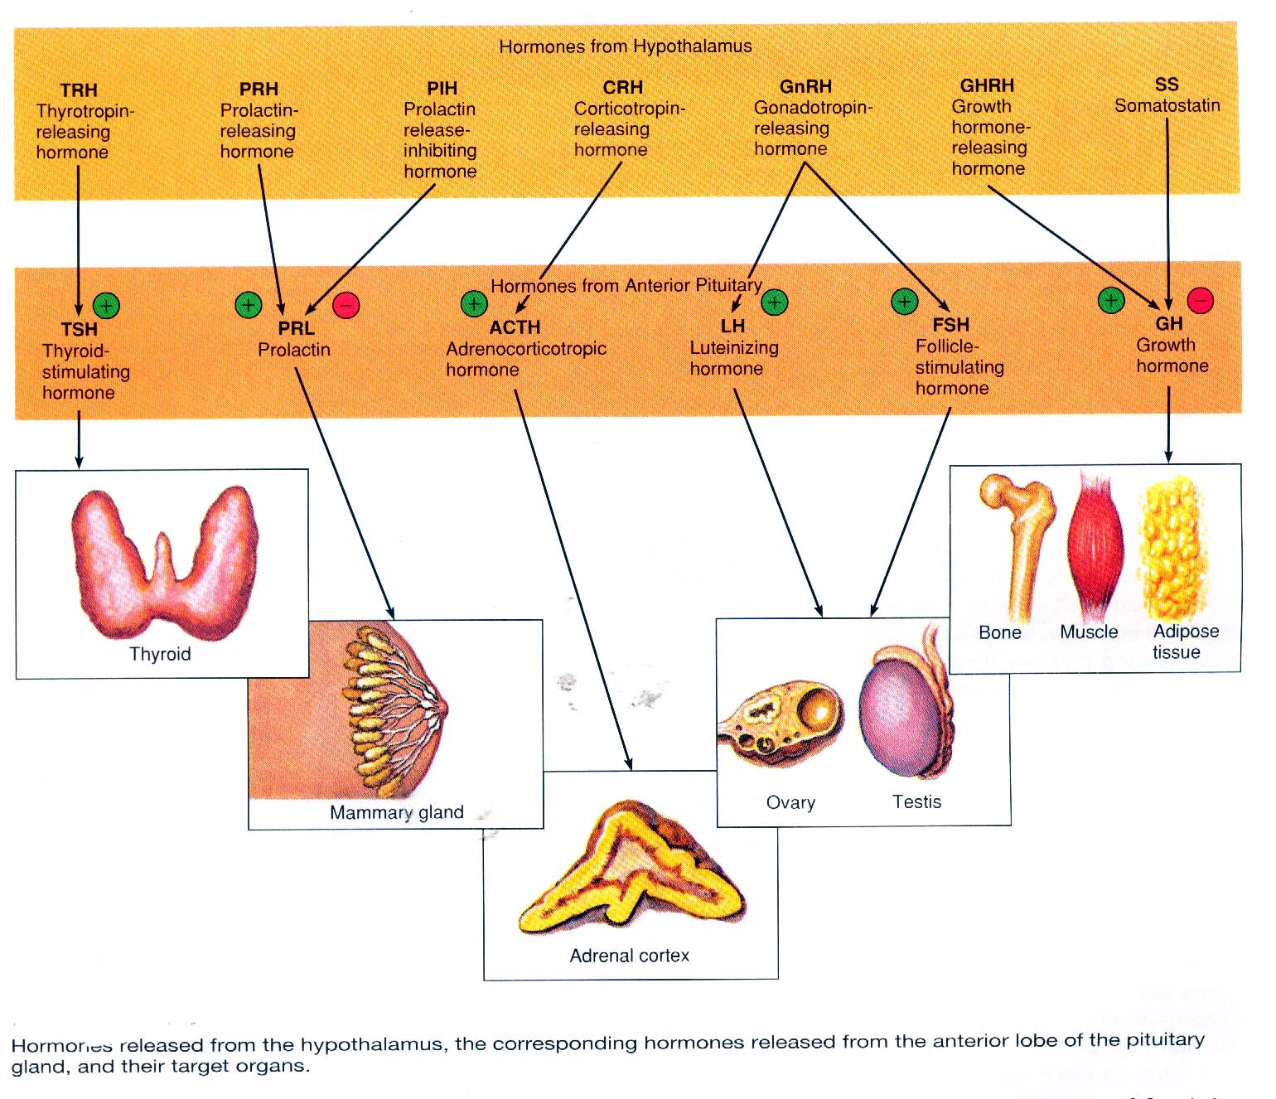

B. Neurohypophysis:

General structure:

The neurohypophysis contains abundant axons whose cell bodies are located mainly in the supraoptic and paraventricular nuclei of the hypothalamus.

Subdivisions:

1-The infundibulum consists of :

a) Infundibular stem (neural stalk)

b) Median eminence of the tuber cinereum.

The infundibular stem carries axons from the hypothalamus to the pars nervosa and contains the capillary loops of the primary capillary plexus.

The median eminence of the tuber cinereum, a funnel shaped extension forms the floor of the hypothalamus.

2-The pars nervosa (infundibular process) is the expanded lobe of the neurohypophysis; it contains axon terminals and numerous capillaries.

The subdivisions of the neurohypophysis all exhibit similar microscopic structure.

The neurohypophysis has three major structural components:

A) axons, B) capillaries, and C) pituicytes.

A. Axons of Neurosecretory Cells:

The neurohypophysis stains poorly if at all.

It contains many unmyelinated axons whose cell bodies are located mainly in the supraoptic and paraventricular nuclei of the hypothalamus.

Axons passing from these nuclei to the pars nervosa are together termed the hypothalamohypophyseal tract.

The axons contain neurosecretory granules and exhibit large granule-filled dilations called Herring bodies.

The neurosecretory materials in these granules, synthesized and packaged in the above-mentioned cell bodies, include the following products:

1. Neurohypophyseal hormones.

2. Neurophysins.

3. Adenosine triphosphate (ATP).

1. Neurohypophyseal hormones.

The hypothalamic neurons terminating in the neurohypophysis release oxytocin and antidiuretic hormone around the capillaries in this part of the pituitary.

Oxytocin (amino-acid peptide) synthesized mainly by cells of the paraventricular nucleus. It stimulates milk ejection by the mammary glands and stimulates uterine smooth muscle contraction during copulation and childbirth.

Antidiuretic hormone (ADH, arginine vasopressin) is amino-acid peptide synthsized mainly by cells in the supraoptic nucleus. It stimulates water resorption by the renal medullary collecting ducts and contraction of vascular smooth muscle.

2. Neurophysins are binding proteins that complex with neurohypophyseal hormones.

3. Adenosine triphosphate (ATP) acts as a chemical energy source for neurosecretion.

B. Fenestrated capillary plexus:

Surrounds the axon terminal in the pars nervosa, these capillaries pick up the neurosecretory products and convey them to the general circulation.

C. Pituicytes :

These are highly branched glial cells whose processes surround and support the unmyelinated axons. Pituicytes form about 25% of the neurohypophysis.

