|  |  |  |
| --- | --- | --- |
| **Fifth stage** | **Pediatric** | **Lec-8** |
| **د.اثل** | **17/11/2015** |

**Vesicoureteral Reflux**

VUR is the retrograde flow of urine from the bladder to the ureter or up to the kidney.

**Classification of VUR**

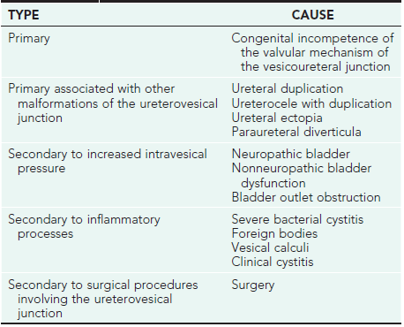

**Various anatomic defects of the ureterovesical junction associated with VUR.**

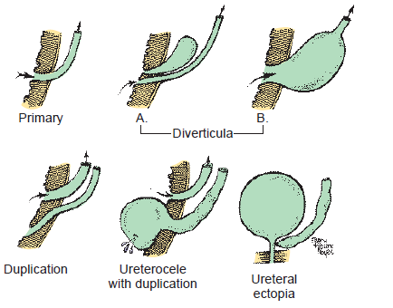

**Grading of VUR (Very Important):**  
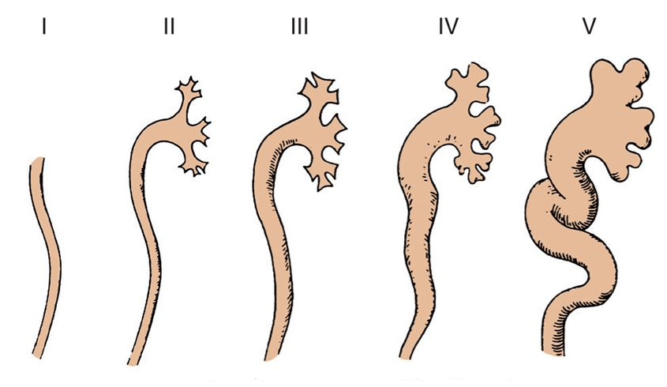

* ***Grade I:*** into a nondilated ureter.
* ***Grade II:*** into the pelvis and calyces without dilatation.
* ***Grade III:*** mild to moderate dilatation of the ureter, renal pelvis, and calyces with minimal blunting of the fornices.
* ***Grade IV:*** moderate ureteral tortuosity and dilatation of the pelvis and calyces.
* ***Grade V:*** gross dilatation of the ureter, pelvis, and calyces; loss of papillary impressions; and ureteral tortuosity.

**CLINICAL MANIFESTATIONS**

* VUR is most often identified during radiologic evaluation following a UTI.
* The younger the patient with a UTI, the more likely VUR is present.
* No clinical signs are reliable in differentiating children with UTI with and without VUR.

**DIAGNOSTIC STUDIES**

An imaging study can be performed after initiation treatment of UTI.

* RUS
* VCUG (radionuclide cystogram ): anatomical details
* NCG (radionuclide cystogram ): less anatomical details but less radiation risk.

**Indication of VSUG:**

Recent AAP guidelines:

* Infant with 1st UTI between 2-24 mo in whom RUS reveals hydronephrosis , scarring, other finding suggestive high grade VUR or obstructive uropathy.
* Recurrent febrile UTI.
* Atypical infection.
* **VSUG:** showing

G 4 right VUR

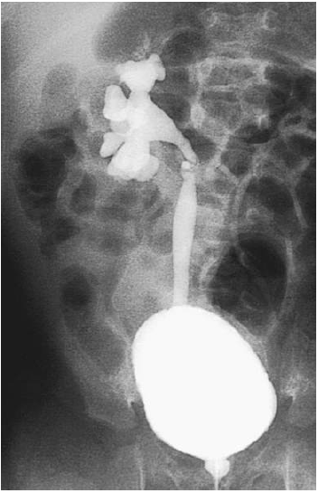

**TREATMENT**

* Controversy remains about whether long term *prophylactic antibiotics* is indicated in mild –moderate VUR.
* *Surgery:* open or laproscopic.
* *Endoscopic repair* of VUR involves injection of a bulking agent through a cystoscope just beneath the ureteral orifice, creating an artificial flap-valve. The FDA approved the use of a biodegradable material, dextranomer microspheres suspended in hyaluronic acid (Deflux), for subureteral injection.
* Endoscopic correction of VUR. Through a cystoscope, a needle is inserted into the submucosal plane deep to the ureteral orifice and bulking agent is injected, creating a flap-valve to preventVUR.

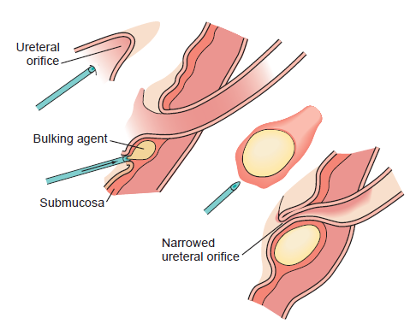

A, Endoscopic view of right vesicoureteral refluxing ureter.

B, The same ureter after subureteral injection of dextranomer microspheres.

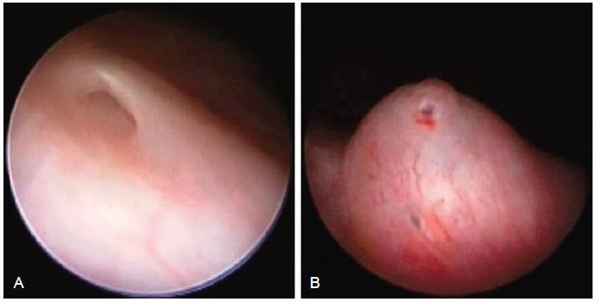

**Complications**

* Hypertension
* CKD