د. رجاء فسلجة 19\3\2018
عدد الاوراق ( 5 ) م\2\موصل lec: 5
Stomach
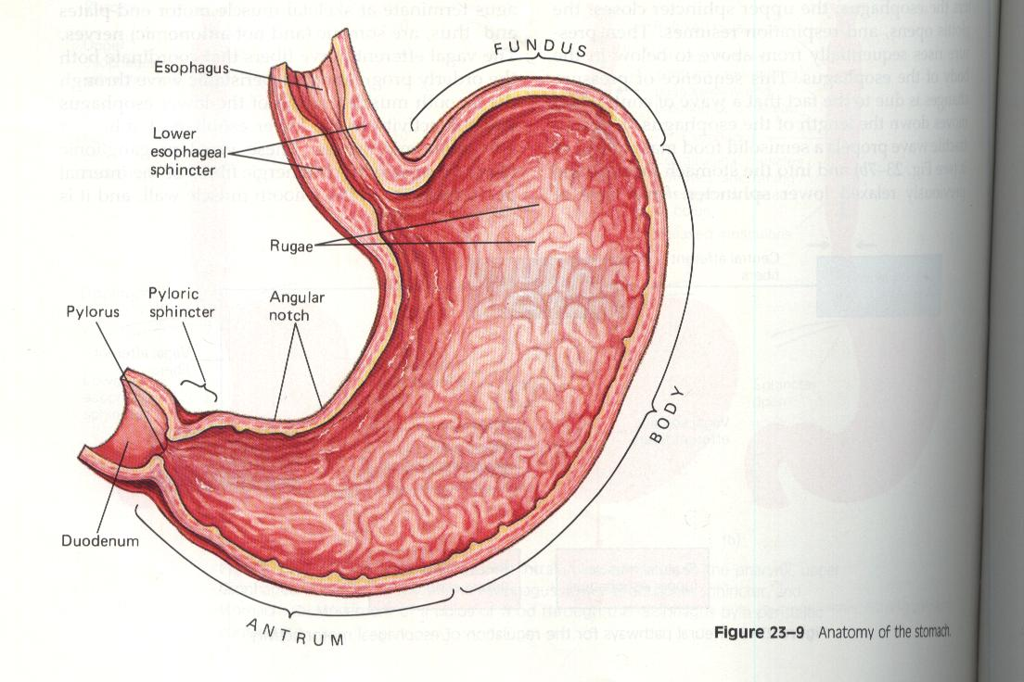

The stomach is a j – shaped , pouch like organ about 20-30 cm long which hangs under the diaphragm in the upper left portion of the abdominal cavity .

The stomach receives food from the esophagus , Food is stored in the stomach; mixed with acid, mucus, and pepsin; and released at a controlled, steady rate into the duodenum.
It has a capacity of about one liter or more and its inner lining is marked by thick folds ( rugae ) of the mucosal and submucosal layers that tend to disappear when its wall is distended .

Physiological anatomy
The stomach can be divided into :
a. cardiac region which is a small area near the esophageal opening .
b. Fundic region which balloons above the cardiac portion is a temporary storage area and sometimes filled with swallowed air
c. Body region which is the main part of the stomach is located between the fundic and pyloric portion .
d. pyloric region ( antrum) is a funnel – shaped portion which narrows and becomes the pyloric canal as it approaches the small intestine.
- At the end of pyloric canal the circular layer of fibers in its muscular wall thickens forming a powerful muscle the pyloric sphincter ( pylorus ) which prevents regurgitation of food from the intestine back into the stomach and also prevents excessive release of gastric acid into the duodenum.
The gastric mucosa contains any deep glands :
1. gastric glands ( also called oxyntic glands ) which are located in the body (including the fundus ) of the stomach constituting 80% of the stomach .
2. pyloric glands which are located on the antral portion of the stomach .
3. cardiac glands located near the lower esophageal sphincter ( LES )
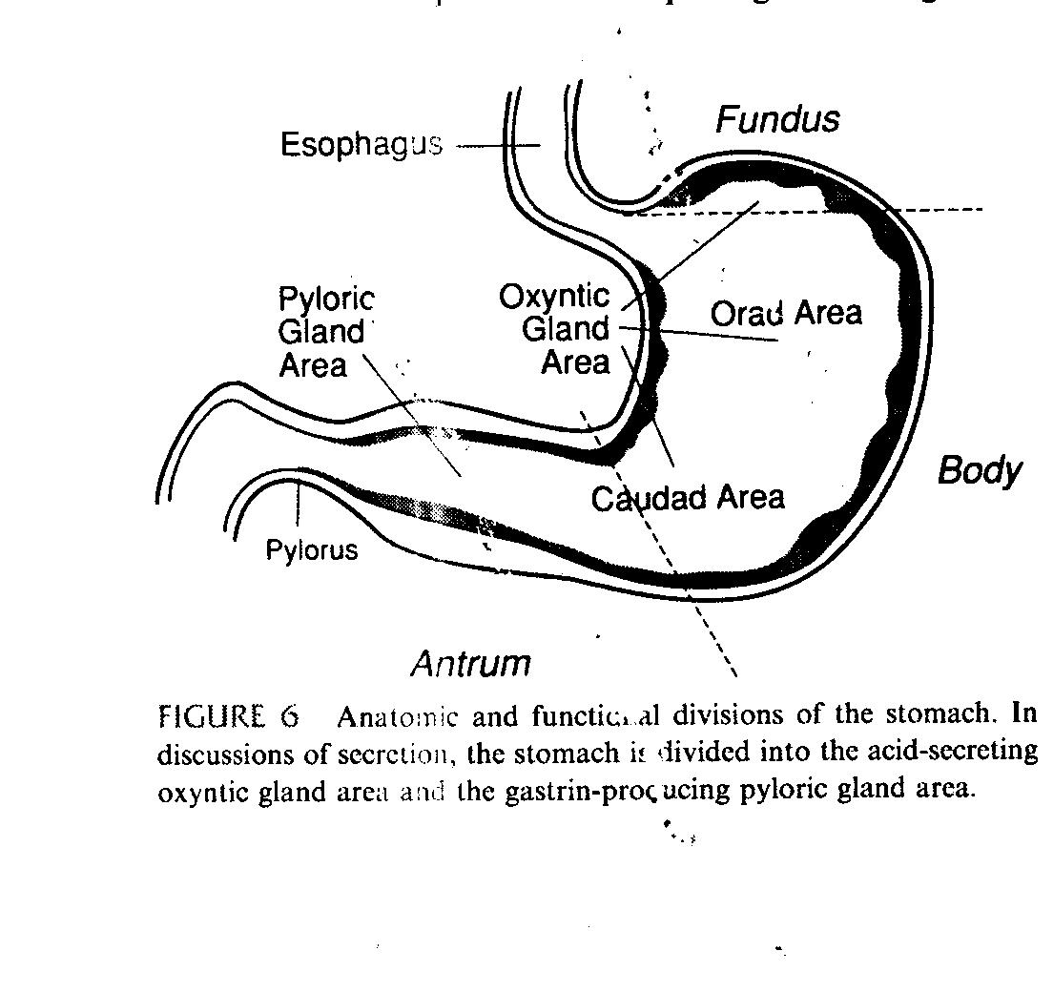
Gastric secretion :
About 2500ml ( 2.5 L ) of gastric juice is secreted daily . gastric juice contains hydrochloric acid , pepsinogen , mucus and intrinsic factor in addition to cations ( such as Na+ ,K+ , Mg2+ , H+ , anions ( Cl- ) , HCO3- , So4 and digestive enzymes .
secretion from oxyntic ( gastric ) glands which secrete mucus , pepsinogen , hydrochloric acid ( HCl ) and intrinsic factors .
oxyntic gland is composed of three types cells :
a. mucus neck cells which secrete mainly mucus .
b. peptic ( chief) cells which secrete large quantities of pepsinogen
c. parietal ( or oxyntic cells ) which secrete HCl and intrinsic factor .
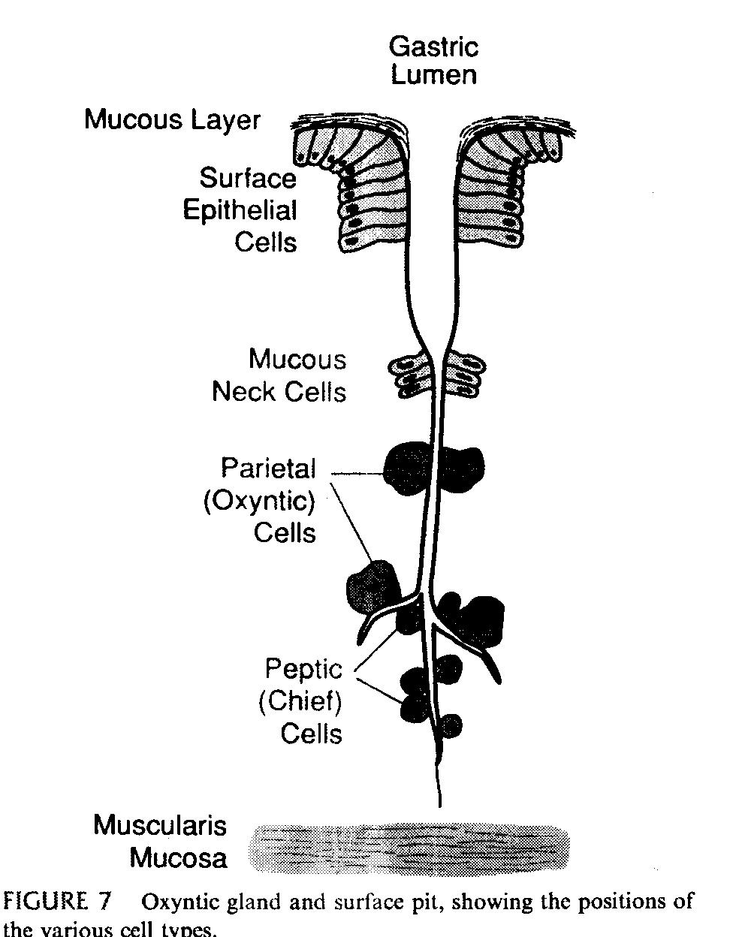
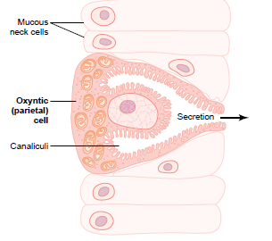
hydrochloric acid secretion :
When stimulated , the oxyntic cells secrete an acid solution that contains about 160 mmol of HCl per liter . the PH of this acid is 0.8 .
Mechanisms of hydrochoric acid secretion steps :
1. chloride ion ( Cl- ) is transported actively from cytoplasm of parietal cell into the lumen of canaliculi and sodium ions are actively transported from lumen of canaliculi into the cytoplasm of parietal cell . There two effect causes diffusion of potassium ion(k+) & small number of Na+ from the parietal cell into the canaliculus.
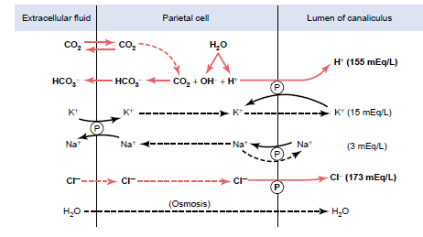
2. Water becomes dissociated into hydrogen ions (H+) and hydroxyl ion (OH-) in the cell cytoplasm .The H+ are actively secrete into the canaliculus in exchange with K+. This active exchange process is catalyzed by H+- K+ ATPase. In addition Na+ is reabsorbed actively in exchange With K+ by Na+- K+ Pump ,and H+ take their place in the canaliculus giving a strong solution of HCl in the canaliculus. And HCl from canaliculus move into the lumen of the gland.
3.Water passes in to the canaliculus by osmosis Thus the final secretion from the in canaliculi contains water, HCl at a concentration of about 150 to 160 meq/L and KCl at concentration of 15meq / L and small amounts of Nacl .

4. Finally carbon dioxide ( CO2) either formed during metabolism in the cell or entering the cell from the blood , combines with OH- from (step 2 ) to form bicarbonate ions ( HCO3- )under the influence of carbonic anhydrase . These then diffuse out of the cell cytoplasm into the extracellular fluid in exchange with Cl- that enter the cell from ECF and later secreted into the canaliculi .
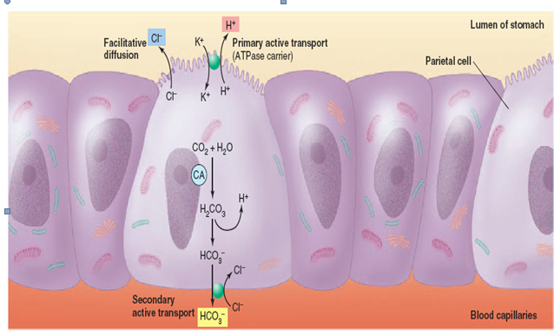

Function of HCl :
1.kills many ingested bacteria.
2. aids protein digestion .
3. provides the necessary pH for pepsin to start protein digestion .
4.stimulate the flow of bile and pancreatic juice .

- Pepsinogen Secretion :
Pepsin is secreted by chief peptic or zymogen cells , mucus neck cells and also by pyloric glands . Pepsin is in the form of inactive precursor called pepsinogen .
When pepsinogen contacts with the HCl from parietal cells , it changes rapidly into pepsin . Pepsin function as an active proteolytic enzyme in a highly acidic medium (pH : 1.8 – 3.5 ) but a pH above 5 it has no proteoyltic activity.

Secretion of intrinsic factor
Is another component of gastric juice which is secreted by the parietal cells of oxyntic glands, Intrinsic factor is essential for absorption of vitamins B12 in the ileum ,by is secreted along with the HCl by the parietal cells . When parietal cells are destroyed which frequently occurs in chronic gastritis , the person develops not only achlorhydria ( lack gastric acid secretion ) but also pernicious anemia because of failure of maturation of red blood cells in the absence of vitamin B12 stimulation of bone marrow .

Secretion of mucus :
Is secreted by mucous neck cells of oxyntic glands also by pyloric glands . the entire surface of the stomach mucosa between glands has a continuous layer of special type of mucous cells called surface mucous cells .
They secret a large quantities of a very viscid mucus.
1.that coats the stomach mucous more than 1 millimeter thick thus providing a major shell of protection for the stomach ,
2. lubrication of food transport .
3. surface mucus cells secrete HCO3- , therefore the normal underlying stomach wall is not directly exposed to the highly acidic preteolytic secretion .

Stimulation of gastric acid secretion
Gastric juice is produced continuously and is controlled neurally and hormonally .
acid secretion is stimulated by :
a. histamine via H2 receptors
b. acetylcholine via muscarinic receptors .
c. gastrin via gastric receptors.
These receptors are present on the membrane of parietal ( oxyntic ) cells . H2 receptors , muscarinic receptors and gastric receptors activation will activate protein kinases inside the parietal cell which is in turn increase the transport of H+ into the gastric lumen in exchange with K+ by K+ - H+ pump.

Gastric also acts by stimulating the secretion of histamine from enterochromaffin like cells ( ECL cells ) which are endocrine cell type in the acid secreting portion (parietal)of the stomach . these cells have acetylcholine and gastric receptors on their cell membrane . they are inhibited by somatostain . It's now aclear that the principal pathway by which gastric stimulates acid secretion is via these cells . the main function of ECL cells is to secrete histamine .

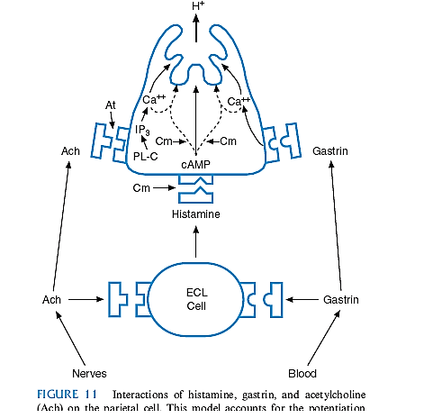
The rate of formation and secretion of HCl – by parietal cell is directly related to the amount of histamine secreted by the ECL cells . in turn the ECL cells can be stimulated to secrete histamine in several ways :
a. the most potent mechanism for stimulating histamine secretion is by the hormone gastrin which is formed in the G-cells in the antral portion of the stomach mucosa in response to protein .
Histamine is very effective in promoting secretion of gastric acid through effective of H2- receptors .
b. by the acetylcholine released from stomach vagal nerve ending
c. by hormonal substances secreted by the enteric nervous system of stomach wall .

By vagal stimulation about 500ml of HCl is secreted daily(500ml/day),while by gastrin release about 200ml /day is released.
Prostaglandins will inhibits acid secretion and this explain in part the increased incidence of ulcers in patients taking anti-inflammatory drugs that inhibit prostaglandin synthesis .

Phases of Gastric Secretion
1. cephalic phase .

2. gastric phase .
3. intestinal phase

Cephalic phase :It begins before any food reaches the stomach and possibly even before eating . In this stage parasympathetic reflexes operating through the efferent vagus nerves stimulate gastric secretion. . vagally moderated increases in gastric secretion are easily conditioned . in humans , sight smell , though , or taste of food and the greater the appetite the more intense is the stimulation . Neurogenic signals that cause the cephalic phase of gastric secretion originate in the cerebral cortex and in the appetite centers of the amygdala and hypothalamus.
This phase of secretion normally account about 20% of the gastric secretion associated eating meals .

Gastric phase :This phase status when food enter the stomach , it excites :
1. vagovagal reflexes from the stomach to the brain and back to the stomach
2. local enteric reflexes
3. gastrin release all of the which in turn cause secretion of gastric juice during several hours while food remains in the stomach . this phase of secretion accounts for about 70% of total gastric secretion associated with eating a meal and therefore accounts for most of the total daily gastric secretion of about 1500 milliliters.

Intestinal phase :which is accounts for about 5% of the total secretory response to a meal .The presence of food in the upper portion of the small intestine particularly in the duodenum will cause stomach to secrete a small amount of gastric juice due to the release of gastrin .
The intestinal factor that inhibits gastric secretion this results from at least two influences :
1. Neural effect: the presence of food in the intestine initiates the entrogastric reflex transmitted through myenteric system ,vagus nerves and extrinsic sympathetic that inhibits gastric secretion. This reflex can be initiated by :
a. distension(stretch) b. presence of acid in the small intestine
c. presence of protein breakdown. d. irritation of mucosa

2. Hormonal effect:
Presence of acid , fat , amino acids , hyperosmotic or hypo – osmotic irritating factors cause release of several intestinal hormones such as secretin ,GIP , VIP ,and somatostain that inhibits gastric juice secretion .
The functional purpose of inhibitory gastric secretion by intestinal factors is presumably to slow passage of chyme from the stomach when the small intestine is already filled or already overactive.

Emotional State: Psychic stated are effects on gastric secretion that are mediated through vagi for example anger and hostility cause hypersecretion and hyperemia while fear and depression causes hyposecretion , inhibit motility and decrease blood flow .

