د. رجاء فسلجة 19\3\2018
عدد الاوراق ( 5 ) م\2\موصل lec: 6+7

GASTRIC MOTILITY
Gastric Mobility and Emptying :
The motor functions of stomach are :
1. storage of large quantities of food until the food can be processed in the stomach , duodenum and lower intestinal tract .
2. mixing of the food with gastric secretion until it forms a murky semifluid or paste called chyme.
3. slow emptying of the chyme from the stomach into the small intestine at a rate suitable for proper digestion and absorption by the small intestine
Storage function of the stomach :
An empty stomach has a volume of about 50 ml and the diameter of its lumen is only slightly larger than that of the small intestine . When food enters the stomach , the fundus and upper portion of the body, relax ( receptive relaxation ) before the arrival of the food allowing the stomach 's volume to increase to as much as 1- 5 liters . Receptive relaxation is mediated by vagovagal reflex from stomach to the brain stem and then back to the stomach
- The pressure in the stomach remains low until this limit is approached . The newest food lying closest to the esophageal opening and the oldest food lying nearest the outer wall of the stomach .

Mixing functions :
Gastric glands are presented in the enteric wall of the body except a narrow strip along on the lesser curvature of stomach and secrete digestive juices which come into contact with that portion of stored food ling against the mucosal surface of the stomach . As long as food is in the stomach, weak peristaltic constrictor waves called mixing waves , begin in the mid to upper portions of the stomach wall and move toward the antrum about once every 15 -20 seconds .
Waves occurs 3 to 4 times per minute . As the constrictor waves progress from the body to antrum portions of the stomach , they become more intense constrictor rings that force the antral contents under higher and higher pressure toward the pylorus .
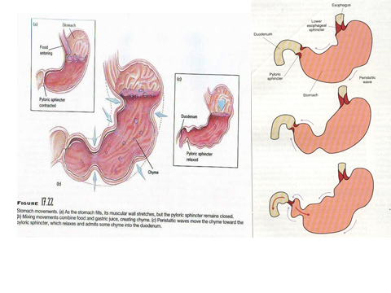
These constrictor rings also play an important role in mixing stomach contents . After food in the stomach has become thoroughly mixed with the stomach secretions , the resulting mixture that passes down the gut called chyme .
The degree of fluidity of the chyme leaving the stomach depends on the relative amounts of food , water , and stomach secretions and on the degree of digestion that had occurred .
The appearance of chyme is that of murky semifluid or paste . Each time a peristaltic wave passes down the antral wall toward the pylorus it digs deeply into the food contents in the antrum .
The opening of the pylorus is small enough that only a few millimeters or less of antral contents are expelled into the duodenum with each peristaltic wave . Also as each peristaltic wave approaches the pylorus , the pyloric muscle itself often contracts which further impedes emptying through the pylorus . Food remains in the stomach about 1 – 3 hours .
Regulation Of Gastric Motility And Emptying
gastric emptying regulated by :
1. pyloric pump which are intense peristaltic contractions of stomach antrum that pump chyme from the stomach into the duodenum.

2. Under normal condition , the pyloric sphincter opens enough for water and other fluids to empty from the stomach into the duodenum with ease . Decrease in the tone ( contraction ) of pylorus increases gastric empty . Stimuli from stomach ( both neural and hormonal ) that decrease pyloric tone increase empting .

A. Gastric factors that promote Emptying (i.e.
increases the pyloric pump and at the same time decreases pyloric tone) are :
1.neural effect by: a. increased food volume in the stomach promotes increased emptying .However stretching of the stomach wall does elicit local myenteric reflexes that greatly accelerate activity of the pyloric pump and at the same time inhibit the pylorus .

2. Hormonal , gastrin : the presence of certain types of foods in the stomach—particularly digestive products of meat—elicit release of a hormone called gastrin from the antral mucosa. This has potent effects to cause secretion of highly acidic gastric juice by the stomach glands.

B. Factors That Inhibit Stomach Emptying:
1. enterogastric reflexes from the duodenum : When the duodenum fills with chyme , its internal pressure increases . This action stimulates sensory receptors in the wall of duodenum ,triggering an enterogastric reflexes.

Enterogastric begins in the small intestine (entero ) and ends in the stomach ( gastric ) that pass from the duodenal wall to the stomach and stop stomach emptying .
These reflexes are mediated by three routes :
a. directly from the duodenum to the stomach through the enteric nervous system in the gut wall .
b. through extrinsic nerves that go to the prevertebral sympathetic ganglia and turn back to the stomach through inhibitory sympathetic nerve fibers .
c. to a slight extent through the parasympathetic nerve to the brain stem where they inhibit excitatory signals transmitted to the stomach through the vagi .

2. Hormonal Feedback from the Duodenum Inhibits Gastric Emptying—Role of Fats
If the chyme entering the intestine ,is fatty , the intestinal wall releases different hormones from small intestine . In turn , the hormones are carried by the way of the blood to stomach where they inhibit the pyloric pump and at the same time increase the strength of concentration of the pyloric sphincter.

The most potent hormone is cholecytokinin ( CCK ) which is released from mucosa of jejunum in response to fatty substance to the chyme . other hormones are :
secretin which is secreted in response to gastric acid
GIP is released from small intestine in response to mainly fat in the chyme and to less extent to carbohydrates .

Since the fats are effective in inhibitory gastric emptying some people drink milk cream or even olive oil before a cocktail party . The fat keeps the alcohol in the stomach for a long time , where its absorption is slower than in the small intestine and the intoxicant enters the small intestine in a slow , steady stream so that theoretically at least a sudden rise of the blood alcohol to a high level and consequent embarrassing intoxication are avoided.

Hunger Contractions. Besides the peristaltic contractions
that occur when food is present in the stomach, another type of intense contractions, called hunger contractions, often occurs when the stomach has been empty for several hours or more. They are rhythmical peristaltic contractions in the body of the stomach. When the successive contractions become extremely strong, they often fuse to cause a continuing tetanic contraction that sometimes lasts for 2 to 3 minutes.

Pancreas
Lec. 7
Dr. Rajaa Ahmad
Pancreas
The pancreas, which lies parallel to and beneath the Stomach, is a complex organ composed of both :
a. Endocrine portion that secrete insulin and glucagon
b. Exocrine portion which secretes digestive enzymes .

The pancreas consists of a head located within the curvature of the duodenum , a body and tail which extends to the spleen .
Exocrine portion of pancreas secrete the pancreatic juice . Digestive enzymes are secreted by the pancreatic acinar cells and bicarbonate by duct cells . The pancreatic juice flows into long pancreatic duct that joins the hepatic duct immediately before it empties into the duodenum through the papilla of vater surrounded by the sphincter of Oddi . The pancreatic duct usually connects with bile duct from liver and gallbladder .

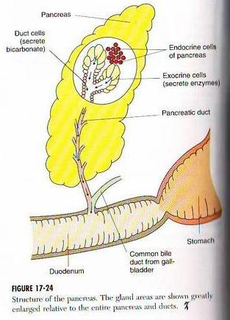
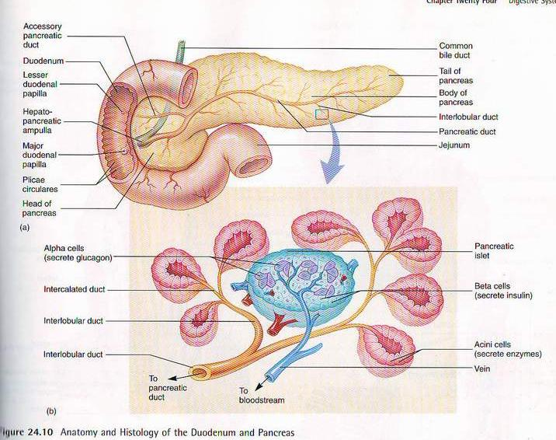
Composition of Pancreatic juice
1. about 1500ml of pancreatic juice is secreted per day.
pancreatic juice is alkaline due to the presence of high concentration of bicarbonate ( HCO3 - )approximately 113meq/L versus 24meq/L in plasma .Its pH 8 which provides a favorable conditions for the action of digestive enzymes and helps to neutralize the acidic chyme as it arrives from the stomach .
At the same time , the alkaline condition in the small intestine blocks the action of pepsin which might damage the duodenal wall .

2. pancreatic juice contain enzymes that digest carbohydrates , fats , proteins , and nucleic acids .
a. digestive enzymes for carbohydrates are pancreatic amylase which hydrolyze carbohydrates except cellulose .
b. the main enzyme for fat digestion are : pancreatic lipase , cholesterol esterase , phospholipase .

c. the protein splitting ( proteolytic ) enzymes are : trypsin , chymotrypsin , carboxypolypeptidase .
By far the most abundant of these ,is trypsin .These enzymes are stored in inactive forms as trypsinogen , chymotrypsinogen , procacrboxypeptidase within cellular structures called zymogens granules .

They become activated only after they are secreted into the intestinal tract . Trypsinogen is activated by an enzyme called enterorkinase which is secreted by the intestinal mucosa into the trypsin . chymotrypsinogen and procarboxypolypeptidase are activated by trypsin into chymotrypsin and carboxypolypeptide respectively .

It is important that proteolytic enzymes of the pancreatic juice not become activated after they have been secreted into the intestine because the trypsin and other enzymes would digest the pancreas itself .
Fortunately , the same cells that secrete proteolytic enzymes secrete another enzyme called trypsin inhibitor which prevents activation of trypsin . And because it is trypsin that activates other pancreatic proteolytic enzymes , trypsin inhibitor prevents activation of the others as well .

A painful condition called acute pancreatitis results from a blockage in the release of pancreatic juice . Trypsinogen activated as pancreatic juice builds up , digests parts of pancreas , pancreatitis may be caused by alcoholism , gallstones , certain infection a traumatic injury
or a side effect of some drugs .
d. pancreatic juice also contains two nucleases which are enzymes that
break nucleic acid molecules into nucleotide .

Regulation of Pancreatic Secretion
1. Hormonal 2. Neural
Hormonal secretion of pancreatic juice is primarily under hormonal control of two
types of hormones .
a. secretin b. cholecystokinin ( CCK )

2. Neural control : Role of Ach
Ach which is released from the parasympathetic vagus nerve ending and from other cholinergic nerves in the enteric nervous system . vagi causes secretion of a small amount of pancreatic juice rich in enzymes .
When all the different stimuli of pancreatic secretion occur at once, the total secretion is far greater than the sum of the secretions caused by each one separately. Therefore, the various stimuli are said to “multiply,” or “potentiate,”one another. Thus, pancreatic secretion normally results from the combined effects of the multiple basic stimuli, not from one alone.

Phases of Pancreatic Secretion
Pancreatic secretion occurs in three phases the same as for gastric secretion.
1. cephalic phase 2. Gastric phase 3. Intestinal phase .
Cephalic phase :
The cephalic phase of pancreatic secretion results from sight , swell thought or taste of food cause ACH release by vagus nerve endings in the pancreas . This causes secretion of moderates amounts of pancreatic enzymes accounting for about 20 per cent of the total secretion of pancreatic enzymes after a meal.

Gastric phase :
When food enters the stomach , the nervous stimulation of enzyme causes release of small amounts of pancreatic enzymes , accounting for another 5 to 10 per cent of pancreatic enzymes secreted after a meal.
Intestinal phase :
After the chime leaves the stomach and enters the small intestine , pancreatic secretion becomes copious , mainly in response to the hormone secretion .

