Prof.Dr. Amer A. Taqa
2013-2014

Solutions
A solution A homogeneous mixture of two or more components
Examples of solutions
Sugar in water, oxygen in water, dental filling, air
Components in a solution
A solution consists of two component types.
Solvent: component in the greater extent
Solute:component in the lesser extent (You may have more than one.)

Properties of solution
Characteristics of a solution:
The solute can’t be filtered out.
The solute always stays mixed.
Particles are always in motion.
Volumes may not be additive.
A solution will have different properties than the solvent.

Physical states of solutions
Solutions can exist in any of the three states.
Solid solutions: dental fillings, 14K gold, sterling silver
Liquid solutions : saline, vodka, vinegar, sugar water
Gas solutions :the atmosphere, anesthesia gases
Solubility
A measure of how much of a solute can be dissolved in a solvent.
Common unit: grams of solute / 100 g of water, at given T.
Factors affecting solubility:
- Temperature: usually the higher T, the higher the solubility, except for gases.
- Pressure: (mostly for gases), the higher the pressure the higher the solubility.
- Polarity (similarity in charges). Like dissolves like.
- Solubility of some substances
- Temperature Solubility
- Substance ºC g/100 ml water
- NaCl (s) 100 39.12
- PbCl₂ (s) 100 3.34
- AgCl (s) 100 0.0021
- CH₃CH₂OH (l) 0 - 100 infinity
- CH₃CH₂OCH₂CH₃ (l) 15 8.43
- O₂ (g) 60 0.0023
- CO₂ (g) 40 0.097
- SO₂ (g) 40 5.41
Saturation
When a solution contains as much solute as it can at a given temperature. It’s saturated.
Unsaturated Can still dissolve more.
Saturated Have dissolved all you can.
Supersaturated Temporarily have dissolved too much.
Precipitate Excess solute that falls out of solution.

Properties of aqueous Solutions
There are two general classes of solutes.
Electrolytic (electrolytes)
  - conduct electricity
  - may be strong or weak .
Nonelectrolytic (non electrolytes)
  - do not conduct electricity

Dissolving ionic compounds
When an ionic solid dissolves in water, the solvent removes ions from the crystal.
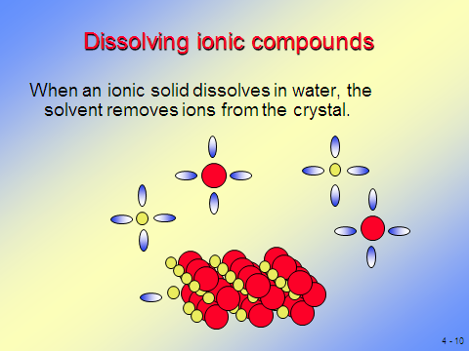

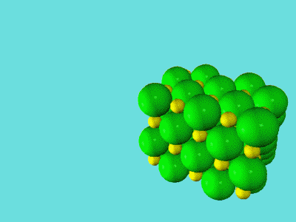

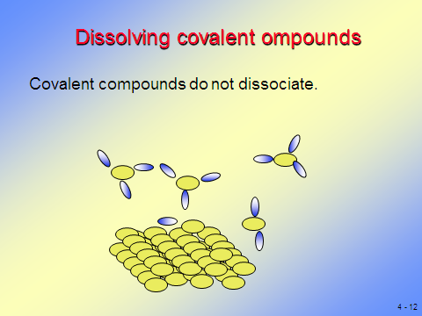

Concentration of solutions
We need a way to tell how much solute is in a solution - concentration.
There are many systems - we will cover four.
  - Mass / volume percent
  - Volume / volume percent
  - Mass / Mass percent
  - Molarity
  - Molality
  - Molar fraction
  - Parts per million
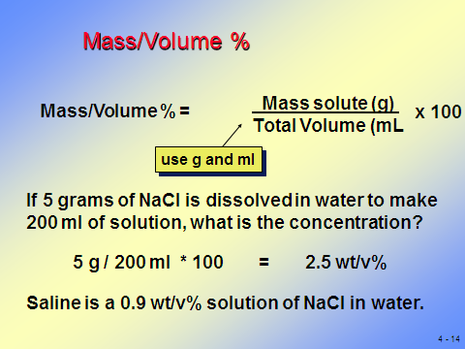

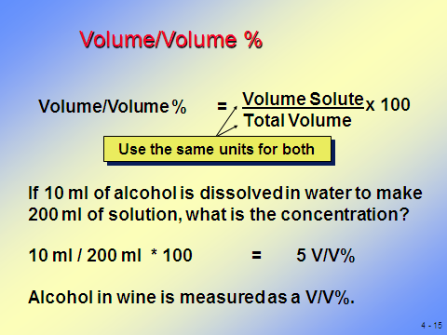

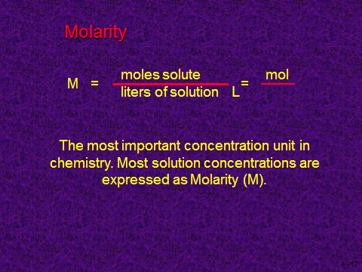
MOLARITY
What is moles?
Amount of matter expressed in grams.
1 mol of O₂ has a mass of 32 g.
1 mol of sodium has a mass of 23 g.
1 mol of H₂O has a mass of 18 g.
Grams of the substance (g)
moles (n) = molar mass (g/mol)


