Lab 3
Special Stain
By which we can stain special structures of bacterial cell like spores, flagella and capsule.
A-Capsule stain (negative stain): Capsulated bacteria have the ability to
form gelatinous materials outside the cell called capsule, many
saprophyticus species can form capsule.
Function of capsule:-
- To protect the cell from desication.
- To protect the cell from harmful environmental conditions.
- Protect the cell from phacocytosis.
- Serve as a mean of adherance of organism to the surface.
- Appear to be help in holding the cell together after cell division, this leading to chain formation.
- It's possible that capsule may aid in blocking the surface of receptor of bacteria to bacteriophage.
Chemical composition of capsule:-
Capsul is a layer of gelatinous materials lies out side the cell wall of many bacteria, capsule is either poly saccharides e.g. Streptococcus pneumoniae or proteins (polypeptide) e.g. Bacillus anthracis or complex of hyaluronic acid and muco polysaccharide e.g. Str. pyogenes.

Procedure:-
- By means of bacteriological loop, put a drop of nigrosin stain or india ink stain on a clean slide, then transfer a small amount of culture on the drop, mix and spread it .
- Leave the preparation to dry and examine under oil immersion power
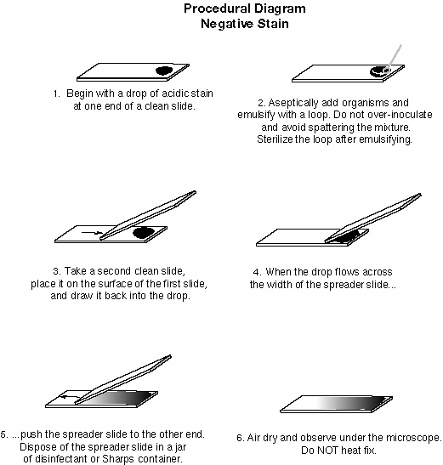
Note:- because capsule is highly hydrate polymer it will shrink dramatically when heat is applied.
Results:- clear zone cells of capsulated microorganism and the backing ground is black. (so we stain the surrounding of capsule and leave capsule unstained).
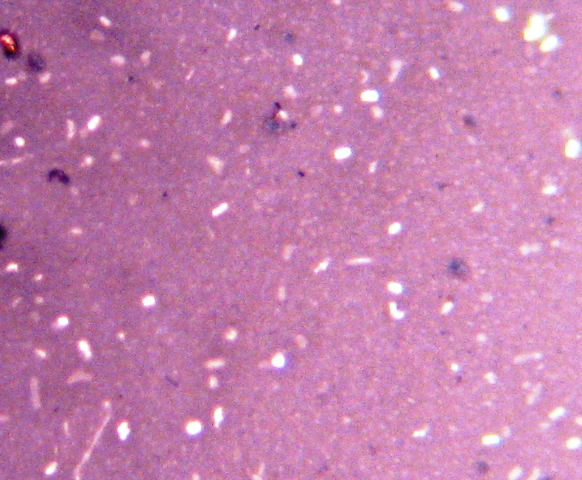
B- Spore Stain:-
Some species of bacteria form a special structure called (endospore) when the environment is not suitable such as: low of O₂ , low of nutrient , change of PH and other conditions that prevent the growth of vegetative cell .
Spores are dormant forms , spore is unstained because it is impermeable to anything or to any stain.

Spore consist of :-
- Core: consist of chromatin materials, proteins, lipids, enzymes, carbohydrates, minerals, less of water and greater of calcium .
- Cortex: consist of muco peptide and cadipicolonate .
- Coat: keratin like materials.
The resistant of spore due to:-
Low of metabolic activity.
Low of enzymatic activity.
Low amounts of water.
High amount or concentration of cadipicolonate.
We classify bacteria according to the presence of spore, location, and shape.
Sporulated bacteria
Presence
Non sporulated bacteria
Spherical
Shape
Oval

Centrally e.g. B. anthracis
Location Terminally e.g. Clostridium tetani
Sub terminally e.g. Cl. botulinum

Procedure:-
- Prepare a smear from young culture, fix with minimum heat.
- Apply malachite green for 3-5 mins, heat the preparation untile steam rises, avoid boiling .
- Wash with water .
- Stain with carbol fuchsin for 1 min .
- Wash with water .
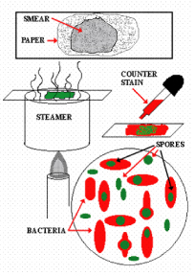
Result :- spore green, bacteria red

