ECTOPIC PREGNANCY

DEFINITION
Any pregnancy where the fertilised ovum gets implanted & develops in a site other than normal uterine cavity.

INCIDENCE
>1 in 100 pregnancies.

Recent evidence indicates that the incidence of ectopic pregnancy has been rising in many countries.
- USA-5 fold
- UK-2 fold
- France 15/1000 pregnancies
- India-1in100 deliveries

Recurrence rate - 15% after 1st, 25% after 2 ectopics

AETIOLOGY
- Any factor that causes delayed transport of the fertilised ovum through the fallopian tubes.
- Fallopian tube favours implantation in the tubal mucosa itself thus giving rise to a tubal ectopic pregnancy.
- These factors may be Congenital or Acquired.
- CONGENITAL - Tubal Hypoplasia, Tortuosity, Congenital diverticuli, Accessory ostia, Partial stenosis

- ACQUIRED -
- Inflammatory: PID, Septic Abortion, Puerperal Sepsis, MTP (intraluminal adhesion)
- Surgical: Tubal reconstructive surgery, Recanalisation of tubes
- Neoplastic: Broad ligament myoma, Ovarian tumour
- Miscellaneous Causes: IUCD, Endometriosis, ART (IVF & & GIFT),
Previous ectopic

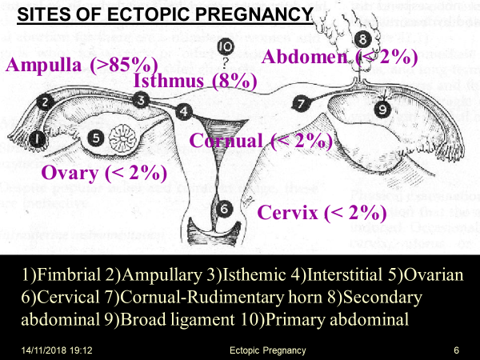

CLINICAL PRESENTATION
Ectopic Pregnancy remains asymptotic until it ruptures when it can present in two variations - Acute &. Chronic

SYMPTOMS:
- Amenorrhea
- Abdominal Pain
- Syncope
- Vaginal Bleeding
- Pelvic Mass

Tubal Pregnancy
Commonest site of ectopic pregnancy (99%) and The ampulla is the most frequent location of implantation (64%).

Symptoms:
- Onset occurs ~7 weeks after LMP
- Abdominal pain
- Vaginal bleeding
Signs:
- Abdominal tenderness (91%)
- 1st trimester bleeding (79%)

Common associated findings:
- Adnexal tenderness (54%), Amenorrhea
- Early pregnancy symptoms
- Cullen’s sign (Periumbilical bruising)
- Nausea, vomiting, diarrhea, dizziness
Other Signs:
- Tachycardia, Low grade fever
- Hypoactive bowel sounds
- Cervical Motion Tenderness
- Enlarged uterus
- Tender pelvic or adnexal mass
- Cul-de-sac fullness
- Decidual cast (Passage of decidua in one piece)

Signs suggestive of ruptured ectopic pregnancy:
- Usually between 6- and 12-weeks gestation
- Severe abdominal tenderness with rebound, guarding
- Orthostatic hypotension

Differential Diagnosis
- Appendicitis
- Threatened Abortion
- Ruptured ovarian cyst
- PID
- Salpingitis
- Endometritis
- Nephrolithiasis
- Ovarian torsion
Intrauterine pregnancy

Alternative diagnoses:
        - Dysmenorrhea
        - Dysfunctional uterine bleed
        - UTI
        - Diverticulitis
        - Mesenteric lymphadenitis

METHODS OF EARLY DIAGNOSIS:
- Immunoassay utilising monoclonal antibodies to beta HCG
- Ultrasound scanning – Abdominal & Vaginal including Colour Doppler
- Laparoscopy
- Serum progesterone estimation not helpful

A combination of these methods may have to be employed.

At 4-5 weeks-
- TVS can visualise a gestational sac as early as 4-5 weeks from LMP.
- During this time the lowest serum beta HCG is 2000 IU/Lt.
- When beta HCG level is greater than this and there is an empty uterine cavity on TVS, ectopic pregnancy can be suspected.
- In such a situation, when the value of beta HCG does not double in 48 hours ectopic pregnancy will be confirmed.
The USG features of ectopic pregnancy after 5 weeks can be any of the following-
- Demonstration of the gestational sac with or without a live embryo (Begel’s sign) - The GS appears as an intact well-defined tubal ring by 6 weeks when it measures 5 mm in diameter. Afterwards it can be seen as a complete sonolucent sac with the yolk sac and the embryonic pole with or without heart activity inside.
- Poorly defined tubal ring possibly containing echogenic structure and POD typically containing fluid or blood.
- Ruptured ectopic with fluid in the POD and an empty uterus.

(here methods of early diagnosis end)

INVESTIGATIONS-
- Laboratory/Chemical test –
- Serial quantitative beta HCG level by RIA
- Serum progesterone level (<5 mg/ml in ectopic pregnancy)
- Low levels of Trophoblastic proteins such as SPI and PAPP-, Placental protein 14 & 12
- USG- usually haematocele is found
- Laparoscopy

Initial Investigations
Monitor βhCG levels
- βhCG- hormone produced by the placenta (and fetal kidney)
- Detectable in plasma and urine following blastocyst implantation
- Blood levels rise rapidly, doubling every 2d and plateaus at 8-10 weeks gestation
- Serum βHCG levels correlate with the size and gestational age in normal embryonic growth

βHCG with inadequate increase may suggest ectopic pregnancy
** β-hCG level does not predict ruptured ectopic, ruptured ectopic may occur at any
β-HCG level

MANAGEMENT
- Depends on the stage of the disease and the condition of the patient at diagnosis.
- Options: -
- Surgery – Laparoscopy / Laparotomy
- Medical – Administration of drugs at the site / systemically
- Expectant – Observation

MANAGEMENT OF ACUTE ECTOPIC PREGNANCY
- Hospitalisation
- Resuscitation -
- Treatment of shock
- Lie flat with the leg end raised
- Analgesics
- Blood transfusion
- Laparotomy should be done at the earliest.
- Salpingectomy is the definitive treatment.
(No benefit from removing Ovary along with the tube)

Options
- SURGICAL-
- SURGICALLY ADMINISTERED MEDICAL (SAM) TREATMENT
- MEDICAL TREATMENT
- EXPECTANT MANAGEMENT

MEDICAL TREATMENT WITH METHOTREXATE
- Ectopic pregnancy size should be < 3.5 cm.
- Can be given IV/IM/Oral, usually along with Folinic acid
- Recent concept is to give Methtrexate IM in a single dose of 50 mg/m² without Folinic acid. If serum HCG does not fall to 15% within 4-7 days, then a second dose of Methtrexate is given and resolution confirmed by HCG estimation

Advantages
- Minimal Hospitalisation. Usually outdoor treatment
- Quick recovery
- 90% success if cases are properly selected
Disadvantages
- Side effects like GI & Skin
- Monitoring is essential- Total blood count, LFT & serum HCG once weekly till it becomes negative

EXPECTANT TREATMENT
Today only selected cases are managed expectantly, screened and identified by high resolution ultrasound scanner and monitored by serial serum HCG assay
Criteria for this management:
initial HCG less than 250 I.U plus other criteria for medical treatment
It has high success rate reaching 70-80%.

