# Oral Histology

**Lec.2 Dr. Anes Adnan**

**Development of the tooth**

**Part one \ Odontogenesis**

Tooth development or odontogenesis is the complex process by which teeth form from embryonic cells, grow, and erupt into the mouth.

**Stages of tooth development**

Tooth development is commonly divided into the following stages: the initiation stage, the bud stage, the cap stage, the bell stage, and finally maturation. All these stages, growth and morphogenesis of the teeth are regulated by a protein called sonic hedgehog. At the end of week 4, the center of the developing facial structures is formed by an ectodermal depression, the stomodeum, is lined by stratified primitive oral epithelium and surrounded by the first pair of pharyngeal arches.

**Initiation Stage**

The dental lamina is a band of epithelial tissue seen in histologic sections of a developing tooth. The initiation stages of tooth development occur between the sixth and seventh week of prenatal development. The dental lamina is first evidence of tooth development and begins at three weeks after the rupture of the buccopharyngeal membrane or at the sixth week of prenatal development.

**Bud stage**

The bud stage is characterized by the appearance of a tooth bud without a clear arrangement of cells. The stage technically begins once epithelial cells proliferate into the ectomesenchyme of the jaw. Typically, this occurs when the fetus is around 8 weeks old.

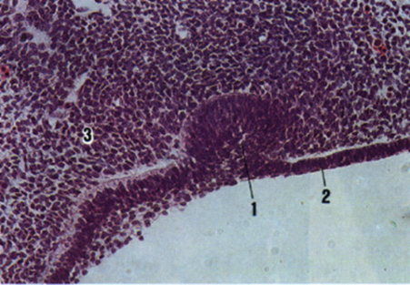

1. Tooth bud
2. Oral epithelium
3. Mesenchyme

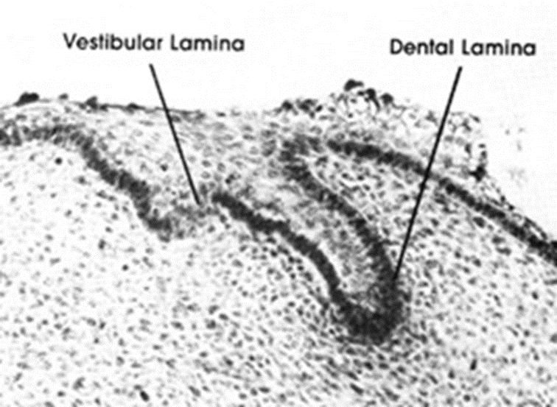



The tooth bud itself is the group of cells at the periphery of the dental lamina. Along with the formation of the dental lamina, 10 round epithelial structures, each referred to as a bud, develop at the distal aspect of the dental lamina of each arch. These correspond to the 10 primary teeth of each dental arch, and they signify the bud stage of tooth development. Each bud is separated from the ectomesenchyme by a basement membrane. Ectomesenchymal cells congregate deep to the bud, forming a cluster of cells, which is the initiation of the condensation of the ectomesenchyme.

**Cap stage**

The first signs of an arrangement of cells in the tooth bud occur in the cap stage. A small group of ectomesenchymal cells stops producing extracellular substances, which results in an aggregation of these cells called the dental papilla. The cap stage occurs between the Ninth and tenth week of prenatal development.

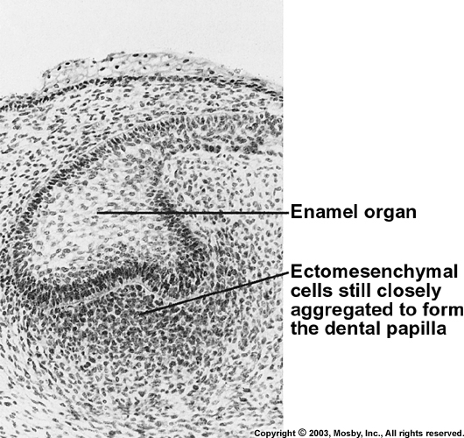

At this point, the tooth bud grows around the ectomesenchymal aggregation, taking on the appearance of a cap, and becomes the enamel (or dental) organ covering the dental papilla. A condensation of ectomesenchymal cells called the dental sac or follicle surrounds the enamel organ and limits the dental papilla.

Eventually, the enamel organ will produce enamel, the dental papilla will produce dentin and pulp, and the dental sac will produce all the supporting structures of a tooth, the periodontium.

**Bell stage**

The bell stage is known for the histodifferentiation and morphodifferentiation that takes place. The bell stage occurs between the Eleventh and twelfth week of prenatal development. The dental organ is bell-shaped during this stage, and the majority of its cells are called stellate reticulum because of their star-shaped appearance. The bell stage is divided into the early bell stage and the late bell stage. Cells on the periphery of the enamel organ separate into four important layers.

1. Cuboidal cells on the periphery of the dental organ are known as outer enamel epithelium (OEE).

2. The columnar cells of the enamel organ adjacent to the enamel papilla are known as inner enamel epithelium (IEE).

3. The cells between the IEE and the stellate reticulum form a layer known as the stratum intermedium.

4. The rim of the enamel organ where the outer and inner enamel epithelium join is called the cervical loop.

The dental lamina disintegrates, leaving the developing teeth completely separated from the epithelium of the oral cavity; the two will not join again until the final eruption of the tooth into the mouth.

The crown of the tooth, which is influenced by the shape of the inner enamel epithelium, also takes shape during this stage. Throughout the mouth, all teeth undergo this same process. Other structures that may appear in a developing tooth in this stage are enamel knots, enamel cords, and enamel niche.

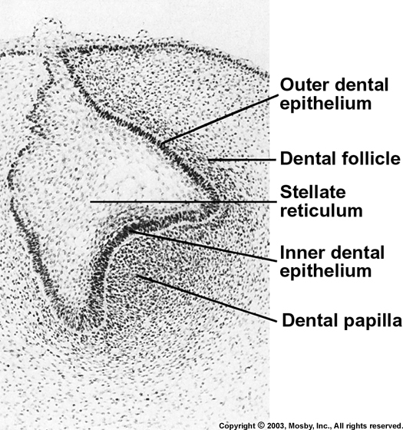

**Advanced bell stage**

Hard tissues, including enamel and dentin, develop during the next stage of tooth development. This stage is called the crown, or maturation stage. Important cellular changes occur at this time.

At this stage, the IEE cells change in shape from cuboidal to columnar and become preameloblasts. The adjacent layer of cells in the dental papilla suddenly increases in size and differentiates into odontoblasts, which are the cells that form dentin.

As the changes to the IEE and the formation of odontoblasts continue from the tips of the cusps, the odontoblasts secrete a substance, an organic matrix, into their immediate surrounding. The organic matrix contains the material needed for dentin formation.

As odontoblasts deposit organic matrix termed predentin, they migrate toward the center of the dental papilla. Thus, unlike enamel, dentin starts forming in the surface closest to the outside of the tooth and proceeds inward. Cytoplasmic extensions are left behind as the odontoblasts move inward. After dentin formation begins, the cells of the IEE secrete an organic matrix against the dentin. This matrix immediately mineralizes and becomes the initial layer of the tooth's enamel.

Outside the dentin are the newly formed ameloblasts in response to the formation of dentin, which are cells that continue the process of enamel formation; therefore, enamel formation moves outwards, adding new material to the outer surface of the developing tooth.

