Orthopedic Surgery
5th Stage

Developmental dysplasia of hip joint
Definition
DDH: It is abnormal development or abnormal formation of the hip joint in
which the femoral head is not stable in the acetabulum

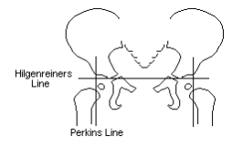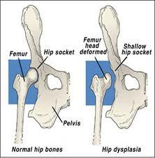

May occur during fetal development or at birth or after birth due to deviation in normal development of infantile growth period.
Instability ↔ mal devop. of acetab
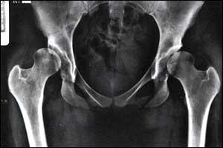
DDH include spectrum of disorders:
1. Acetabular dysplasia without displacment of femoral head.
2. Hip instability which either:
• subluxation
• Dislocation
3. Teratological dislocation.
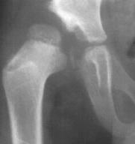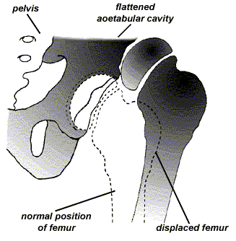

Incidence
• Neonatal instability
♣ At birth 5 -20\1000
♣ At 3wk 1-2 \1000
• female > male 7:1
• Lt > Rt
• Bilateral 1:5
Aetiology
1. Exact cause is unknown.
2. Genetic factor
a. It run in families b. It run in population
3. Hormonal factor.
4. Intra uterin factors
a. Malposition
b. Large baby
c. Oligohydramnios
5. Post-natal factors.
Child at risk
1. Female
2. Breech presentation.
3. Postive family history.
4. Other cong anomilies.
5. First baby.
They need extra care and they need frequent re-examination.
Pathology
1. At birth: The hip normal in shape but the capsule is stretched and
redundant.
2. Infancy
• The head dislocated sup-lat.
• Acetab. is shallow and antev
• Delay app of epiph of head
• The head is anteverted
3. At wt bearing
• intensification of all changes above
• increase antever of head and acetab
• false acetab
• hour-giass app.
Clinical features
Every new born should examine for sign of instability

Neonate | Ortolanis test  Barlows test
Infancy | Symp | - difficult to apply napkins  - asymmetrical skin creases  - click during hip movement  - short limb  - delay walking
Signs | If unilat  - asymmetry  - Short leg  - Missing of head in groin  If bilateral  - wide perineal gab  - Little abduction
walking age | Signs | If unilat: limping  If bilate: wadling gaite

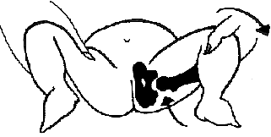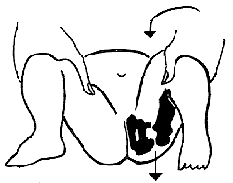

Imaging
1. U/S in the neonatal period. Should done for
• every child at risk and
• every hip with sign of instability
2. X-ray signs
• In neonate → Von rosens line
• In infancy →
♣ Shentons line
♣ Perkins line
♣ Acetabular roof angle
♣ Smal epiphysis
• In child hood → false acetabulum
3. Arthrography
4. C.T SCA

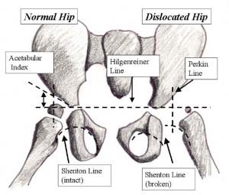
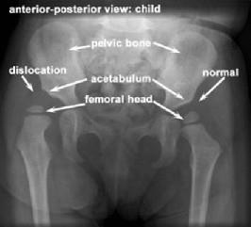

Treatment
first 6 months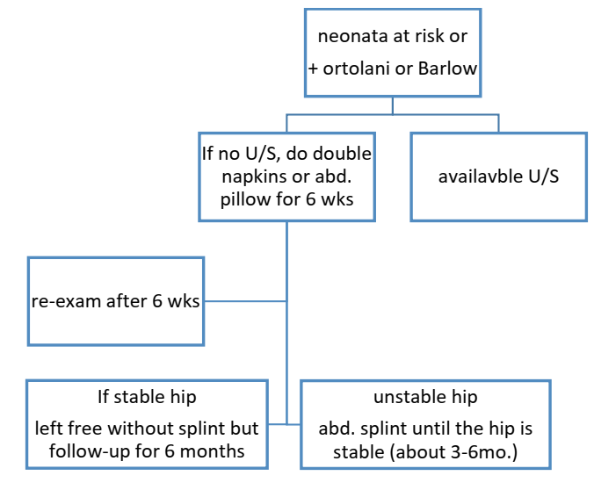
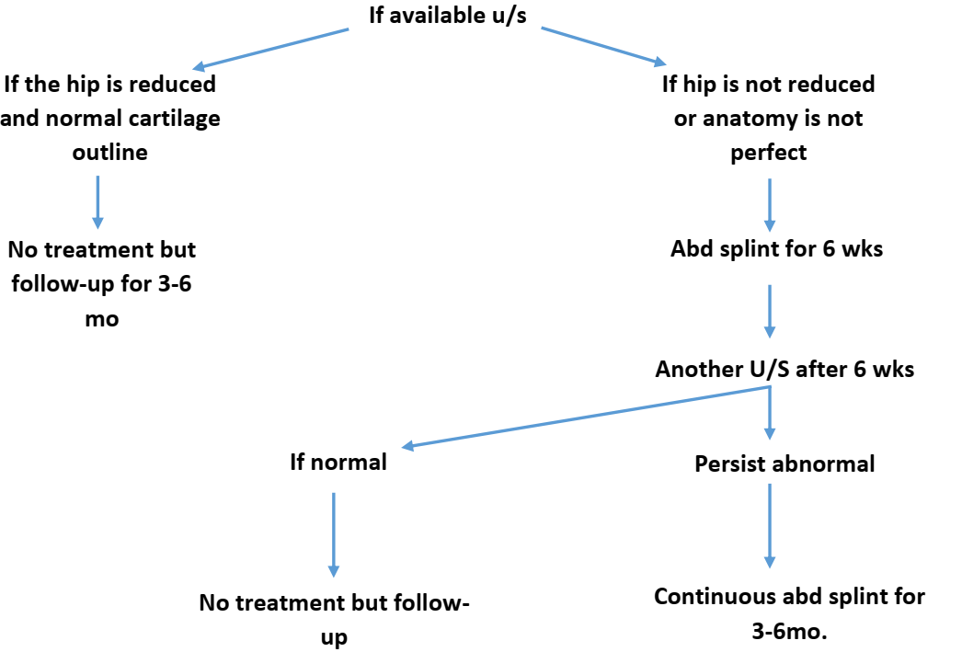
Splintage
Objective: to hold hip flexed and
abducted
Types:
• Pavlik harness
• Vonrosen splint
• Cast splint
Golden rules:
• Proper reduction
• Avoid extreme postion
• Allow slight mov
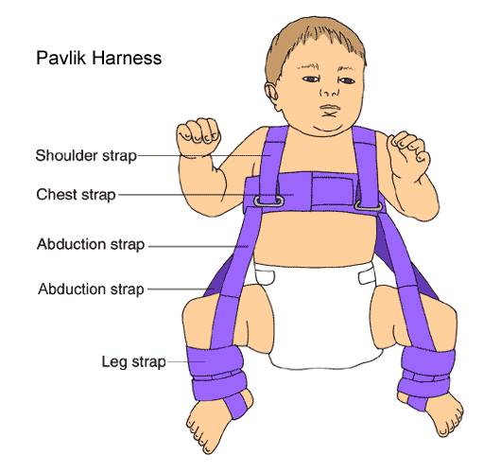

6 – 18 months (missed dislocation)

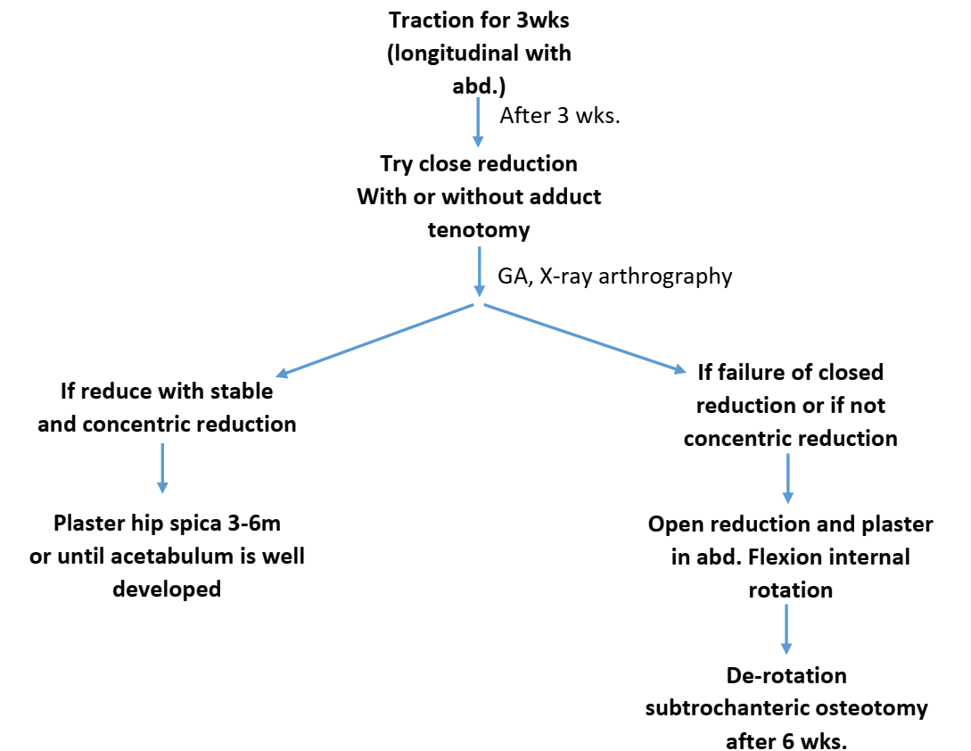

Pt 18m – 4y
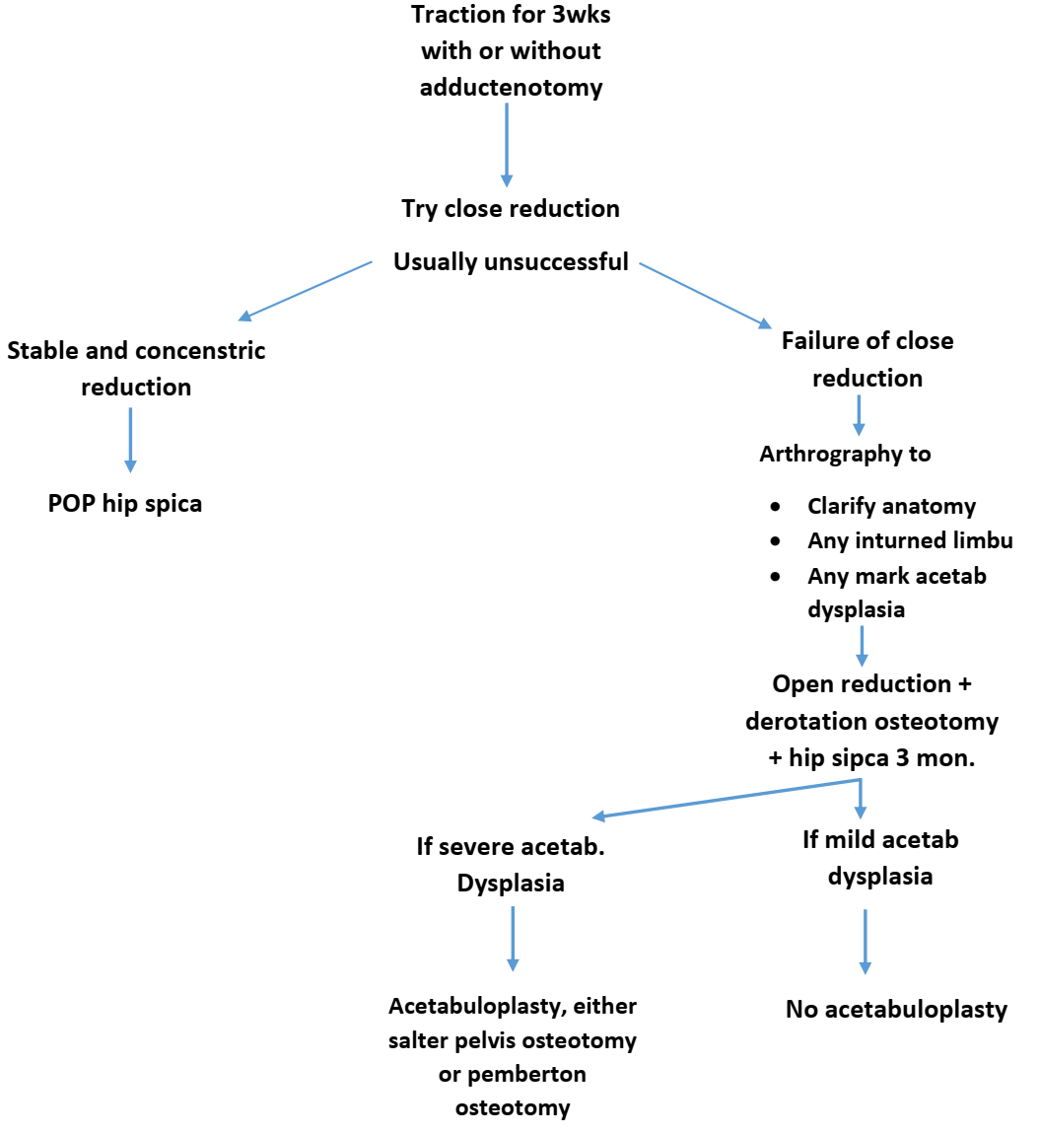

Obstacles for close reduction
1. Redundent capsule
2. Psoas tendon (hour –glass deformity)
3. Hypertrophic lig. Teres.
4. Inverted limbus.
Pt > 4y
• If pt 4-8 y + unilat: OR + derotation osteotomy + acetabuloplasty
• If pt 4-8 y + bilat: no treatment at this time
• If pt > 8y: no treatment

