Objectives:
- To know the technique of breast feeding
- To verify the let-down reflex
- To explain the criteria of adequacy of milk intake.
- To study the stages of lactations
- To learn the technique of expression of human milk
- To explore the methods of storage of human milk
- To discuss the weaning from breast feeding
- To understand the methods of cessation of nursing
Technique of Breast Feeding
Breast feeding should begin as soon after delivery as the condition of the mother and the infant permit.
At feeding time,the infant should be hungry,dry and neither too cold nor too warm.
Infant and the mother should both be comfortable.The baby should be in semi- sitting position to prevent vomiting with eructation. The baby should be supported comfortably with the face held close to the mother breast by one arm and hand, while the other hand supports the breast,with the thumb and index finger above the nipple,making the nipple easily accessible to the baby mouth without obstructing nasal breathing.The baby lip should engage considerable areola as well as nipple.
The infant"latches on" by compressing lips The mechanism of normal suckling include suction of 4-6 cm of areola, compression of the nipple against the palate,stimulation of milk suction by initial rapid non nutritive sucking,and extraction of milk from the lactoferrous sinuses by a slower suck swallow rhythm of approximatelly One per second.

In each feed,it is advisable to nurse from both breasts.some infants empty breasts in 5 min. others need 20 min. for nursing. Most of milk obtaind early in feeding(50% in 1st 2 min and 90% in the 1st 4 min.). At the end of nursing,the baby should be held erect over the mother shoulder with gentle rubbing or patting of the back to assist in expelling swallowed air.
Adequacy of Milk Intake
Note all women experience fullness or the sensation of milk let down reflex despite successful breast feeding. Three possibilities should be excluded before assuming that the mother cannot produce sufficient milk 1- errors in the feeding technique . 2.remediable maternal factors related to diet,rest,or emotional stress 3.physical disturbances of the infant that interfere with nursing or weight gain.
Criteria of Adequacy of milk intake
1. infant sleeps 2-4hr between feeding.
2. infant gains weight adequately.
3. infant voids 6-8 times dialy.
4. passes motion 4-6 per day.
5. presence of symptomatic milk ejection reflex.

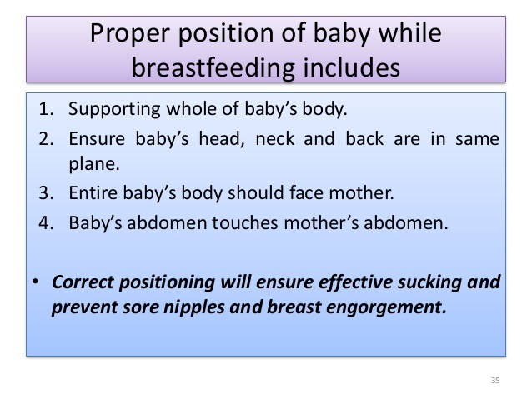
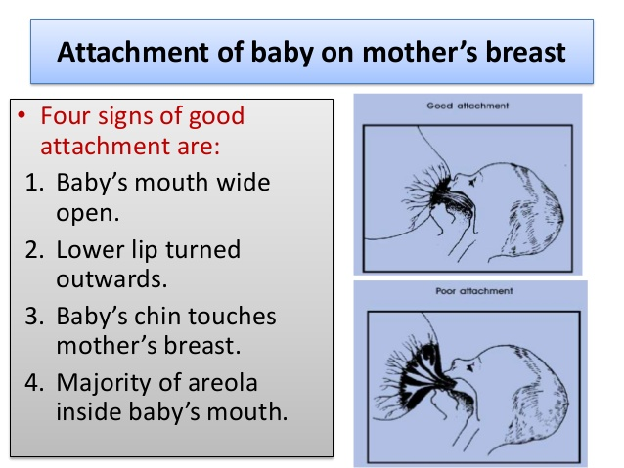

Stages of Lactation
A.Colostrum
It is early milk(0-5)days,yellowish in colour due to high carotene content.It has less carbohydrates & fat than mature milk,but high protein content.Dialy volume 15-50 cc. It is alkaline,S.G.1040-1060.Contain more electrolytes than mature milk.It contains secretary IgA antibodies ,lysozymes,lactoferrin & maternal leucocytes.It contains less calories (67kcal/dl) than mature milk (75kcal/dl).
B.Transitional milk (5-10 days).It's lower in protein in comparison to colostrum.
C.Mature milk volume 850ml/day (600 kcal/day).It's of two types:
Foremilk: The milk that comes at the start of a feed is called foremilk.Foremilk which is watery has low level of fat and is high in lactose sugar,protein,vitamins,minerals and water.It satisfied the baby thirst.
Hindmilk:Hindmilk which comes later in a feed is richer in fat.It satisfies the baby's hunger and supplies more energy than foremilk.Babies who fed fore and hind milk sleepwell and grow healthy.

Expression of Breast Milk a.manual expression . b.hand pump . c.battery-operated pump. d.electric-breast pump.
Advantages:it increases milk production
Uses:
a) relieve engorgement of breasts
b) safely stored to be used later by the mothers who work outside the home.and by the premature babies who had immature swallowing reflexes in the neonatal care units through nasogastric tube.

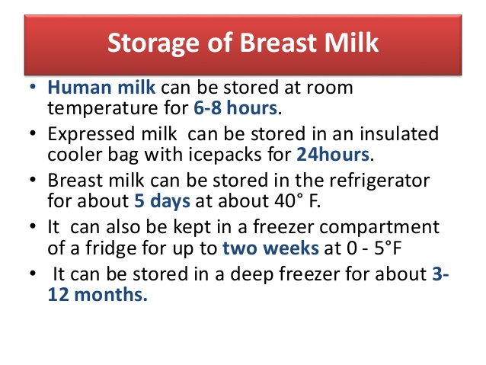

Weaning From Breast Feeding
Is the transition from an all-milk liquid diet to a varied diet using semisolid and solid foods.or Is the process of changing from breast or bottle to spoon,liquid to solid,smooth to texture,warm to a variety of temperatures and milk to a variety of tastes. Solid foods introduced between 4—6 months because breast milk becomes increasingly inadequate. Early introduction of solids is undesirable due to : a.lack of neuromuscular coordination. b.gut motility and maturation unsufficient c.kidneys are not ready for solute load . d.high energy food lead to obesity. E.interference with mineral absorption. f.nutritional requirements are well met.
NB.delayed introduction of solid foods lead to nutritional deficiencies.
From 3—4 months,many babies exihibit behavioral changes eg. increased crying and poor sleeping which may represent hunger and for solid food.
The general signs of readiness for feeding: 1.ability to held head up & sit unsupported . 2.bringing objects to the mouth. 3.showing interests in food . 4.ability to track a spoon & open the mouth.

The introduction of solid food should be gradual and step by step.Introduce one food item at a time.The second item should be added only after the infant has started accepting and tolerating the first food. Non-wheat cereals,good source of iron usually introduced first followed by vegetables and vitamins (high energy) ,then meat and finally eggs. Avoid foods with high allergenic potential (cow milk, eggs, fish, nuts, soybeans( . Avoid added sugar and salt to weaning food. Phytate intake should be low to enhance mineral absorption.
At the proper age,encourage a cup & spoon rather than a bottle. Breast milk should continue to 12 mon.,formula is then substituted.Give no more than 24 oz/day of cow milk. Fluid other than breastmilk,formula,and water should be discouraged.Give no more than 4—6 oz/day of fruit juice.No soda.Vegetarian diet not recommended for first 2 years of life.
Methods of Cessation of Nursing 1.use of a tight breasts binder. 2.application of ice bags. 3.restriction of mother fluid intake. 4.small doses of estrogen for 1-2 days (inhibit prolactin secretion).

Common Breast Feeding Problems 1.sore(tender)nipple causes: a.early prolonged suckling b.poor postioning & tauma s/s pain,abrasions & crackling Rx-exposure of nipples to air,apply pure lanolin,avoiding soap,changing nursing position and keeping breasts dry between feeding.

Decreasing feeding due to sore nipple lead to breast engorgement.

2.Breast Engorgement refers to uncomfortable swelling of the breasts that occurs when regular, effective breast emptying does not take place.
Rx: 1-increase feeding on affected side, 2- warm compresses during feeding
3-Cold compresses between feeding.

3.Mastitis
Term when lactating woman reports fever, chills and malaise
Rx: 1.frequant & compelet emptying of breast. 2-antibiotics.

4.Breast Abscess
Hotness, redness, tenderness, pus discharge, fever & swelling
Rx:1.incision and drainage
2.regular emptying of breast
3.anti-biotics
4.nursing from contralateral breast

