Artificial (Formula) Feeding
Manufacturers change the composition of cow milk
1.The protein and electrolytes of cow milk are reduced.
2.The whey : casein ratio altered to improve protein quality & digestability. 3.The calcium:phosphorus content reduced
4.The CHO.content increased.
5.The fat changed to vegetable oil.
6.Trace minerals,iron,copper added.
7.vitamines are added.
Indications for use of infant formulas
1. as a supplement or substitute for breast milk when the mother cannot or chooses not to breast fed.
2. infants whose mothers are infected with organisms known to be transmittable by human milk (eg.HIV).
3. infants whose mothers are undergoing chemotherapy or receiving cytotoxics.
4.infants whose mothers are receiving drugs excreted into human milk that could harm the baby or drink unsafe levels of alcohol.

5. infants who are unable to tolerate human milk bec. of metabolic disorders (e.g. galactosaemia).
6.infants who are unable to tolerate human milk bec. of metabolic disorders (eg. Galactosaemia)
7.The baby is unable to breastfeed because of birth defects such as cleft lip and palate
8.Rarely due to food allergies,when the mother eat foods that may provoke an allergic reaction to the infant.
Composition of human milk, cow's milk and infant formula (per 100 ml)
 | Mature breast milk | Cow's milk | Infant formula (modified cow's milk
Energy(kcal) | 62 | 67 | 60—65
Protein (g) | 1.3 | 3.5 | 1.5—1.9
Carbohydrate(g) | 6.7 | 4.9 | 7---8.6
Casein:whey | 40:60 | 63:37 | 40:60
Fat (g) | 3 | 3.6 | 2.6—3.8
Sodium(mmol) | 0.65 | 2.3 | 0.65—1.1
Calcium(mmol) | 0.88 | 3 | 0.88—2.1
Phosphorus(mmol) | 0.46 | 3.2 | 0.9—1.8
Iron (µmol) | 1.36 | 0.9 | 8—12.5

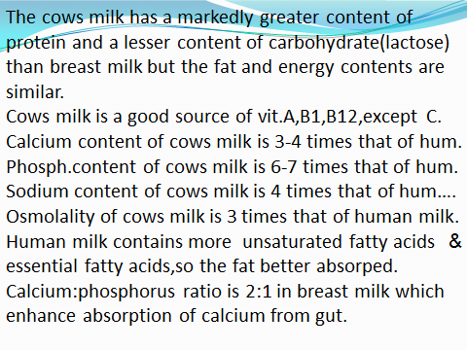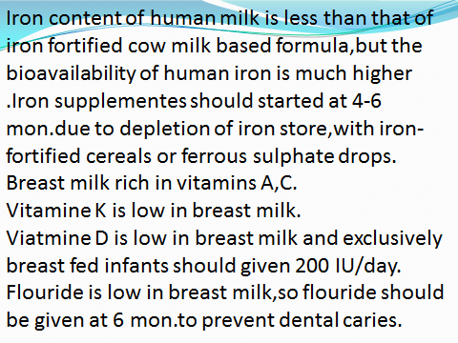
Most infant formulas contain a- protein source(mixture of bovine proteins(Casein and whey are major protein constituents ) or soya protein or hydrolysed protein), b-carbohydrate source( lactose or glucose polymers or sucrose), c-fat source ( mixture of vegetable oils), d-mineral salts, and vitamins
Most formulas are fortified with:
Prebiotics(scGOS(short-chain galacto-oligosaccharides ) /lcFOS(long-chain fructo-oligosaccharides) : stimulate the growth of benificial bifidobacteria and lactobacillus by lowering the PH of gut enviroment, balance immunity and protect from gastroenteritis.
Selenium,vitamines A,E & C as antioxidants.
Vitamine D & Ca to promote bone & teeth development.
Iron & Omega 3 to support brain and nerve tissue development and prevent iron deficiency anemia.
Choline:plays important role in development of brain esp. hippocampusm which plays critical role in memory and learning.
Taurine:involved in the function of the cerebral cortex cerebellum , hippocampus,spinal cord and retinal neurons.
5 Major Nucleotides:important in the regeneration of damaged gut cells and strenghten the immune system.
Long-chain polyunsaturated fatty acids(LCPUFA)

Ordinary milk formula should not be used :
a) for routine feeding of premature and low birth weight.
b) in the dietary management of documented clinical allergic reaction to cow's milk protein &/or soya protein formula.
c) in the routine management of infantile colic.
Pasturized cows milk
Pasturized cow's milk should not be given to infants under 1 year of age and semi-skimmed milk should be avoided in children below 2 years.Other milk products such as yoghurt,cheese may be used from 6 months onwards.
Unmodified Milk ( Raw milk,Door-step milk)
from cows,sheep,goat are unsuitable for feeding infants They are nonhygenic,generate high solute load,have inappropriate Ca:Ph ratio & low in iron and vitamins B₁₂

Types of Milk Formula
1.Cows Milk-Based Formula
Are composed of reconstituted,skimmed cows milk or a mixture of skimmed cows milk and electrolyte-depleted cows milk whey or casein proteins.
The fat used is a mixture of vegetable oils,palm,,coconut , corn,or safflower oils.
The CHO.is lactose & there is lactose free formulas.
The caloric content is 20 kcl/oz (0.67 kcl/ml ) eg.Enfamil, Similac,Novelac, Dovelac, S26,Guigoz ,Dielac, Nactalia,…………and lactose free formulas……………..

2. Soya Protein-Based Formulas
Are alternative when there is intolerance to cow's milk based formulas.
The fat mixture & caloric contents are similar to that of cow's milk-based formula
The CHO are glucose oligomers (smaller molecular weight , corn, starches) and sometimes sucrose.
Eg. Isomil, Prosbee.,………..

Indications of soya protein formulas
1. management of galactosemia.
2. primary & secondary lactose intolerance.
3. vegeterians,not take animal protein formulas.
Side effects of soya formulas
a.protein losing entero pathy in patient with cystic fibrosis.
b.neonatal rickets in premature infants
c.hypothyrodism.
d.phytates diminish iron, calcium ,zinc absorption.

3.Casein-Hydrolysate Formulas (hypoallergenic formulas)
Created by extensively hydrolyzing the cow milk casein ,thereby reducing its Mwt to less than 1250 kda…..
Designed to treat :
A .digestive and absorpative insufficiency. B. protein hypersensitivity (cow milk or soya protein).
Protein is casein hydrolysate supplemented with selected amino acids
The CHO. are glucose oligosacharrides,modified corn starch.
Fat is vegetable oils provides essential fatty acids and medium chain triglycerides.
E.g. Pregestimil, Nutramigen.

4-Special medical formulas
a) Antiregurgitation infant formulas (AR) : designed to help reduce spit-up and regurgitation associated with gastroeseophagal reflux(GFR).They contain thickening agents like(starch,carob bean gum,locust bean gum,soy fiber,cereal ,or rice starch).
b) Anticolic infant formulas (AC):
Contain antispasmodics which help in relieving infantile colic c) Hypoallergic infant formula (HA) d) Lactose free infant formula (LF) e)Anti diarrheal infant formula (AD)
f) Specal formula for prematures g) Specail formulas for inborn error of metabolism

Technique of Formula Feeding
Firstly the mother hands should be washed and clean .The added water should be sterilized by boiling to 100ºc for 10 min.the bottle and teats should be clean as well ,no. of bottles not less than 4,glass type better than plastic type.The nipple hole should be of appropriate size(drips 12-15/min) because too small hole leads to fatigue of the baby,while too large hole leads to chocking or aspiration.
The standard for all being to add 1 level scoop of powder to 1 fluid ounce(30ml) of cooled boiled water (1:1).Each ounce(30ml) of reconstituted milk had 20 kcal.The daily caloric requirement is 110 kcal-120 kcal/day.Average fluid intake is 150-200 ml/day.
The bottle of formula is warmed to body temperature.
The baby head should be supported and raised to prevent regurgitation,the bottle should be tilted so that the teat is always full of milk to avoid air swallowing. The bottle fed infant is demand fed in the same way as breast fed infant.
The technique of"burping" should be the same as described for breast fed infants.

Problems Associated with Artificial Feeding
1..frequent infections due to a)lack of protective factors like IgA ,lysozymes ,macrophages ,lymphocytes b) frequent contamination.
2.hypocalcaemic tetany because phosphorus is high
3.obesity due to over feeding by an anxious and over- zealous mother.
4.higher incidence of cow milk protein allergy,atopic diseases,eczema,bronchitis,caeliac d.,malabsorption
5.higher incidence of regurgitation and colic
6.inadequate weight gain because of:
a.dilution of feeds
b.small nipple hole.
c.frequent infection.
7.infant bottle tooth decay.
8.hypernatreamic dehydration:related to the inability of the immature gut to cope with the renal osmolar load presented by milks of high minerals and protein content under conditions of increased fluid loss such as fever and gastroenteritis.This has been exacerbated in some cases by the improper reconstitution of powdered milks with insufficient water.

