بسم الله الرحمن الرحيم
Lecture 3- Neurophysiology Dr. Noor Jawad
2nd stage
………………………………………………………………
Brain stem
Objectives
1.what is the brain stem? Its function?
2. what is the basal ganglia, its main components?
The brainstem is the posterior part of the brain, adjoining and structurally continuous with the spinal cord. Also the brain stem is a tube-shaped mass of nervous tissue a little over 3 inches (8 cm) long. It is located at the base of the brain, superior to the spinal cord and inferior to the cerebrum.
In the human brain the brainstem includes:
- Midbrain,
- pons, and
- the medulla oblongata.
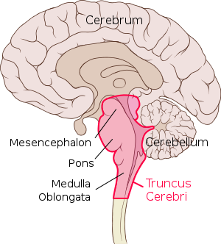
Figure show structure of brainstem

- Superiorly continuous with forebrain.
- Inferiorly continuous with spinal cord .
- Posteriorly pons and medulla is separated by forth ventricle.
The medulla is the inferior-most region of the brain stem that connects the brain to the spinal cord. It is a tube very similar structurally to the spinal cord, but is wider and contains several masses of gray matter internally.
Superior to the medulla is the pons, which is larger and structurally more complex than the medulla.
Finally, the midbrain forms the most superior and most complex region of the brain stem.

Function
There are three main functions of the brainstem:
- The brainstem plays a role in conduction. That is, all information relayed from the body to the cerebrum and cerebellum and vice versa must traverse the brainstem.
- The cranial nerves III-XII emerge from the brainstem. These cranial nerves supply the face, head, and viscera. (The first two pairs of cranial nerves arise from the cerebrum).
- The brainstem has integrative functions being involved in cardiovascular system control, respiratory control, pain sensitivity control, alertness, awareness, and consciousness. Thus, brainstem damage is a very serious and often life-threatening problem

basal ganglia
The basal ganglia (or basal nuclei) is a group of subcortical nuclei, of varied origin, in the brains of vertebrates including humans, which are situated at the base of the forebrain. The basal ganglia, like the cerebellum, constitute another accessory motor system that functions usually not by itself but in close association with the cerebral cortex and corticospinal motor control system. In fact, the basal ganglia receive most of their input signals from the cerebral cortex and also return almost all their output signals back to the cortex.
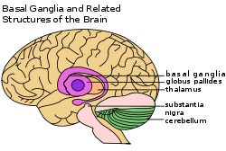

Main components of basal ganglia
Basal ganglia consist of :
The caudate nucleus, putamen, globus pallidus, substantia nigra, and subthalamic nucleus.
They are located mainly lateral to and surrounding the thalamus, occupying a large portion of the interior regions of both cerebral hemispheres.
Almost all motor and sensory nerve fibers connecting the cerebral cortex and spinal cord pass through the space that lies between the major masses of the basal ganglia, the caudate nucleus and the putamen. This space is called the internal capsule of the brain. It is important because of the intimate association between the basal ganglia and the corticospinal system for motor control.

FUNCTION OF THE BASAL GANGLIA IN EXECUTING PATTERNS OF MOTOR ACTIVITY
One of the principal roles of the basal ganglia in motor control is to function in association with the corticospinal system to control complex patterns of motor activity. An example is the writing of letters of the alphabet. When the basal ganglia sustain serious damage, the cortical system of motor control can no longer provide these patterns. Instead, one’s writing becomes crude, as if one were learning how to write for the first time.

Other patterns that require the basal ganglia are cutting paper with scissors, hammering nails, shooting a basketball through a hoop, passing a football, throwing a baseball, the movements of shoveling dirt, most aspects of vocalization, controlled movements of the eyes, and virtually any other of our skilled movements, most of them perform subconsciously.

ROLE OF THE BASAL GANGLIA FOR COGNITIVE CONTROL OF SEQUENCES OF MOTOR PATTERNS—THE CAUDATE CIRCUIT
The term cognition means the thinking processes of the brain, using both sensory input to the brain plus information already stored in memory. Most of our motor actions occur as a consequence of thoughts generated in the mind, a process called cognitive control of motor activity. The caudate nucleus plays a major role in this cognitive control of motor activity.
After the signals pass from the cerebral cortex to the caudate nucleus, they are transmitted to the internal globus pallidus, then to the relay nuclei of the ventroanterior and ventrolateral thalamus, and finally back to the prefrontal, premotor, and supplementary motor areas of the cerebral cortex, but with almost none of the returning signals passing directly to the primary motor cortex.

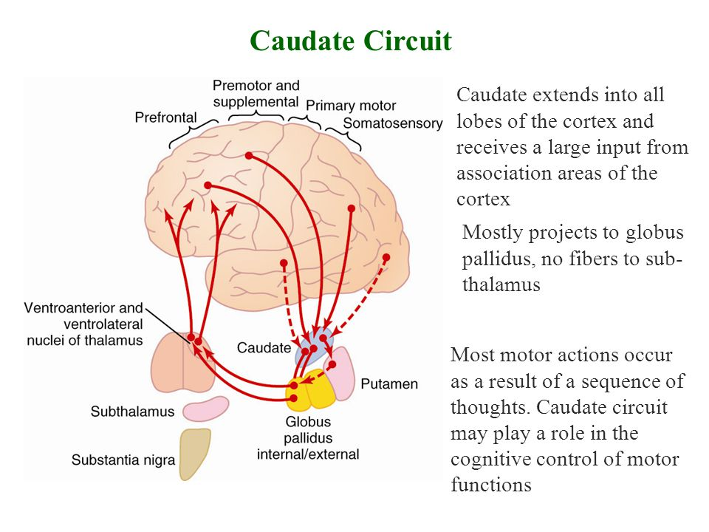
Instead, the returning signals go to the accessory motor regions in the premotor and supplementary motor areas that are concerned with putting together sequential patterns of movement lasting 5 or more seconds instead of exciting individual muscle movements.

FUNCTION OF THE BASAL GANGLIA TO CHANGE THE TIMING AND TO SCALE THE INTENSITY OF MOVEMENTS
Two important capabilities of the brain in controlling movement are to (1) determine how rapidly the movement is to be performed and (2) control how large the movement will be. For instance, a person may write the letter “a” slowly or rapidly. Also, he or she may write a small “a” on a piece of paper or a large “A” on a chalkboard. Regardless of the choice, the proportional characteristics of the letter remain nearly the same.

BASAL GANGLIA FUNCTION
The basal ganglia and related nuclei are characterized as one of three types of nuclei. Input nuclei receive signals from various sources in the brain. Output nuclei send signals from the basal ganglia to the thalamus. Intrinsic nuclei relay nerve signals and information between the input nuclei and output nuclei. The basal ganglia receive information from the cerebral cortex and thalamus through input nuclei. After the information has been processed, it is passed along to intrinsic nuclei and sent to output nuclei. From the output nuclei, the information is sent to the thalamus. The thalamus passes the information on to the cerebral cortex.

- CORPUS STRATIUM
The corpus stratium is the largest group of basal ganglia nuclei.
It consists of the caudate nucleus, putamen and the globus pallidus. The caudate nucleus, putamen are input nuclei, while the globus pallidus is considered output nuclei. The corpus stratium uses and stores the neurotransmitter dopamine and is involved in the reward circuit of the brain.

Caudate Nucleus - these C-shaped paired nuclei (one in each hemisphere) are located primarily in the frontal lobe region of the brain. The caudate nucleus is involved in motor processing and planning. It is also involved in memory storage (unconscious and long-term), associative and procedural learning, inhibitory control, decision making, and planning.
- Putamen - these large rounded nuclei (one in each hemisphere) are located in the forebrain and along with the caudate nucleus form the dorsal stratium. The putamen is connected to the caudate nucleus at the head region of the caudate. The putamen is involved in voluntary and involuntary motor control.
- Globus Pallidus - these paired nuclei (one in each hemisphere) are located near the caudate nucleus and putamen. The globus pallidus is divided into internal and external segments and acts as one of the major output nuclei of the basal ganglia. It sends information from basal ganglia nuclei to the thalamus. The internal segments of the pallidus send the majority of output to the thalamus via the neurotransmitter gamma-aminobutyric acid (GABA). GABA has an inhibitory effect on motor function. The globus pallidus is involved in the regulation of voluntary movement.

BASAL GANGLIA: RELATED NUCLEI
Subthalamic Nucleus - these small paired nuclei located just below the thalamus. Subthalamic nuclei receive excitatory inputs from the cerebral cortex and have excitatory connections to the globus pallidus and substantia nigra. Subthalamic nuclei have both input and output connections to the caudate nucleus, putamen, and substantia nigra. The subthalamic nucleus plays a major role in voluntary and involuntary movement. It is also involved in associative learning and limbic functions. Subthalamic nuclei have connections with the limbic system through connections with the cingulate gyrus and nucleus accumbens.
Substantia Nigra - this large mass of nuclei is located in the midbrain and is also a component of the brainstem. The substantia nigra serves numerous functions including controlling voluntary movement, regulating mood, learning, and activity related to the brain's reward circuit
Thank you

References : Guyton and Hall textbook of medical physiology, thirteen edition

