**Biochemistry**

**2nd stage**

**Dr.Lamees Majid Al-Janabi**

**CHOLESTROL METABOLISM**

Cholesterol is the most abundant sterol in humans and performs a number of essential functions in the body. For example, cholesterol is a structural component of all cell membranes, cholesterol is a precursor of bile acids, steroid hormones, and vitamin D.

The liver plays a central role in the regulation of the body's cholesterol homeostasis.

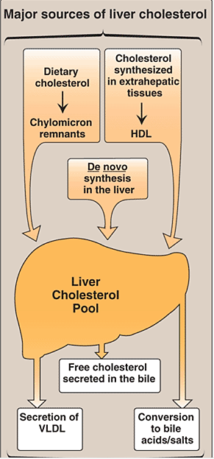

**Synthesis of Cholesterol:-**

Cholesterol is synthesized by virtually all tissues in humans, although liver, intestine, adrenal cortex, and reproductive tissues, including ovaries, testes, and placenta, make the largest contributions to the body's cholesterol pool. Synthesis occurs in the cytoplasm, with enzymes in both the cytosol and the membrane of the endoplasmic reticulum.

Cholesterol biosynthesis may be divided into **five steps** :

**1- Synthesis of mevalonate**

The first two reactions in the cholesterol synthetic pathway are similar to those in the pathway that produces ketone bodies. They result in the production of HMG CoA.

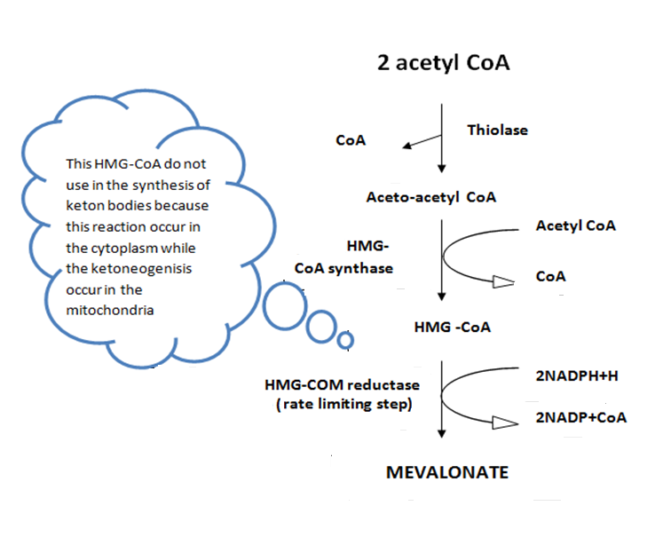

**2- formation of isoprenoid (5C) :**

Isoprenoid unit formed from mevalonate in several steps, need 3ATP and loss one carbon as Co2 .

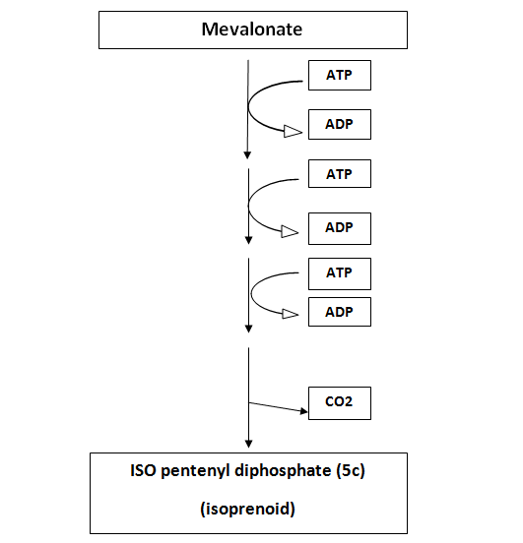

**3- formation of squalene (30c):**

6 isoprenoid units condense to form squalene:

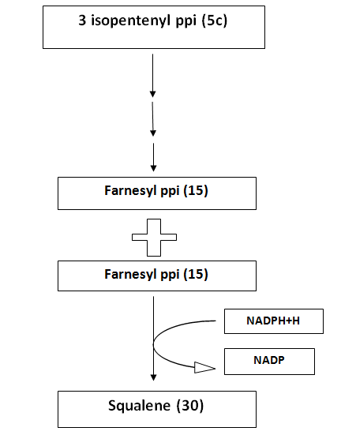

**4- formation of lanosterol (30c)**

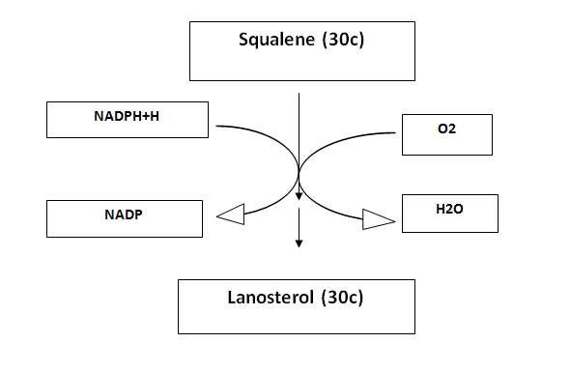

**5- formation of the cholesterol (27c):**

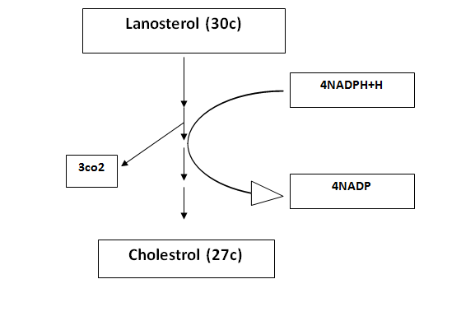

**Regulation of cholesterol synthesis:-**

HMG CoA reductase, the rate-limiting enzyme, is the major control point for cholesterol biosynthesis, and is subject to different kinds of metabolic control.

1. ***Sterol-dependent regulation of gene expression:***Expression of the HMG CoA reductase gene is controlled by the transcription factor. When sterol levels in the cell are low, this lead to increase the concentration of transcription factor. This results in increased synthesis of HMG CoA reductase and, therefore, increased cholesterol synthesis.
2. ***Hormonal regulation:*** The amount (and, therefore, the activity) of HMG CoA reductase is controlled hormonally. An increase in insulin favors up-regulation of the expression of the HMG CoA reductase gene. Glucagon has the opposite effect.
3. ***Sterol-independent phosphorylation/dephosphorylation:***HMG CoA reductase activity is controlled covalently through the actions of adenosine monophosphate (AMP)–activated protein kinase (AMPK),The phosphorylated form of the enzyme is inactive, whereas the dephosphorylated form is active.

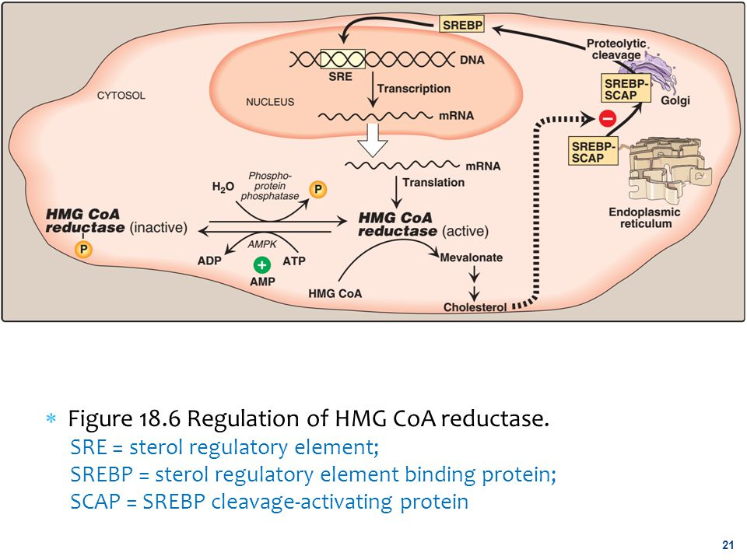

1. ***Inhibition by drugs:*** The statin drugs (atorvastatin, fluvastatin, lovastatin, pravastatin, rosuvastatin, and simvastatin) are structural analogs of HMG CoA, and are (or are metabolized to) reversible, competitive inhibitors of HMG CoA reductase. They are used to decrease plasma cholesterol levels in patients with hypercholesterolemia.

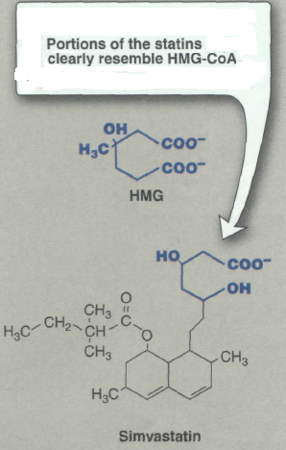

**Degradation of Cholesterol**

The ring structure of cholesterol cannot be metabolized to CO2 and H2O in humans. Rather, the intact sterol nucleus is eliminated from the body by conversion to bile acids and bile salts, which are excreted in the feces, and by secretion of cholesterol into the bile, which transports it to the intestine for elimination.

