Biochemistry
2nd stage
Dr.Lamees Majid Al-Janabi
Plasma Lipoproteins
The plasma lipoproteins are spherical macromolecular complexes of lipids and specific proteins (apolipoproteins or apoproteins).
In humans, the transport system is less perfect than in other animals and, as a result, humans experience a gradual deposition of lipid—especially cholesterol—in tissues. This is a potentially life-threatening occurrence when the lipid deposition contributes to plaque formation, causing the narrowing of blood vessels (atherosclerosis).

Classification of the Lipoproteins:
Numerous types of lipoproteins are present in the plasma; however, we have two principle modes of classification:
- Electrophoresis: Depending on the charge of the lipoproteins.
- Ultra-centrifugation: Depending on the density of the lipoproteins.
1. Electrophoresis:
This type of classification depends on the electrical charge of the lipoproteins. As we know, the lipids are usually neutral, so this classification depends on the charge of the proteins and phosphate molecules in the lipoproteins.
At pH 8.6 , the lipoproteins particles usually carry a negative charge, so they will move toward the positive side; So we get different band of LP according to their charge.
1. Chylomicrons.
2. Beta Lipoprotein (β LP).
3. Pre-beta Lipoprotein (pre-β LP).
4. Alpha Lipoprotein (α1 LP).

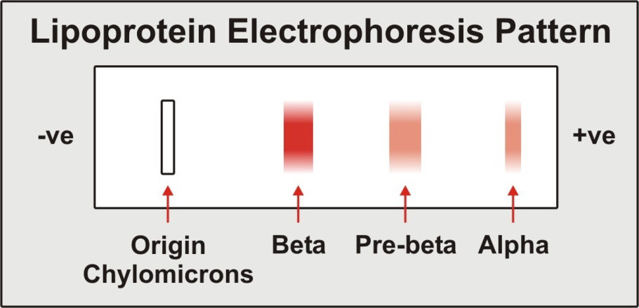

2. Ultra-centrifugation:
This type of classification is also known as density fractionation . It depends on the density of the lipoproteins and these lipoproteins can be divided into four types depending on their density through ultra-centrifugation.
Lipids have low density, while proteins have high density; therefore, the more lipids (less proteins) in the lipoprotein means the lower density, while the more proteins (less lipids) means higher density. i.e.The density of lipoproteins is inversely proportional to the lipids contents, while it is directly proportional to the proteins contents in each type of lipoproteins.
Four (or may be five) types of lipoproteins could be seen in the centrifuge tube:
1. Chylomicrons.
2. Very Low Density Lipoprotein (VLDL or pre-β).
3. Low Density Lipoprotein (LDL or β).
4. High density Lipoprotein (HDL or α).
Note: Sometimes, a fifth type could be detected between the VLDL and LDL known as Intermediate Density Lipoprotein ( IDL ) .

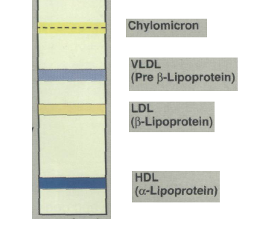

The Composition of the Lipoproteins
Lipoproteins are composed of a neutral lipid core (containing triacylglycerol, and cholesteryl esters) surrounded by a shell of amphipathic apolipoproteins, phospholipid, and nonesterified cholesterol. These amphipathic compounds are oriented so that their polar portions are exposed on the surface of the lipoprotein, thus making the particle soluble in aqueous solution.
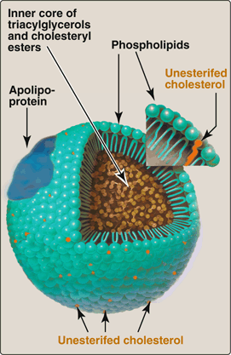
Structure of a typical lipoprotein particle

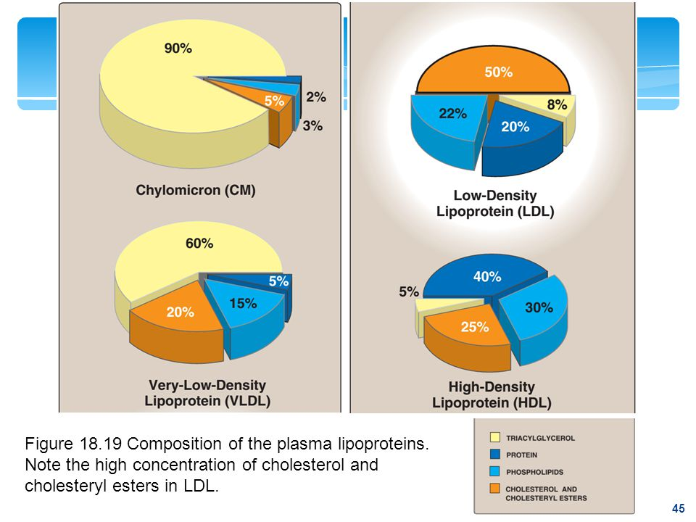

Lipoproteins Functions:
1. Chylomicrons : Their main function is carrying and transport of exogenous (dietary) triglyceride, but to a lesser extent cholesterol, fat soluble vitamins, and other lipids also transported by chylomicrons from the intestine to the systemic circulation.
2. VLDL : Their main function is the transport of endogenous triglyceride from the liver to the peripheral tissues.
3. LDL : Their main function is the transport of cholesterol to the peripheral tissue, but they also have a role in the transport of the phospholipids.
4. HDL :
- Reservoir of apo-proteins (mainly C and E) which are required in the metabolism of VLDL and chylomicrons.
- The uptake of the un-esterified cholesterol from the other lipoproteins and from the cell membranes.
- Esterification of the un-esterified cholesterol by the action of LCAT enzyme (Lecithin-Cholesterol Acyl Transferase).
- Reveres cholesterol transport (from the peripheral tissue to the liver).

The Functions of Apo-proteins
1. Physical Function: promote the solubility of lipoproteins particles in the plasma.
2. Regulatory Function: Lipoproteins have a role in the control of the lipid metabolism by :
A ) Providing a recognition site for the cell surface receptors.
Ex1: Apo-B (which is the major apoprotein of LDL) plays an important role in the uptake of cholesterol from LDL as most tissues posses cell surface receptors that recognize Apo-B
Ex2: Apo-E is probably involved in the hepatic uptake of the chylomicrons remnants .
B )) Activation of enzymes involved in lipoproteins metabolism. (Ex1: Apo-AI is an important activator of LCAT) (Ex2: Apo-CII is an activator of LPL).
Enzymes Involved in Lipid Transport
1. LCAT (Lecithin-Cholesterol Acyl Transferase) :
This enzyme is synthesized in the liver and it binds to nascent HDL. It is stimulated by Apo-AI. The reaction which is catalyzed by this enzyme produces cholesterol ester which is more hydrophobic and it is sequestered in the core of HDL .
2. LPL ( Lipoprotein Lipase ) :
It is an extracellular enzyme anchored by heparan-sulphate to the capillary endothelium of most tissues, but predominantly in adipose tissue, cardiac, and skeletal muscles.LPL is stimulated by Apo-CII on circulating LP particles and catalyzes the hydrolysis of triglycerides in the in chylomicrons and VLDL into glycerol and three molecules of fatty acids.

3. Hepatic Lipase :
The action of this enzyme is similar to that of the LPL, but it seems to be more effective on the triglycerides that present in smaller particles (such as TG in VLDL remnants).
4. Tissue Lipase
( Hormone Sensitive Lipase or Mobilizing Lipase )
It is present in the adipose tissue. This enzyme is inhibited by insulin , while it is stimulated by many hormones ( like epinephrine, nor-epinephrine, ACTH..... etc ) . It acts on the triglycerides present in the adipose tissue. It control the rate of release of fatty acids from the adipose tissue to the plasma.
It is activated by phosphorylation mediated by cAMP dependent protein kinase and deactivated by dephosphorylation.

Metabolism of Lipoproteins
Chylomicrons
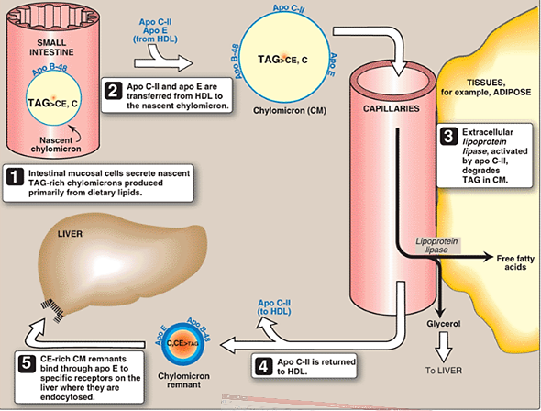

VLDL and LDL Metabolism
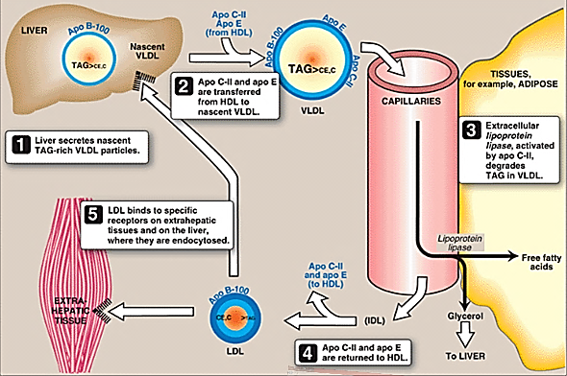

The Metabolism of HDL
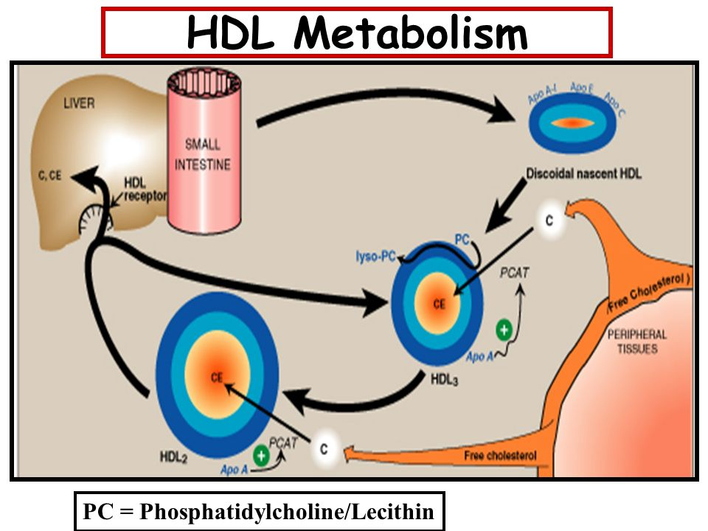
N.B PC = phosphatidylcholine; lyso-PC = lysophosphatidylcholine. PCAT = Phosphatidylcholine cholesterol transferase. CETP = cholesteryl ester transfer protein. ABCA1 = transport protein. [Note: For convenience the size of VLDLs are shown smaller than HDL, whereas VLDLs are larger than HDL.]

