بسم الله الرحمن الرحيم
Lecture 9 - Neurophysioloy Dr. Noor
2stage /2018
Limbic System
Objective:
- Functional Anatomy of the Limbic System?
- Behavioral Functions of the Hypothalamus and Associated Limbic Structures?
The limbic system is a complex set of structures that lies on both sides of the thalamus, just under the cerebrum. It includes the hypothalamus, the hippocampus, the amygdala, and several other nearby areas. The word “limbic” means “border.” Originally, the term “limbic” was used to describe the border structures around the basal regions of the cerebrum, term limbic system has been expanded to mean the entire neuronal circuitry that controls emotional behavior and motivational drives.
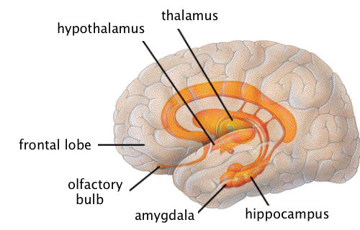
A major Part of the limbic system is the hypothalamus, with its related structures. In addition to their roles in behavioral control, these areas control many internal conditions of the body, such as body temperature, osmolality of the body fluids, and the drives to eat and drink and to control body weight. These internal functions are collectively called vegetative functions of the brain, and their control is closely related to behavior.
Functional Anatomy of the Limbic System
Hypothalamus
The hypothalamus is a small part of the brain located just below the thalamus on both sides of the third ventricle. (The ventricles are areas within the cerebrum that are filled with cerebrospinal fluid, and connect to the fluid in the spine.) It sits just inside the two tracts of the optic nerve, and just above (and intimately connected with) the pituitary gland.
The hypothalamus is one of the busiest parts of the brain, and is mainly concerned with homeostasis. Homeostasis is the process of returning something to some “set point.” It works like a thermostat: When your room gets too cold, the thermostat conveys that information to the furnace and turns it on. As your room warms up and the temperature gets beyond a certain point, it sends a signal that tells the furnace to turn off.
The hypothalamus is responsible for regulating your hunger, thirst, response to pain, levels of pleasure, sexual satisfaction, anger and aggressive behavior, and more. It also regulates the functioning of the autonomic nervous system , which in turn means it regulates things like pulse, blood pressure, breathing, and arousal in response to emotional circumstances.
The hypothalamus receives inputs from a number of sources. From the vagus nerve, it gets information about blood pressure and the distension of the gut (that is, how full your stomach is). From the reticular formation in the brainstem, it gets information about skin temperature. From the optic nerve, it gets information about light and darkness. From unusual neurons lining the ventricles, it gets information about the contents of the cerebrospinal fluid, including toxins that lead to vomiting. And from the other parts of the limbic system and the olfactory (smell) nerves, it gets information that helps regulate eating and sexuality. The hypothalamus also has some receptors of its own, that provide information about ion balance and temperature of the blood.
The other way the hypothalamus controls things is via the pituitary gland. It is neurally and chemically connected to the pituitary, which in turn pumps hormones called releasing factors into the bloodstream. As you know, the pituitary is the so-called “master gland,” and these hormones are vitally important in regulating growth and metabolism.
Hippocampus
The hippocampus consists of two “horns” that curve back from the amygdala. It appears to be very important in converting things that are “in your mind” at the moment (in short-term memory) into things that you will remember for the long run (long-term memory).
If the hippocampus is damaged, a person cannot build new memories, and lives instead in a strange world where everything they experience just fades away, even while older memories from the time before the damage are untouched! .
As in other limbic structures, stimulation of different areas in the hippocampus can cause almost any of the different behavioral patterns such as pleasure, rage, passivity, or excess sex drive.
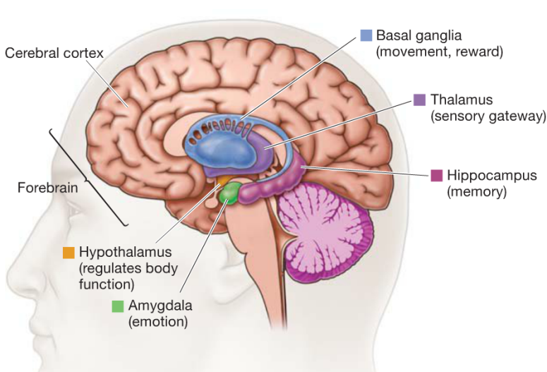

Another feature of the hippocampus is that it can become hyperexcitable. For instance, weak electrical stimuli can cause focal epileptic seizures in small areas of the hippocampi. These often persist for many seconds after the stimulation is over, suggesting that the hippocampi can perhaps give off prolonged output signals even under normal functioning conditions.
Amygdala
The amygdalas are two almond-shaped masses of neurons on either side of the thalamus at the lower end of the hippocampus. When it is stimulated electrically, animals respond with aggression. And if the amygdala is removed, animals get very tame and no longer respond to things that would have caused rage before. But there is more to it than just anger: When removed, animals also become indifferent to stimuli that would have otherwise have caused fear and even sexual responses
.
Behavioral Functions of the Hypothalamus and Associated Limbic Structures
Effects Caused by Stimulation.
In addition to the vegetative and endocrine functions of the hypothalamus, stimulation of or lesions in the hypothalamus often have profound effects on emotional behavior of animals and human beings.

In animals, some of the behavioral effects of stimulation are the following:
1. Stimulation in the lateral hypothalamus not only causes thirst and eating, , but also increases the general level of activity of the animal, sometimes leading to overt rage and fighting,.
2. Stimulation in the ventromedial nucleus and surrounding areas mainly causes effects opposite to those caused by lateral hypothalamic stimulation—that is, a sense of satiety, decreased eating, and tranquility.
3. Stimulation of a thin zone of periventricular nuclei, located immediately adjacent to the third ventricle (or also stimulation of the central gray area of the mesencephalon that is continuous with this portion of the hypothalamus), usually leads to fear and punishment reactions.
4. Sexual drive can be stimulated from several areas of the hypothalamus, especially the most anterior and most posterior portions of thehypothalamus.
Effects Caused by Hypothalamic Lesions.
Lesions in the hypothalamus, in general, cause effects opposite to those caused by stimulation. For instance:
1. Bilateral lesions in the lateral hypothalamus will decrease drinking and eating almost to zero, often leading to lethal starvation. These lesions cause
extreme passivity of the animal as well, with loss of most of its overt drives.
2. Bilateral lesions of the ventromedial areas of the hypothalamus cause effects that are mainly opposite to those caused by lesions of the lateral hypothalamus: excessive drinking and eating as well as hyperactivity and often continuous savagery along with frequent bouts of extreme rage on the slightest provocation. Stimulation or lesions in other regions of the limbic system, especially in the amygdala, the septal area, and areas in the mesencephalon, often cause effects similar to those elicited from the hypothalamus.
“Reward” and “Punishment” Function of the Limbic System
From the discussion thus far, it is already clear that several limbic structures are particularly concerned with the affective nature of sensory sensations—that is, whether the sensations are pleasant or unpleasant.
These affective qualities are also called reward or punishment, or satisfaction or aversion. Electrical stimulation of certain limbic areas pleases or satisfies the animal, whereas electrical stimulation of other regions causes terror, pain, fear, defense, escape reactions, and all the other elements of punishment. The degrees of stimulation of these two oppositely responding systems greatly affect the behavior of the animal.
The major reward centers have been found to be located along the course of the medial forebrain bundle, especially in the lateral and ventromedial nuclei of the hypothalamus. While the punishment centers of the brain, located especially in the periventricular zone of the hypothalamus and in the lateral hypothalamus
Importance of Reward or Punishment in Learning and Memory—Habituation Versus Reinforcement
Animal experiments have shown that a sensory experience that causes neither reward nor punishment is hardly remembered at all. Electrical recordings from the brain show that a newly experienced sensory stimulus almost always excites multiple areas in the cerebral cortex.
But, if the sensory experience does not elicit a sense of either reward or punishment, repetition of the stimulus over and over leads to almost complete extinction of the cerebral cortical response.That is, the animal becomes habituated to that specific sensory stimulus and thereafter ignores it.

If the stimulus does cause either reward or punishment rather than indifference, the cerebral cortical response becomes progressively more and more intense during repeated stimulation instead of fading away, and the response is said to be reinforced. An animal builds up strong memory traces for sensations that are either rewarding or punishing but, conversely, develops complete habituation to indifferent sensory stimuli.
It is evident that the reward and punishment centers of the limbic system have much to do with selecting the information that we learn, usually throwing away more than 99 per cent of it and selecting less than 1 per cent for retention.

References : Guyton and Hall textbook of medical physiology, thirteen edition

