**Lec.7**

**Coll. Medicine \3rd stage**

**Parasitology**

**Assist. Prof. Dr. Amal KH. KH.**

**Intestinal sporozoa**

***Cryptosporidium* *parvum* :**

*Cryptosporidium* is a coccidian ,which causes infection of the intestinal tract, particularly the small intestinal tract . *Cryptosporidium parvum* is the species known to cause infection in man. The first description of infection in man was reported in a three year old healthy girl in USA as late as 1976. Since then, the infection has been frequently diagnosed in patients with acquired immune deficiency syndrome (AIDS) and others receiving immuno-suppressive therapy.

**Morphology :**

The parasite shows six distinct morphological forms during its life cycle: **oocyst, sporozoite, trophozoite, meront, microgamont, and macrogamont.**

***1- Oocyst* :** *Cryptosporidium* oocyst is the smallest coccidian known to cause infection in man. It is colourless, spherical to oval and measures 4.5 to 6 μm in diameter. It does not stain with iodine and is acid-fast. The cyst is surrounded by thin cyst wall. Each oocyst contains up to four slender bow-shaped sporozoites and many small granules. The oocysts are excreted in small numbers in the faeces. The number of oocysts excreted bears no relationship with the severity of illness. The oocysts which sporulate inside the host are of two types: **Thick-walled and Thin-walled.** The thick-walled sporulating oocysts are infectious to susceptible human hosts, whereas thin-walled oocysts always cause autoinfection in the same host only.



***2- Sporozoite* :** The sporozoite is slender, crescent-shaped and measures 1.5 to 1.75 μm in diameter. The anterior end is pointed but the posterior end that contains a prominent nucleus is rounded. The sporozoites numbering four remain always parallel to each other within an oocyst , with apical complex and are released only after partial digestion of the oocyst.

**3-Trophozoite:** It is the intracellular transitional form of the parasite. It is round or oval and measures 2 to 2.5 μ m in diameter. Each trophozoite consists of a large nucleus (1 to 1.3μm in diameter) with or without a conspicuous nucleolus .Unlike in the sporozoites and merozoites, the apical complex is not present in the trophozoite.

**4- Meront :** It is of two types: type I and type Il meronts. These two forms morphologically are indistinguishable form each other. They are crescent-shaped and measure 1 to 5μm in diameter showing rounded anterior and posterior ends .

**5- Microgamont *:***Microgamonts are the male sexual forms. These are wedge-shaped, 0.2 to 0.7 μm in length and are covered by a double layered membrane. Each microgamont contains a large compact nucleus and a polar ring. A single microgamont gives 1 to 4 microgametocytes.

**6- Macrogamont *:*** Macrogamonts are the female sexual forms. These are spherical, measure 3 to 5 μm and are covered by a double layer membrane. Each macrogamont consists of a single large nucleus and endoplasmic reticulum. The old macrogamonts characteristically contain dense polysaccharide granules.





**Life cycle :**

*C*. *parvum* has a simple life cycle . the infective form of the parasite is oocyst . Humans are infected by peroral ingestion of infective oocysts. Cryptosporidium completes its life cycle through the stages of asexual generation (schizogony) and sexual generation (gametogony) in a single host .All these stages of the parasite are truly intracellular and are being surrounded by a host cell membrane, which is extra-cytoplasmic. Man acquires infection on ingestion of food or drink contaminated with the faeces, containing sporulated thick-walled oocysts of C'ryptosporidium. On ingestion, the infective sporozoites after being released from the oocysts in the small intestine, invade the epithelial cells in which they parasitise. Inside the epithelial cells, the sporozoites subsequently differentiate into intracellular trophozoites. These trophozoites multiply asexually by nuclear division to produce two types of meronts, type I and type II . Each type I meront produces six to eight type I merozoites, which develop into type II meronts. These in turn produce four merozoites each, which are known as type II merozoites. Some of the type II merozoites invade new host ceils and initiate sexual replication (gametogony). Inside the host cells, they differentiate either into female (macrogamont) or male (microgametocyte) forms. Each microgametocyte produces 16 sperm-like microgametes, which fertilize the macrogamonts resulting in the formation of oocysts (zygote). Four sporozoites are formed inside each oocyst *in situ.* The sporulating oocysts are of two types, thin or thick-walled. The thin-walled oocysts release the sporozoites inside the lumen of the intestine and cause auto- infection in the same host by repeating the cycle of schizogony and gametogony. The thick-walled oocysts excreted in the faeces are infective to other human hosts. The cysts under favourable conditions remain viable and infectious relatively for a long time. These cysts, when taken up by other susceptible human hosts, cause infection and the cycle are repeated.

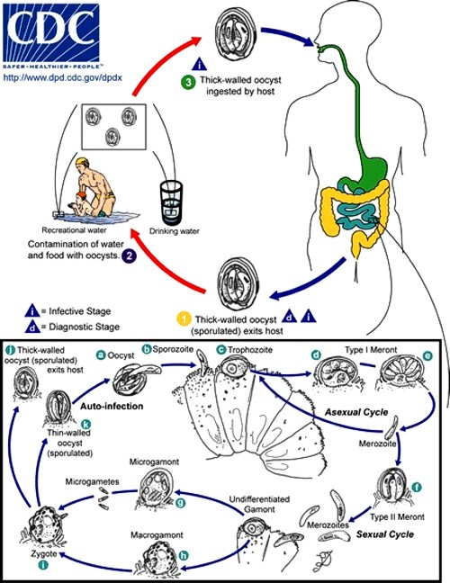

**Pathology and clinical features :**

Infection begins with the firm attachment of *Cryptosporidium* to the mucosal surface of the intestine followed by invasion of epithelial cells. The specific mechanism by which the parasite causes illness in man is not known but cause cholera-like voluminous watery diarrhea, Reduction in the mucosal surface and decrease in the mucosal enzymes frequently seen in this condition also may contribute to pathophysiology of osmotic diarrhea by lowering the absorbing capacity of the small intestine.

Bacterial fermentation of sugars and fatty acids of the unabsorbed nutrients present in the lumen of the intestine, cause offensive and foul smelling stool, characteristically seen in *Cryptosporidium* diarrhea. *Cryptosporidium* is found attached to tile brush border of the small intestine particularly the jejunum . In the immunocompromised hosts, the parasites are also found in the uncommon sites such as pharynx, oesophagus, stomach, gall bladder, ileum, colon or rectum. Incubation period ranges from 2 to 14 days. The prepatent period (time between infection and oocysts shedding) ranges from 5 to 21 days in man. The patent period (duration of oocysts shedding) may last for more than 30 days in an immunocompetent host. The clinical manifestations of *Cryptosporidium* infection vary depending upon the immune status of the host and the symptoms that accompany diarrhea are abdominal cramps , weight loss , flatulence and malaise.

**Diagnosis :**

In *C . parvum* diarrhea feces show oocysts . The oocysts are difficult to visualize in unstained wet preparation . So used Modified Ziehl-Neelson stain readily identifies *C. parvum* oocysts. The four sporozoites present in oocysts are difficult to visualize by the above mentioned methods .So staining with other stains to visualize them .

* Concentration techniques are useful when *C. parvum* oocysts are not seen even examining three fecal smears .
* Intestinal biopsy and enterotest are useful to demonstration the oocysts .

**Treatment :**

The only drug with efficacy against *Cryptosporidium* is Nitazoxanide. management of patients include supportive care with fluids and electrolyte replacement is require .

**Prevention and control :**

* Hygienic precautions when handling oocysts excreters (humans, animals) and diagnostic specimens.
* Improvement of community drinking water processing in some areas. The oocysts are resistant to the standard concentrations of chlorine or ozone in drinking water, but can be killed by heat (>70 Cᵒ) in a few minutes.

***Isospora belli:***

This parasite occurs throughout the world. It is more common in tropical and sub-tropical regions. Human infection with *I. belli* was first described in 1915. It is common in patients with AIDS.

**Morphology and life cycle :**

* I. belli* has a simple life cycle. The life cycle completes in one host. Infective form of the parasite is mature (sporulated) oocyst. Transmission occurs through faeco-oral route. Eight sporozoites emerge after excystation in small intestine; they invade intesinal cells. Asexual reproduction (schizogony) and sexual reproduction (gametogony followed by syngamy) occurs in the cytoplasm of enterocytes. Micro- and Macro-gamets develop as result of gametogony. They unite to form oocysts with a single sporoblast. Soon the sporoblast in the oocyst divides into two. These unsporulated, immature oocyst containing either one or two sporoblasts are is mature either inside or outside the body of host the exit forms. These exit forms, shed in the faeces, mature outside the host to become infective. *I*. *belli* oocysts are elliptical and 22 to 33 µm 10 to 15 µm in size. Immature oocysts seen in the faeces of patients have one or two sporoblasts. In the process of maturation both the sporoblasts contained inside the oocyst become sporocysts. Each sporocyst contains four sausage-shaped sporozoites

**Pathology and clinical features :**

*I*.*belli* damage the intestinal mucosa. Consequently, fatty diarrhea without blood or pus cells ensues, along with abdominal cramps and fat malabsorption. In immune-competent adults the illness is self-limited. AIDS patients, infants and children often have a chronic or relapsing form of disease. Weight loss occurs in long standing illness.

**Diagnosis :**

Finding *I. belli* oocysts in faeces establishes the diagnosis. As the oocysts are transparent it may be difficult to demonstrate them in saline mounts. They are seen in iodine preparation. *I. belli* oocysts appear red by modified acid-fast staining.

**Treatment :**

Iosporiasis promptly responds to one week oral trimethoprim (160mg) plus sulphamethoxasole (800mg) four times a day regimen.

***Cyclospora cayetanensis*:**

The causal agent has been only recently identified as a unicellular coccidian parasite. The species designation *Cyclospora cayetanensis* is responsible for all human cases . Cyclosporiosis has been reported in many countries, but is most common in tropical and subtropical areas. Since 1990, at least 11 foodborne outbreaks of cyclosporiosis, affecting approximately 3600 persons, have been documented in the United States and Canada.

**Life cycle :**

*Cyclospora cayetanensis* has a simple life cycle . When freshly passed in stools, the oocyst is not infective. In the environment , sporulation occurs after days or weeks at temperatures between 22°C to 32°C, resulting in division of the sporoblast into two sporocysts, each containing two sporozoites . the sporulated oocysts are ingested (in contaminated food or water) . The oocysts excyst in the gastrointestinal tract, freeing the sporozoites which invade the epithelial cells of the small intestine . Inside the cells they undergo asexual multiplication (schizogony ) to produce merozoites`that enter new cells, then sexual development (gametogony) initiate by forming micro and macrogametes followed by syngamy to form zygote which is develop to oocysts , which will be shed in stools .

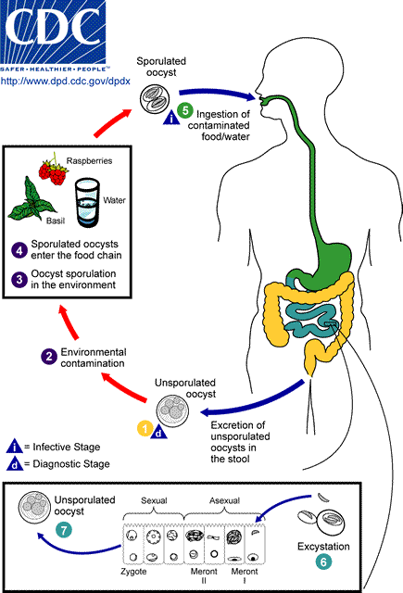

**Clinical features :**

After an average incubation period of 1 week, symptomatic infections typically manifest as watery diarrhea, which can be severe. Other symptoms include anorexia, weight loss, abdominal pain, nausea and vomiting, myalgias, low-grade fever, and fatigue. Untreated infections typically last for 10-12 weeks and may follow a relapsing course. Infections, especially in disease-endemic settings can be asymptomatic.

**Diagnosis:**  
 Currently, the most practical diagnostic method consists of the identification of oocysts in stool specimens by light microscopy. Other methods are also available .*Cyclospora* oocysts can be excreted intermittently and in small numbers. The method most familiar to laboratorians is the formalin-ethyl acetate sedimentation . stained smear (using modified acid fast stain or a modified safranin stain) . the oocyst is spherical , measuring 7 to 10 µm in diameter .

**Treatment and prevention :**

The recommended treatment for cyclosporiasis is a combination of two antibiotics, trimethoprim-sulfamethoxazole, . Supportive measures include management of fluid and electrolyte balance, and rest.

**Prevention** : is achieved by Good personal hygiene and safe water supply help to prevent cyclosporiosis.

***Sarcocystis spp***

Sarcocystis infections occur world wide *.* Only two species of *Sarcocystis* are known to utilize humans as a definitive host: ***Sarcocystis hominis*** and ***S. suihominis***. They are known as human intestinal parasites. Humans Infection results from ingestion of raw or insufficiently cooked meat from cattle or pigs, which frequently contains **muscle cysts** of these species. They infect numerous animals . In human the frequency of *Sarcocytis* infection is relatively low .

**Life cycle :**

*Sarcocystis spp* has a complex life cycle . In ***Sarcocystis hominis*** and ***Sarcocystis suihominis*** infections , human act as the definitive host . and the intermediate hosts is a ( cow , pigs , etc..) .**Sarcocysts** are the infective form of *Sarcocystis hominis* and *Sarcocystis suihominis* for humans . Sarcocysts are present in the striated muscles of cows and heart muscles of pigs .They contain numerous bradyzoites .

Both sporulated oocysts (containing two sporocysts) and individual sporocysts can be passed in stool . Sporocysts contain four sporozoites and a refractile residual body. Sporocysts ingested by the intermediate host (cattle for *S. hominis* and pigs for *S*. *suihominis*) rupture, releasing sporozoites. Sporozoites enter endothelial cells of blood vessels and undergo schizogony, resulting in first-generation schizonts . Merozoites derived from the first-generation invade small capillaries and blood vessels, becoming second-generation schizonts. The second generation merozoites invade muscle cells and develop into sarcocysts containing bradyzoites, which are the infective stage for the definitive host . Humans become infected when they eat undercooked meat containing these sarcocysts. Bradyzoites are released from ruptured cysts in the small intestine and invade the lamina propria of the intestinal epithelium . There, they differentiate into macro- and microgametocytes. Fusion of male and female gametes results in the formation of oocysts . Oocysts sporulate in the intestinal epithelium and are shed from the host in feces . Due to the fragile nature of the oocyst wall, individual sporocysts may also be detected in feces sporocysts are infective to cow and pigs .

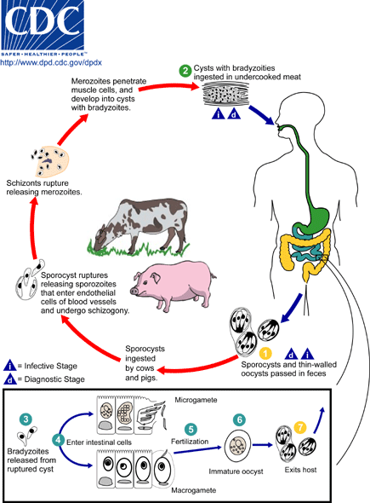

**Clinical features :**

Both species can cause short-lived (six to 48 hours) symptoms within 24 hours of eating meat containing cysts, like nausea, vomiting, and diarrhea as well as a mild fever. *S. suihominis* is more pathogenic than *S. hominis*.

**Diagnosis** : stool examination to observe oocyst and individual sporocyst .Sporocysts are acid fast by modified Ziehl – Neelson technique . diagnosis is made accidentally at biopsy or autopsy by detection of sporocysts or more rarely oocysts.

**Treatment and Prevention**: Albendazole is the drug of choice and prevention is achieved by boiling or deep-freezing (–20 Cᵒ for three days) of pork and beef meat .